Dear Parents
Open Days
We are now taking bookings for our Open Days. This year we are offering potential parents the chance to visit the school on Wednesday 16th October at 9:30am or Wednesday 20th November at 1:30pm. If anyone you know would like to visit please ask them to get in touch with the office.

Bikeability
All children that have signed up for Bikeability will be bringing home information today about training dates and what will be needed on the day. If you have any questions, please ask.

Lunchtime Clubs

The clubs timetable will be published on Weduc this afternoon. If children would like to join a lunchtime club they will need to visit the teacher running the club to sign up.

Top Class Attendance for last week
Turtle | 100%
Squirrel | 100%

Reading Raffle

Key Stage 1
Winners: Rabbit 68%
2nd Place Panda 63%
Key Stage 2
Winners: Falcon 85%
2nd place: Eagle 84%

Top Doodling Classes
Doodle Maths
Falcon | 89%
Dragonfly | 82%
Eagle | 80%
Doodle Tables
Falcon | 93%
Eagle | 76%
Dragonfly | 61%

Stay & Dates 2024/25

We would like to invite you to attend our Stay & sessions this year. This is a great opportunity for you to spend time with your child exploring what they are learning in school.
Each Stay & session would start with a brief presentation from Miss Offer & Mrs Rich in the hall 8:45-9, then in classrooms 9-9:20am.

KS1 Dates

Term 1 | Stay and Talk | Wednesday 2nd Oct
Term 2 | Stay and Calculate | Monday 11th Nov
Term 3 | Stay and SPAG | Wednesday 22nd Jan
Term 4 | Stay and Read | Wednesday 5th Mar (World Book Week)
Term 5 | Stay and Problem Solve | Wednesday 23rd April

KS2 Dates

Term 1 | Stay and Talk | Monday 30th Sept
Term 3 | Stay and SPAG | Monday 20th Jan
Term 4 | Stay and Read | Monday 3rd Mar (World Book Week)
Term 5 | Stay and Problem Solve | Thursday 24th April

Maths Workshops 2024/25
Alongside our Stay & sessions, Mrs Rich will be running the following maths workshops. This is a great opportunity for you to explore the different mathematical strategies with your child.

- Year 3 - Tues 12th Nov at 8:45am
- Year 4 - Wed 13th Nov at 8:45am
- Year 5 - Wed 5th Feb at 8:45am
Star Learners
Well done to this week’s Star Learners
Class | Name | School Value
Dolphin | Oliver Church | Respect
Monkey | Gracie-Leigh Moxham | Resilience
Turtle | Averie Hancock | Respect
Panther | Millie Green | Respect
Butterfly | Luther Dent | Respect, Ambition, Collaboration
Eagle | Oliver Read | Resilience
Falcon | Camron Sharp | Resilience
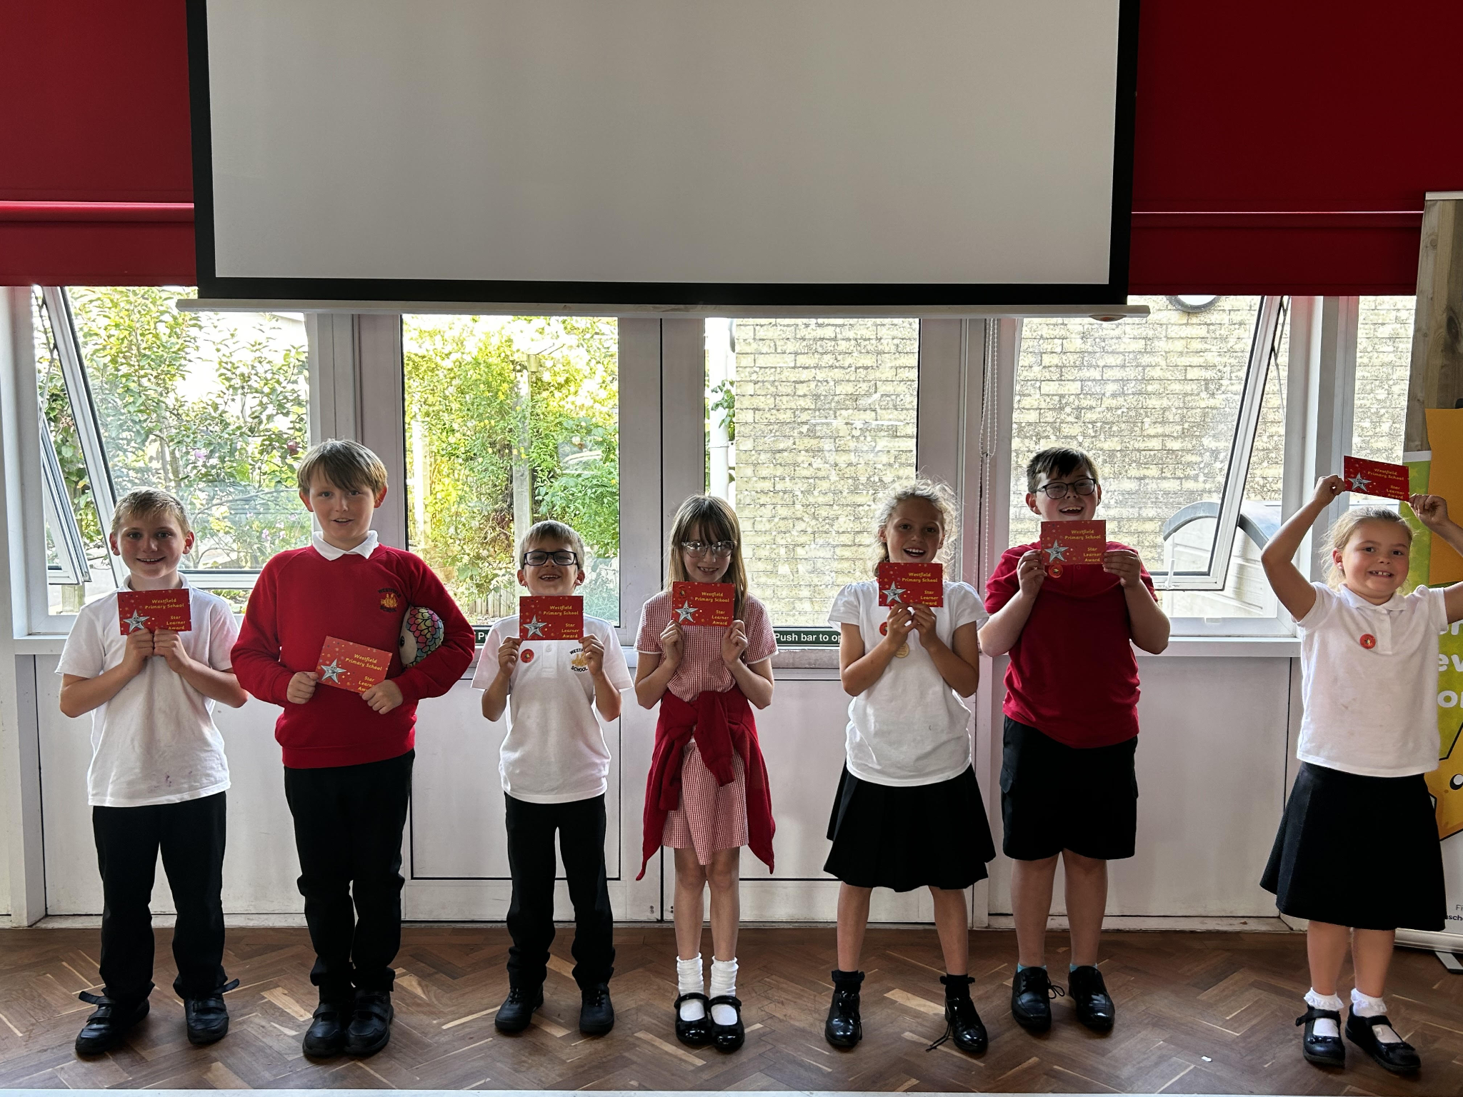
Star Learners
We will now be inviting parents/carers in to celebrate Star Learner achievements. Messages will be sent out on a Monday if your child has been nominated, so please remember to check your inbox for any notification. The children will not be told until the assembly so remember to keep it secret until then.
Please note, the car park will remain closed for star learner parents attending

Diary Dates

September
Mon 23 Year 6 Camp

October
Tue 1 Nigels Coles Photos
Wed 2 Nigels Coles Photos
Tues 8 Harvest Church Service - pupils only
Tue 22 Flu Vaccinations
Fri 25 Inset Day
Mon 28 Half Term

November
Mon 4 Pupils return to school
Tue 12 Bedtime Stories - more info to follow
Tue 12 Maths Workshop Year 3
Wed13 Maths Workshop Year 4
Wed 27 Inset Day

December
Fri 20 End of term
Mon 23 - Fri 3 Christmas Holidays
Mon 6 Inset Day





