Dear Parents

Parents Evening
A reminder of the dates for the upcoming Parents evenings:
- Monday 21st October
- Thursday 24th October
Appointment bookings will be live from 9am on Saturday 12th October and will remain open until 9am on Thursday 17th October
All appointments will need to be booked online using the link below
https://westfieldprimaryschool.schoolcloud.co.uk

Hello Yellow

Thank you to everyone who supported our #HelloYellow day on Thursday. We raised £128 which will go towards the amazing work carried out by Young Minds Charity.

School Photos
All photo proofs have now been sent home. Orders can be made either online or by returning the envelope along with the correct money.
All orders must be made by Tuesday 22nd October.

Top Class Attendance for the week

Falcon | 99.6%

Top Doodling Classes
Doodle Maths
Dragonfly | 89%
Eagle | 80%
Squirrel | 68%
Doodle Tables
Eagle | 88%
Dragonfly | 75%
Falcon | 67%

Reading Raffle

Key Stage 1
Winners: Squirrel 64%
2nd Place Rabbit 63%
Key Stage 2
Winners: Eagle 92%
2nd place: Falcon 85%

Star Learners
Well done to this week’s Star Learners

Class | Name | School Value
Dolphin | Lexi Tadd | Ambition
Monkey | Cora Gobatti | Respect
Dragonfly | Macey Doman | Ambition
Turtle | Darcie Merrett | Ambition
Panther | Paige Gane | **Everything**
Butterfly | Bella Bushnell | Respect & Ambition
Eagle | Phoenix Woodland | **Everything**
Falcon | Sophie Macfarlane | **Everything**
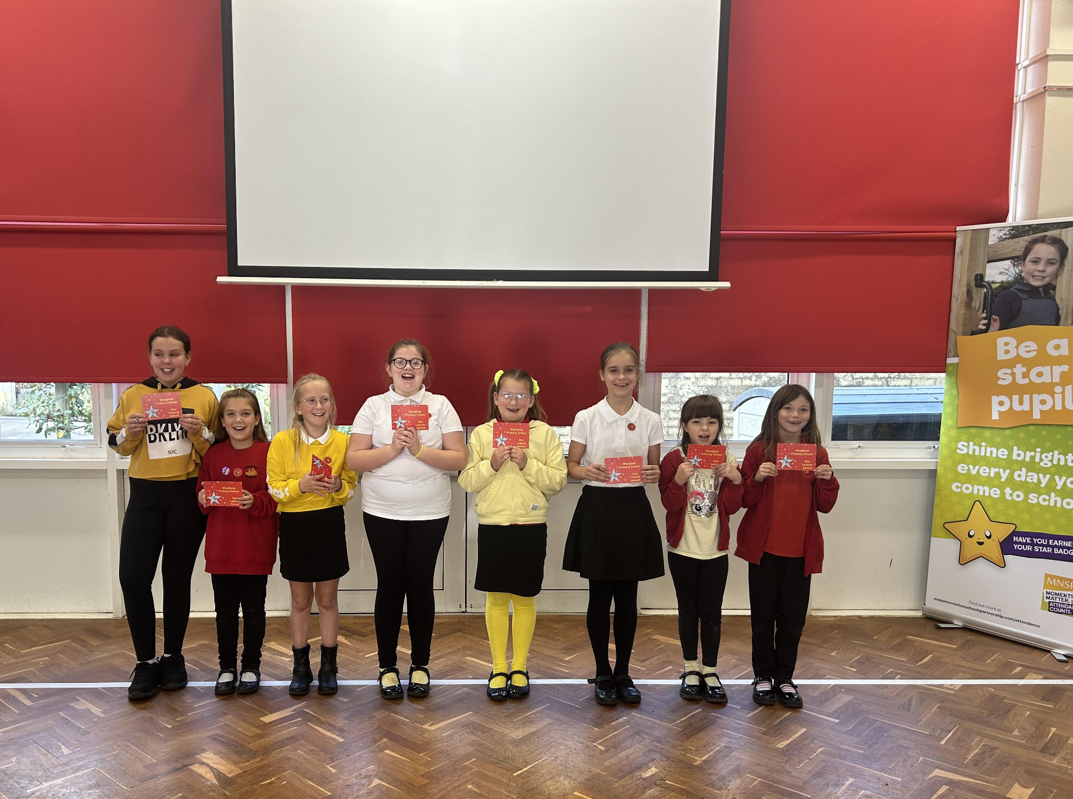

Diary Dates

October

Wed 16 School Tour 9:30am
Fri18 Spooky Chill Night - PTA
Mon 21 Parents Evening
Tue 22 Flu Vaccinations
Thur 24 Parents Evening
Thur 24 PTA Halloween Bake Sale
Fri 25 Inset Day
Mon 28 Half Term

November

Mon 4 Pupils return to school
Tue 12 Bedtime Stories - more info to follow
Tue 12 Maths Workshop Year 3
Wed 13 Maths Workshop Year 4
Wed 20 School Tour 1:30pm
Wed 27 Inset Day

December

Fri 6 PTA Christmas Fair
Fri 20 End of term
Mon 23 - Fri 3 Christmas Holidays

January


Mon 6 Inset Day

