Dear Parents

Sports Day

We can confirm the final arrangements for sports day taking place next week
Years 4, 5 and 6 Thursday 20th June start 9:30am
Year 1, 2 and 3 Thursday 20th June start 1:30pm
Early Years (Nursery & Reception) Friday 21st June 9.15am
Children can come into school wearing their PE kits

Year 6 Camp Meeting
There will be a camp meeting on Tuesday 9th July at 3.15pm in the school hall for those current Year 5 children who will be going on Year 6 Camp in September 2024.

Lunchtime buddy training
We are just coming to the end of our second successful year of Year 6 lunchtime buddies. Year 6 buddies support the SMSAs on the KS1 playground at lunchtime by supporting small friendship issues and engaging in play activities with our younger children.
Now is the time to start thinking about recruiting new buddies for next year. If you are in Year 5 and you would like to be part of a lunchtime buddy rota for next year, please could you write a short letter of application by next Friday. Your letter needs to explain why you would like to be a buddy and which qualities or skills you have that would make you a good buddy.
I would like to say a huge THANK YOU to our current team of 17 Year 6 buddies who have worked tirelessly this year. From handing out drinks in the hall, to leading Reception children out of the hall in an orderly fashion you have all been BRILLIANT!

Top Class Attendance for last week

Panther | 100%
Dolphin | 98.3%

Star Learners
Well done to this week’s Star Learners

Class | Name | School Value
Dolphin | Ayda Kaya | Ambition & Respect
Monkey | Bonnie-Kate Blacker | **Everything**
Dragonfly | Honey Kearn | Ambition
Turtle | Mason Wooltorton | Ambition
Panther | Logan Dewsnap | Collaboration
Butterfly | Taiya Preddy | **Everything**
Eagle | Michael Kubinec | Kindness
Falcon | Maisie Daniells | Ambition

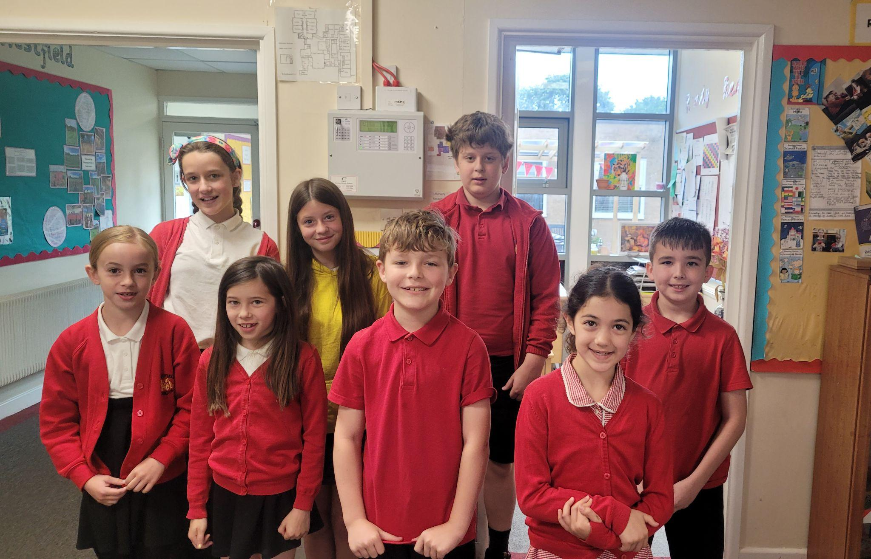

Diary Dates

June

Fri 7 Year 3 Sleepover
Thur 20 School Sports Day
Fri 21 EYFS Sports Day

July

Fri 5 Summer Fayre
Mon 8 Fantastic Futures Week
Tue 9 Year 6 Camp Meeting
Thur 11 Year 6 Production performance
Wed 17 Year 6 Service at St Peter’s
Fri 19 Pupils break up for Summer

September

Mon 2 Inset Day
Tues 3 Pupils return to school

October

Fri 25 Inset Day
Mon 28 Half Term

November

Mon 4 Pupils return to school



