Dear Parents

School photos
Orders for all school class photos need to be in school or done online by Tuesday 14th May.

Sports Day
Years 4, 5 and 6 Thursday 20th June AM
Year 1, 2 and 3 Thursday 20th June PM
Early Years (Nursery & Reception) Friday 2st June AM
We will confirm times nearer the date.

Year 6 Leavers Events
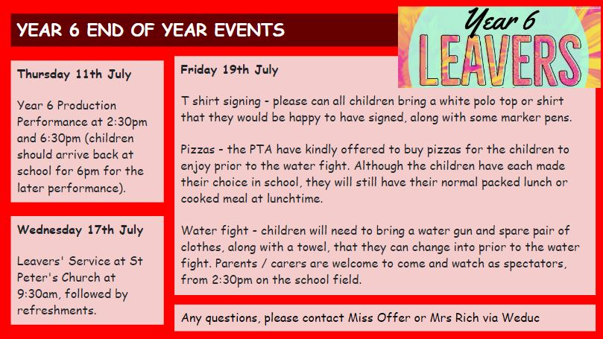

Reading Raffle

Key Stage 1
Winners: Panda 66%
2nd Place Owl 56%
Key Stage 2
Winners: Falcon 89%
2nd place: Eagle 81%

Top Class Attendance for last week

Butterfly | 98.6%
Monkey | 97%

Top Doodling Classes
Doodle Maths
Falcon | 75%
Squirrel | 60%
Monkey | 37%

Doodle Tables
Falcon /Eagle | 79%
Butterfly | 45%
Dolphin | 21%

Star Learners
Well done to this week’s Star Learners

Class | Name | School Value
Dolphin | Ruby Rogers | Resilience
Monkey | Darcey Merrett | Ambition
Panther | Phoenix Woodland | Ambition
Butterfly | Sophie Lowe | Resilience
Eagle | Lycus Denning-Kuijper | Ambition/Resilience
Falcon | Finley Robson | Respect

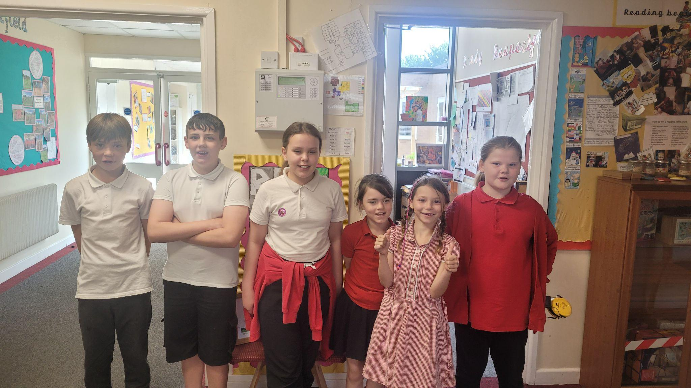

Diary Dates

May

Mon 13- Fri 17 Year 6 SATS week
Mon 27 - Fri 31 Half Term

June

Mon 3 Start of term 6
Fri 7 Year 3 Sleepover
Thur 20 School Sports Day
Fri 21 EYFS Sports Day

July
Fri 5 Summer Fayre
Thur 11 Year 6 Production performance
Wed 17 Year 6 Service St Peter’s
Fri 19 Pupils break up for Summer

September
Mon 2 Inset Day
Tues 3 Pupil return to school

