Dear Parents

Sponsored Read Results!
Following our Sponsored Read, we raised...(drumroll) £406.95!!
A huge thank you to everyone who supported and encouraged their children's reading at home and gathered sponsorship money. Of course, a super well done to every child who took part. This money, along with previous sponsorship raised, will mean that we have £500 to spend on brand new books for our classrooms and libraries!
A special well done to the following children who read the highest number of times in each key stage:

KS1 winner: Harry Martin
KS2 winner: Thomas Rossiter
The winning classes with the highest collective reads were:
KS1 class: Owl (174 reads)
KS2 class: Dragonfly (317 reads)

Last but not least, a special thank you and well done to Autumn Crang and her family who raised a huge £100 towards the sponsored read!
We will welcome a special visitor to our Monday assembly who will announce the winners, present certificates and give out prizes.
We appreciate all of your support and look forward to sharing our brand new books with you all!

Rainbow Raffle
On Thursday 28th March we will be holding a non-uniform day in exchange for an item of a designated colour listed below. Year group Colours, as follows:
Nursery/Reception – Red
Year 1 Orange
Year 2 Yellow
Year 3 Green
Year 4 Blue
Year 5 Pink
Year 6 Purple

These items can be anything from sweets, chocolates, drinks, biscuits, toiletries, a candle, as long as it’s the correct colour. The condition of this item needs to be new and goods need to be non-perishable.
Please bring these items in on the morning of Thursday 28th with your child.

Top Class Attendance for last week

Rabbit | 100%
Falcon | 97%

Top Doodling Classes
Doodle Maths
Squirrel | 75%
Monkey | 74%
Falcon | 71%

Star Learners
Well done to this week’s Star Learners

Class | Name | School Value
Dolphin | Ellie-Mae Oatley | Collaboration & Ambition
Monkey | Charley Plummer | Collaboration
Dragonfly | Isla Murray | Ambition & Respect
Turtle | Hayden Brewer | Collaboration & Resilience
Panther | Tegan Page | Ambition
Butterfly | Lucy Parsons | Ambition & Respect
Eagle | William Bailey | Resilience, ambition & Collaboration
Falcon | Mia Barnard | Ambition & Respect

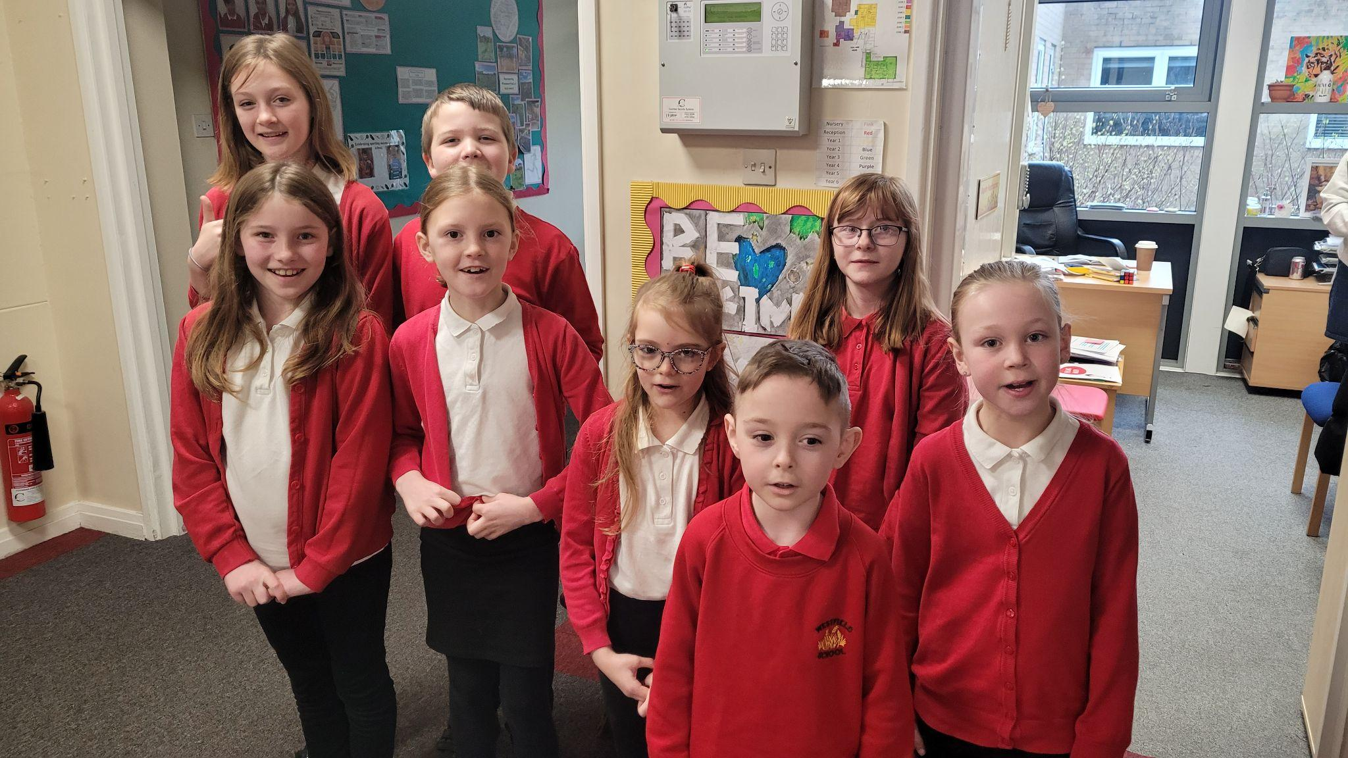

Diary Dates

Fri 22 PTA Easter Bingo
Thur 28 End of term - non uniform day
Fri 29 - 12 April Easter Holidays

April
Mon 15 Pupils return to school
Fri 26 PTA School Disco

May
Mon 6 Bank Holiday
Mon 27 - Fri 31 Half Term

July
Fri 5 Summer Fayre
Fri 19 Pupils break up for Summer

September
Mon 2 Inset Day
Tues 3 Pupil return to school

