Dear Parents

School Applications

Reminder - If your child is due to start school in September 2024 then you need to apply for their school place by 15th January.

Year 6 SATS Meeting - Wednesday 24th January 8:30am - 9am
On Wednesday 24th January, parents and carers are invited to attend our Year 6 SATS information meeting at 8:30am in the school hall. Throughout the meeting, we will go through important information regarding how we can both prepare and support your child in the lead up to SATS. You will also have the opportunity to ask questions about your child's upcoming SATS.

Year 6 camp September 2024
All Year 5 parents/carers should have now received a Weduc message regarding Year 6 Camp for September 2024. Please can you take a moment to read through and respond by Friday 19th January.

Join Team Westfield
We have three exciting vacancies that we are looking to fill. Applications are now open for the below positions:
- Nursery Midday Supervisor
- Bank SMSA
- Nursery Practitioner
Details of all these opportunities and how to apply can be found on the below link:
https://www.eteach.com/careers/westfieldprimary
If you think you have what it takes to join our friendly and professional team we would love to hear from you.

Reading Raffle

Key Stage 1
Winners: Bumblebee 58%
2nd Place Owl 56%
Key Stage 2
Winners: Falcon 77%
2nd place: Eagle 64%

Top Doodling Classes
Doodle Maths
Squirrel | 74%
Monkey | 56%
Eagle | 46%

Doodle Tables
Butterfly | 48%
Monkey | 37%
Panther | 36%

Maths Support
Radstock College are still running courses for parents, guardians, and caregivers to help them gain confidence in supporting their key stage 2 children when it comes to Maths homework and SATS.
There are some spaces available from 9.30am to 11.30am and 12.30pm to 2.30pm.
The course is being held at the Radstock Family and Childrens Centre.
Covering the following topics,
Number and Place Value
Addition and Subtraction
Multiplication and Division
Fractions
Measurement
Properties of Shape
Position and Direction
Statistics
If you are interested, then please contact:
01225 328822 or acl@bathcollege.ac.uk

Star Learners
Well done to this week’s Star Learners

Class | Name | School Value
Dolphin | Justin Smith | **Everything**
Monkey | Emilia Cairns | Collaboration
Dragonfly | Lexie Merrett | Ambition
Turtle | Ella Davies | **Everything**
Panther | Connie Wisbey | **Everything**
Butterfly | Thomas Seymour | Collaboration
Eagle | Freya Dickinson | **Everything**
Falcon | Alfie Francis | Ambition

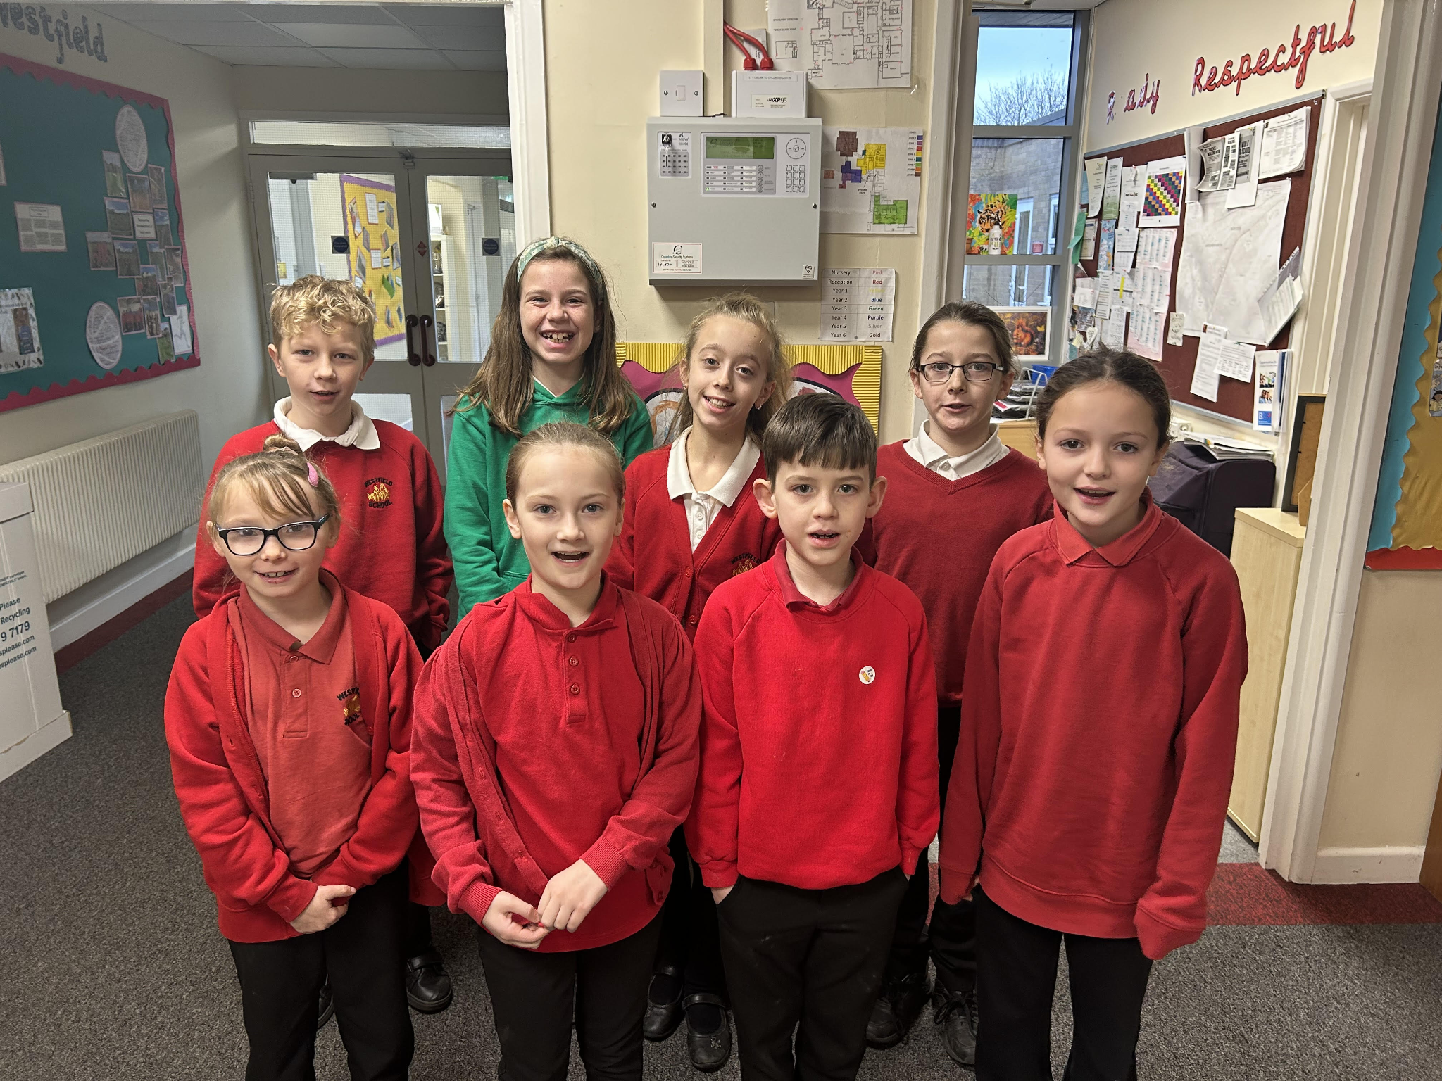


Diary Dates

February
Mon 12 – Fri 15 Half Term
Mon 19 Pupils return to school

March
Thur 7 World Book Day
Thur 28 End of term
Fri 29 - 12 April Easter Holidays

April
Mon 15 Pupils return to school

May
Mon 6 Bank Holiday
Mon 27 - Fri 31 Half Term

July
Fri 19 Pupils break up for Summer


September
Mon 2 Inset Day
Tues 3 Pupil return to school

