Dear Parents


Christmas Fayre
A huge thank you to everyone that came along and helped us raise a massive £1460 at the Christmas Fayre last Friday.

Also, a big thank you to everyone who kindly donated prizes towards the tombola and raffle.
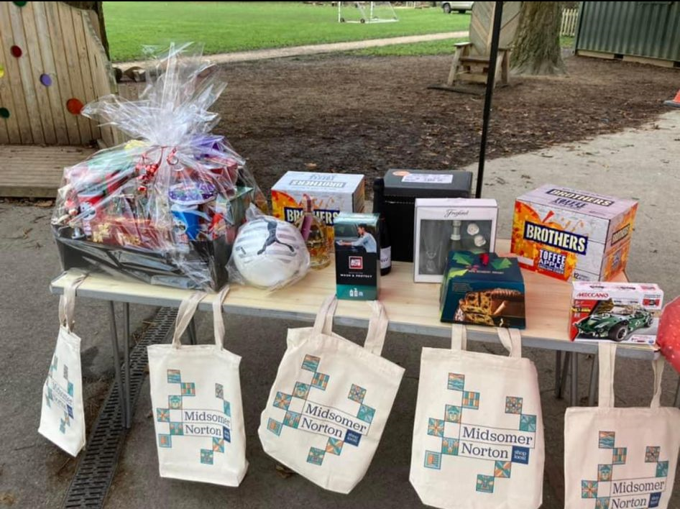

Sun Down Club
Sun Down Club will close at 5pm on the last day of term, Tuesday 19th December.

Nativities
This year, Nativities will be held the week of the 11th December.

Tuesday 12th December Reception

Wednesday 13th December Year 2

Thursday 14th December Year 1

All performances at 9.15am and 2.15pm.

Top Class Attendance for last week

Badger | 100%
Owl | 99.2%

Reading Raffle

Key Stage 1
Winners: Owl 56%
2nd Place Panda 50%
Key Stage 2
Winners: Panther 83%
2nd place: Falcon 81%

Top Doodling Classes
Doodle Maths
Squirrel | 63%
Monkey | 59%
Falcon | 52%

Doodle Tables
Dragonfly | 52%
Eagle | 46%
Butterfly | 45%

Star Learners
Well done to this week’s Star Learners

Class | Name | School Value
Dolphin | Josh Hutchins | Ambition
Monkey | Emilia Cairns | Respect
Dragonfly | Niamh Whelan | Collaboration/ Respect
Turtle | Leo Bryant | Resilience
Panther | Amelia Ford | Respect
Butterfly | Emmie Hamblin | **Everything**
Eagle | Chloe Rodd | Collaboration
Falcon | Maddison Padfield | Ambition/Respect

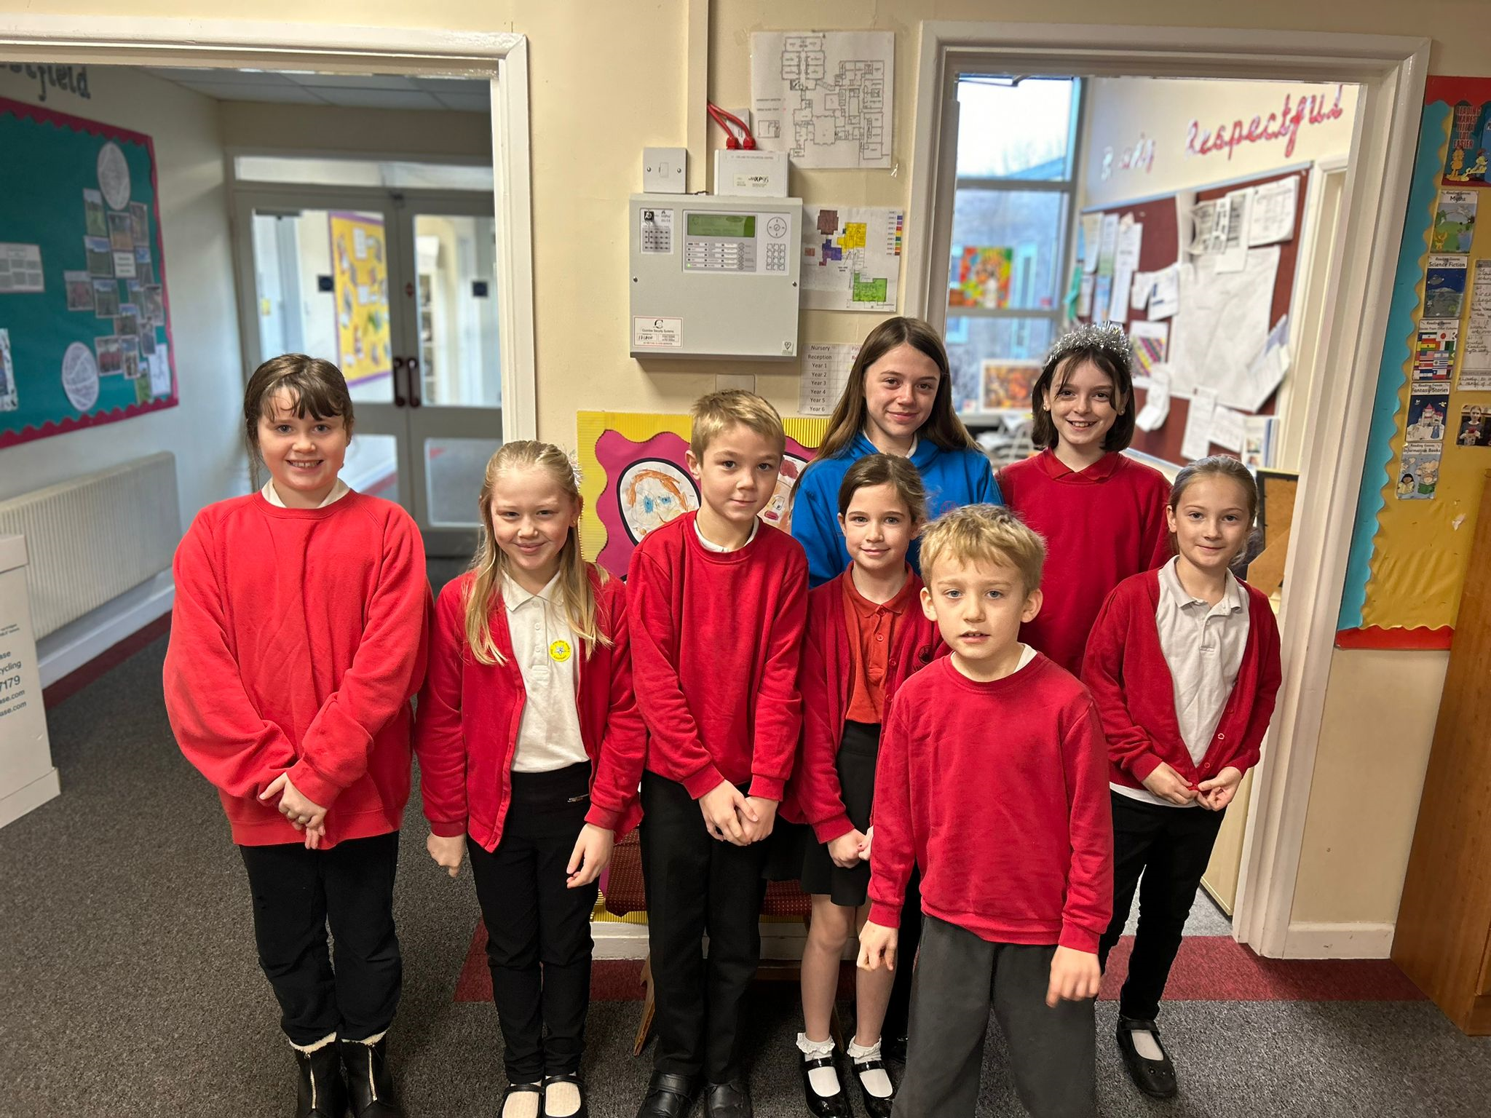



Diary Dates

Dec

Mon 11 Rainbow Theatre Pantomime
Tues 19 Christmas Dinner Day
Christmas Jumper Day
PTA Mad hair day
Tues 19 End of Term
January
Tues 2 Inset Day
Wed 3 Inset Day
Thurs 4 Pupils return to school

February
Mon 12 – Fri 15 Half Term
Mon 19 Pupils return to school

