Dear Parents

Panto 11th December
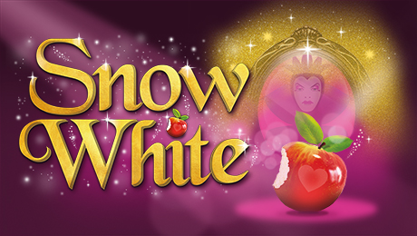
Reminder - The Panto is taking place in school on Monday 11th December. If you would like your child to watch, please could you pay £1 per child on ParentPay by the end of the day.

Nativities
This year, Nativities will be held the week of the 11th December.

Tuesday 12th December Reception

Wednesday 13th December Year 2

Thursday 14th December Year 1

All performances at 9.15am and 2.15pm.

DoodleMaths Winter Calendar
Well done to Monkey and Butterfly class who won top Doodling Class this week for Maths and Doodle Tables.
We’re excited to announce the return of the Winter Calendar - Between the 1st of December and the 24th of December, children can unlock the doors on a Doodle advent calendar by completing their daily exercise in the run-up to Christmas.
The Winter Calendar can be found as a colourful icon on the My Robot page of DoodleMaths and unlocking the doors will reward learners with seasonal accessories and exclusive songs for their jukebox.
Who will complete their calendar?


Top Class Attendance for last week

Owl | 99.6%
Dolphin | 97.2%

Reading Raffle

Key Stage 1
Winners: Panda 70%
2nd Place Badger 62%
Key Stage 2
Winners: Falcon 92%
2nd place: Panther 78%

Star Learners
Well done to this week’s Star Learners
Class | Name | School Value
Dolphin | Libby James | Collaboration
Monkey | Riley Edgell | Resilience
Dragonfly | Ceejay Painter | Ambition
Turtle | Jack Macfarlane | Ambition
Panther | Summer Willcox | Ambition
Butterfly | Sam Rumney | Resilience
Eagle | Emily James | Resilience
Falcon | Jessica Mellor | **EVERYTHING**

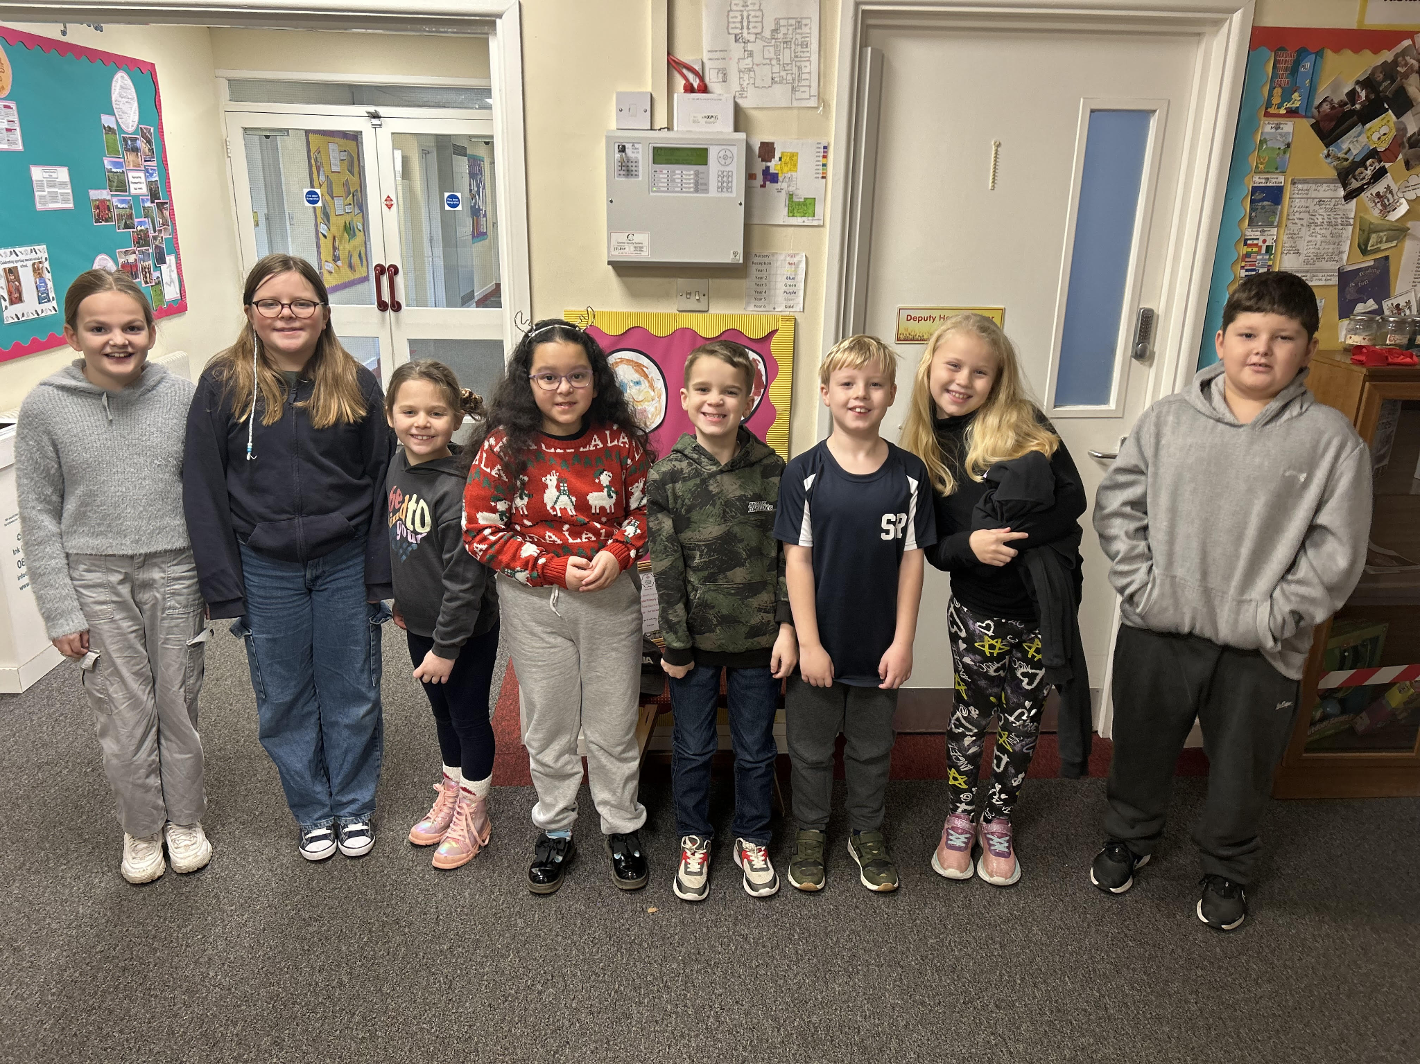
Diary Dates

Dec
Fri 1 PTA Christmas Fayre
Tues 5 Year 6 Height & weight
Mon 11 Rainbow Theatre Pantomime
Tues 19 Christmas Dinner Day
Christmas Jumper Day
PTA Mad hair day
Tues 19 End of Term
January
Tues 2 Inset Day
Wed 3 Inset Day
Thurs 4 Pupils return to school

February
Mon 12 – Fri 15 Half Term
Mon 19 Pupils return to school

