Dear Parents

We would like to wish everyone a very Merry Christmas and Happy New Year. Please remember our last day of term is Tuesday 19th December and will return back to school on Thursday 4th January.
Visit from Santa
The children have all enjoyed a surprise visit from Santa today!! Santa visited the children in their classrooms and everyone received a small gift from Santa and the PTA. Merry Christmas from all the Westfield PTA
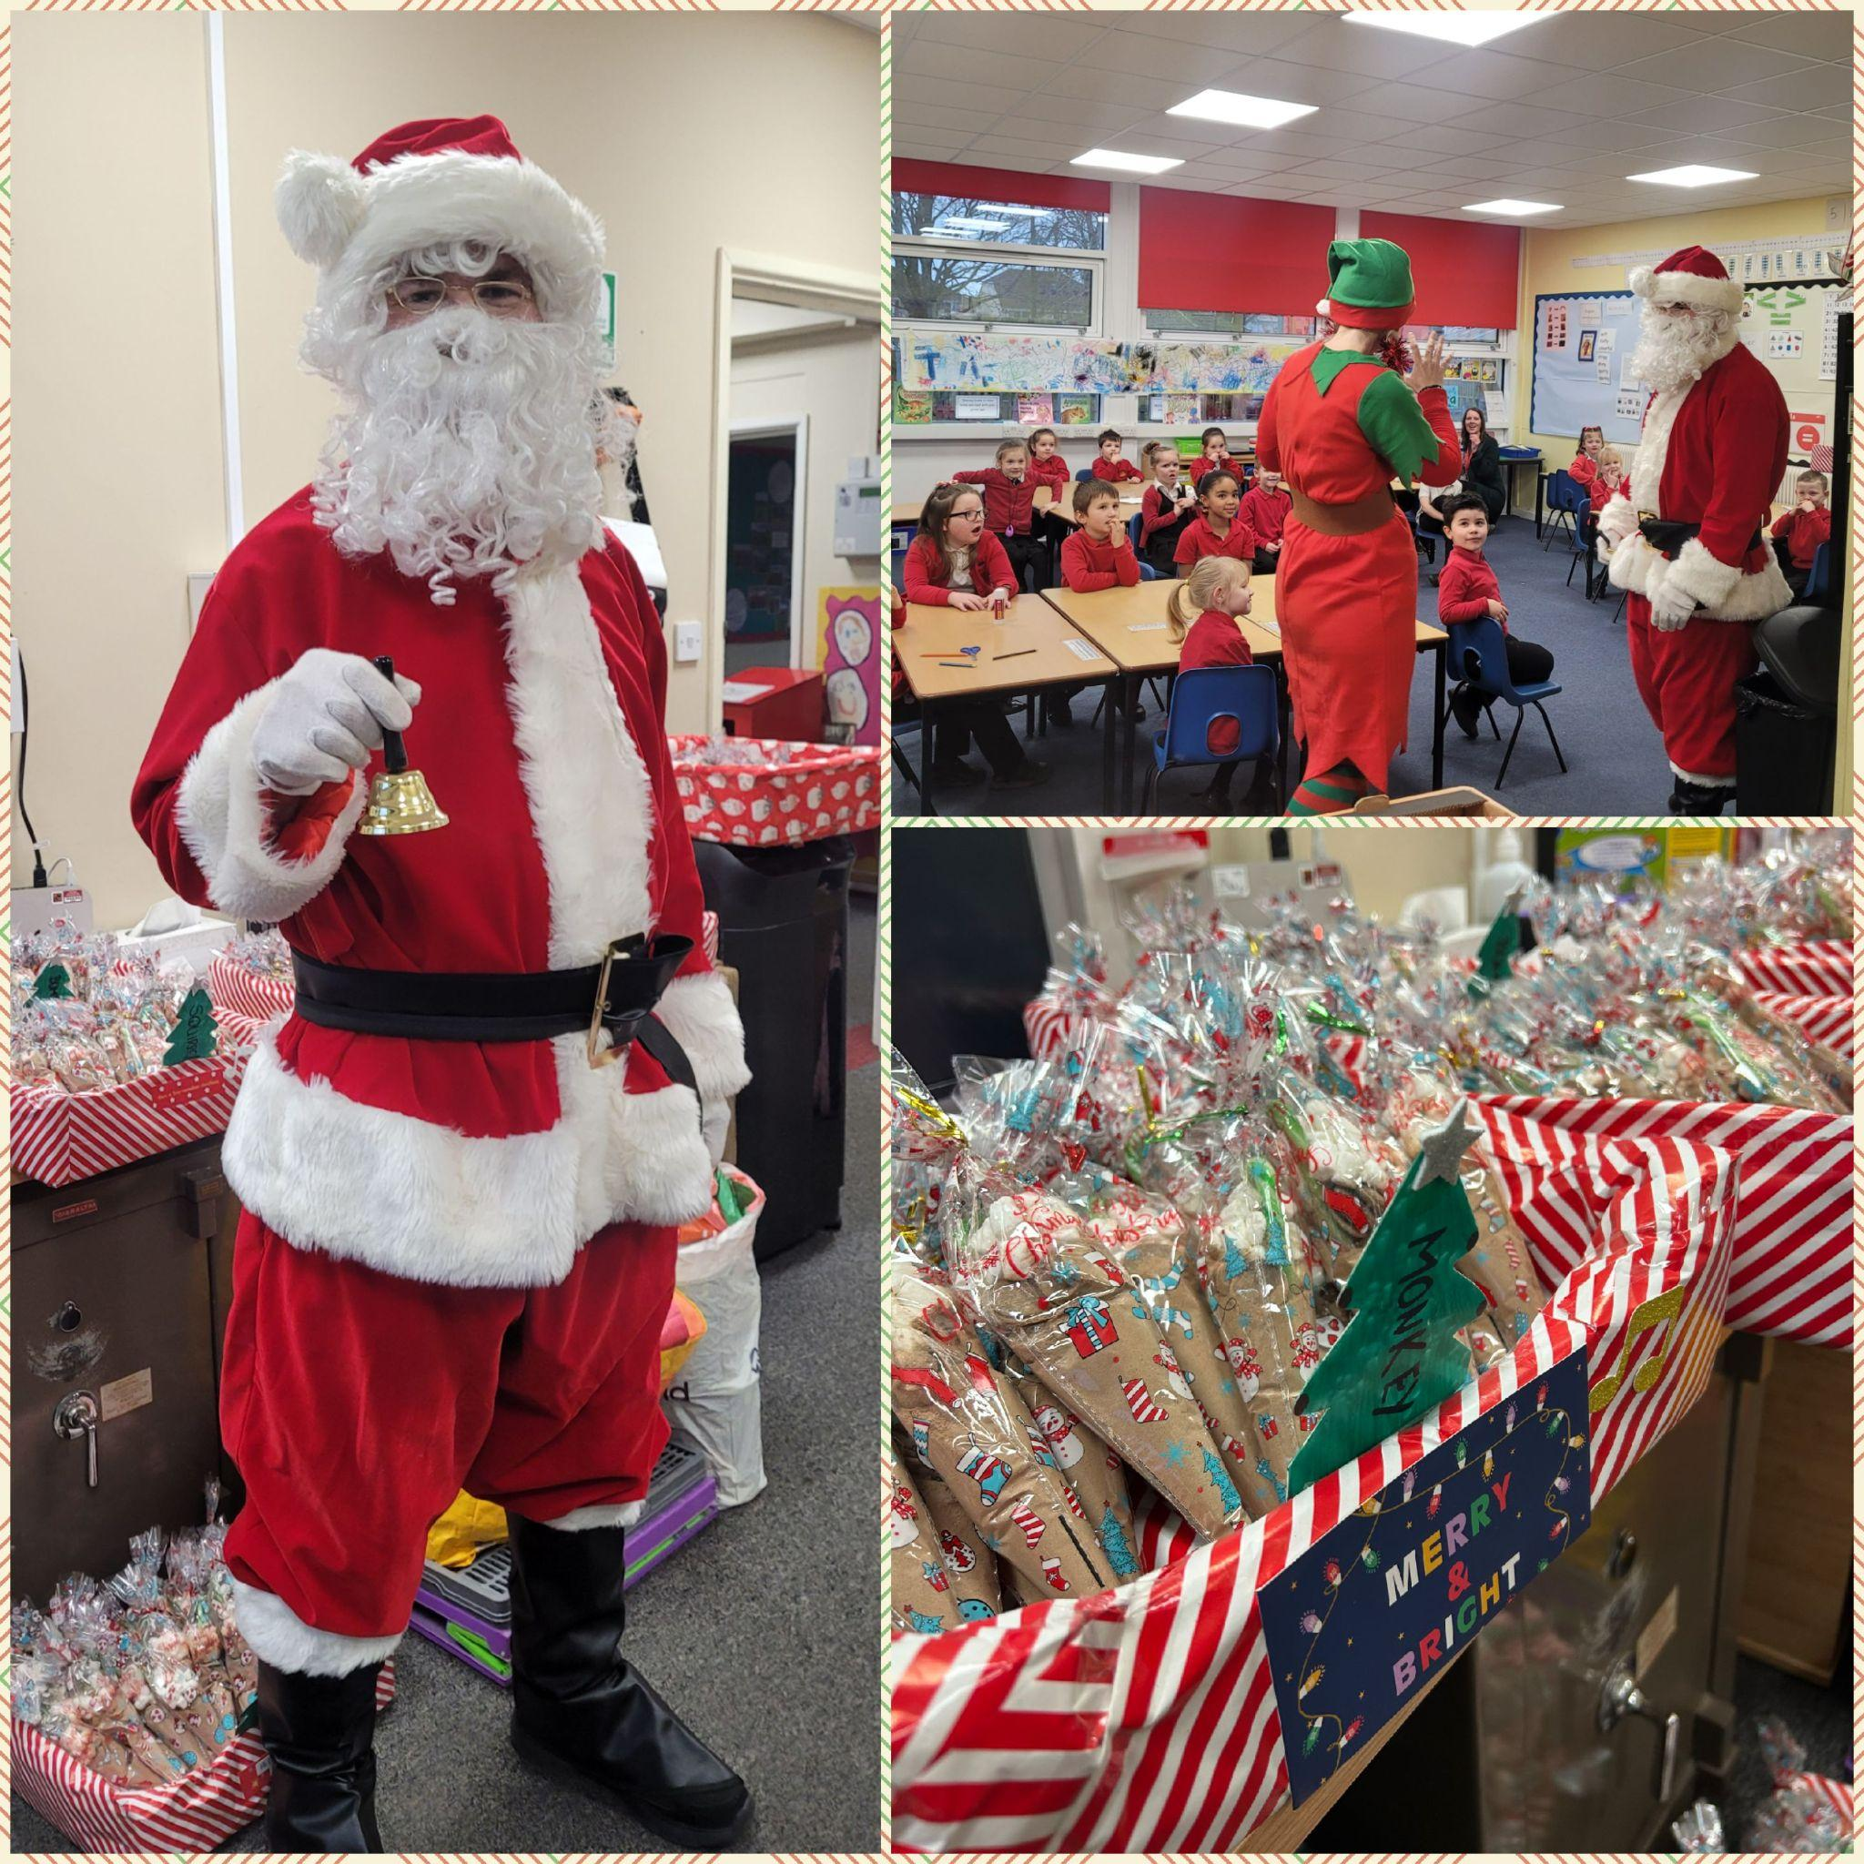
Christmas Dinner Day
We will be having our Christmas Dinner on Tuesday 19th December. This will also be Christmas Jumper day and Mad Hair day.
Baby News
Mason Wooltorton has become a big brother! Congratulations to Mason and his family.
Sun Down Club
Sun Down Club will close at 5pm on the last day of term, Tuesday 19th December.
Top Class Attendance for last week

Owl | 99.2%
Dolphin | 97.6%

Reading Raffle

Key Stage 1
Winners: Panda 60%
2nd Place Badger 57%
Key Stage 2
Winners: Falcon 85%
2nd place: Eagle 79%

Christmas Cupcakes
On Tuesday, our Values Champions delivered cupcakes to Whitehaven care home. The cupcakes were made by children as part of this year's Design Technology competition. As expected, the cakes were decorated beautifully with festive toppings and icing, and were very gratefully received by Whitehaven residents and the manager, Lynne.
A big 'well done' and 'thank you' to all the children who baked cakes and to our Values Champions who were superb ambassadors for the school.

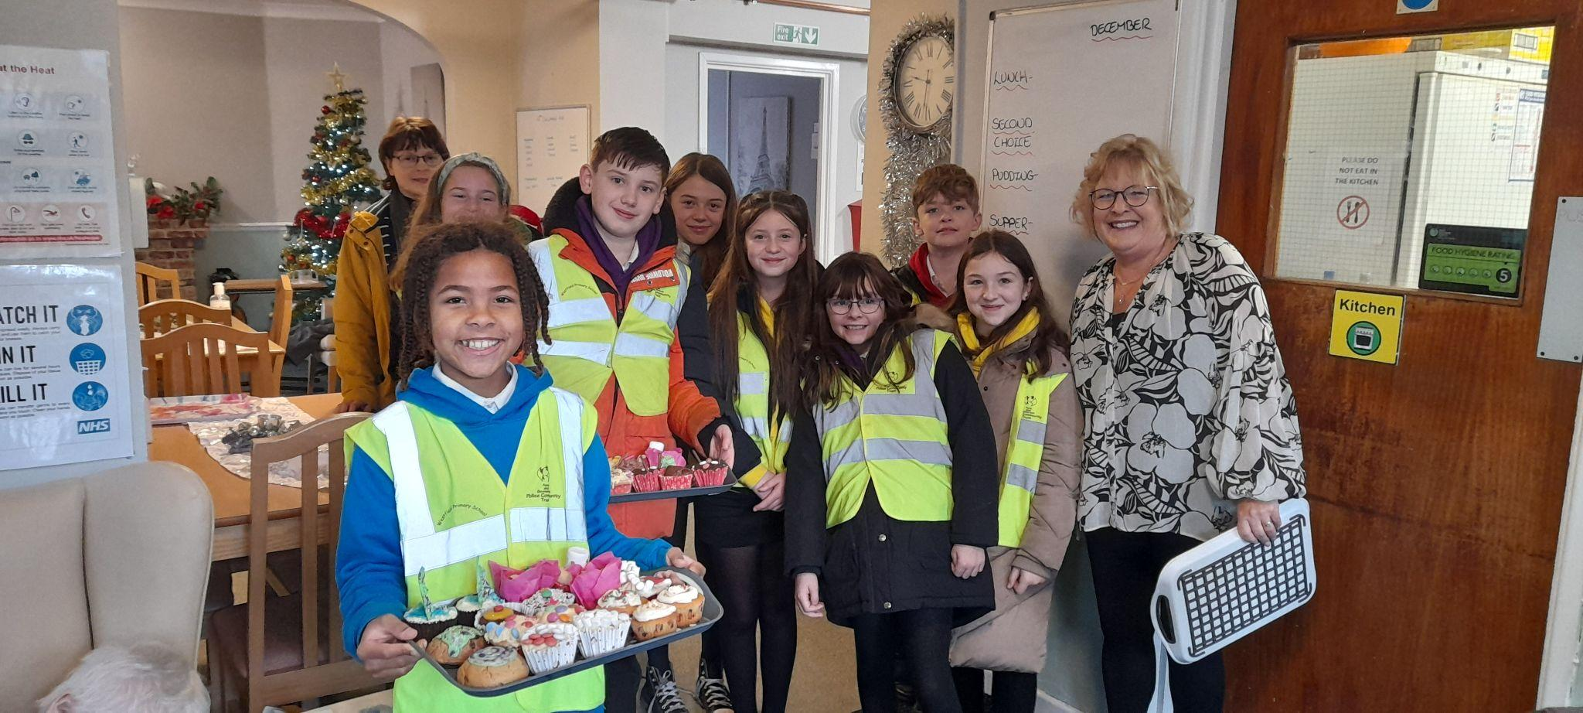

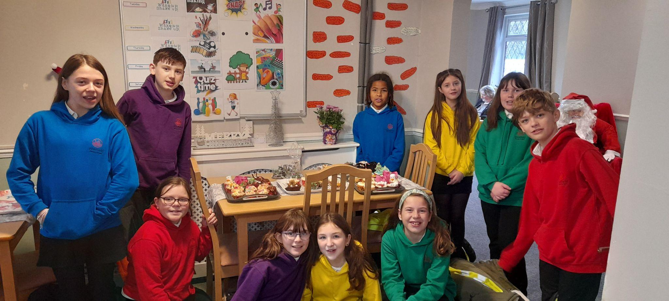


Top Doodling Classes
Doodle Tables
Butterfly | 55%
Eagle | 39%
Falcon | 37%

Star Learners
Well done to this week’s Star Learners

Class | Name | School Value
Dolphin | Amber Rose Vining | **Everything**
Monkey | Averie Hancock | Resilience
Dragonfly | Blake Andow | Respectful
Turtle | Bella Bushnell | Ambition
Panther | T’Maine Forde | Cooperation
Butterfly | Solomon Jeffery-Bradley | Resilience/Ambition
Eagle | Maisie Rippin | **Everything**
Falcon | Riley Bishop | Collaboration

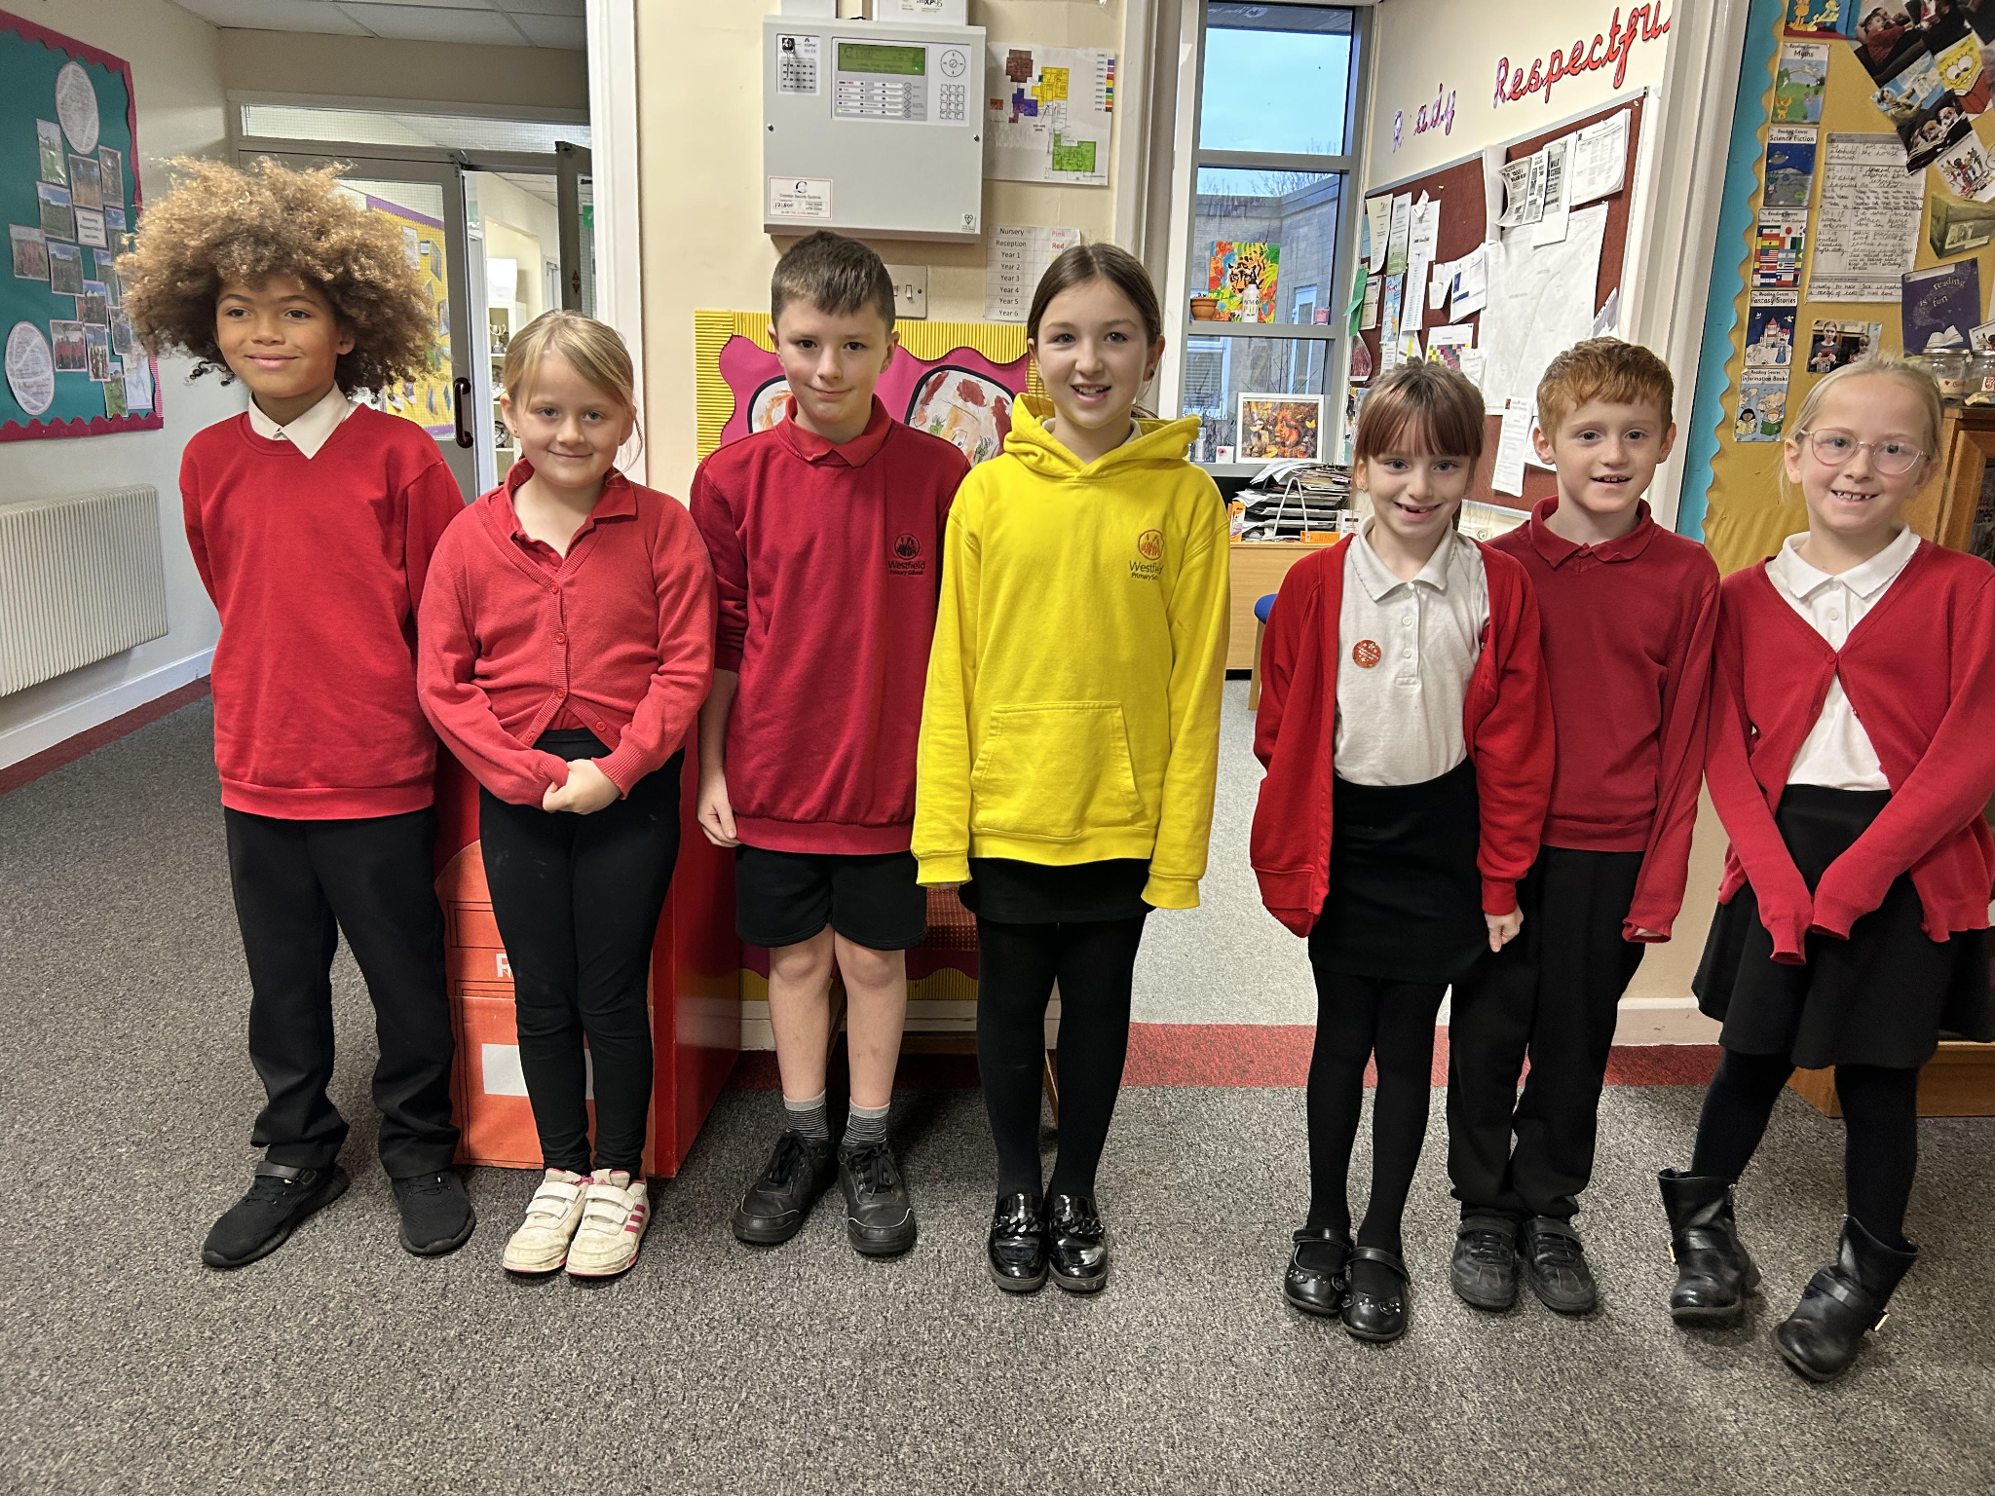

Lunchtime Award Winners
Well done to Millie, Lacey, Alfie, Sahath and Oliver who have all been nominated by the SMSA’s for their fantastic behaviour at lunchtime. They were rewarded with a delicious treat from Fosseway Cafe.
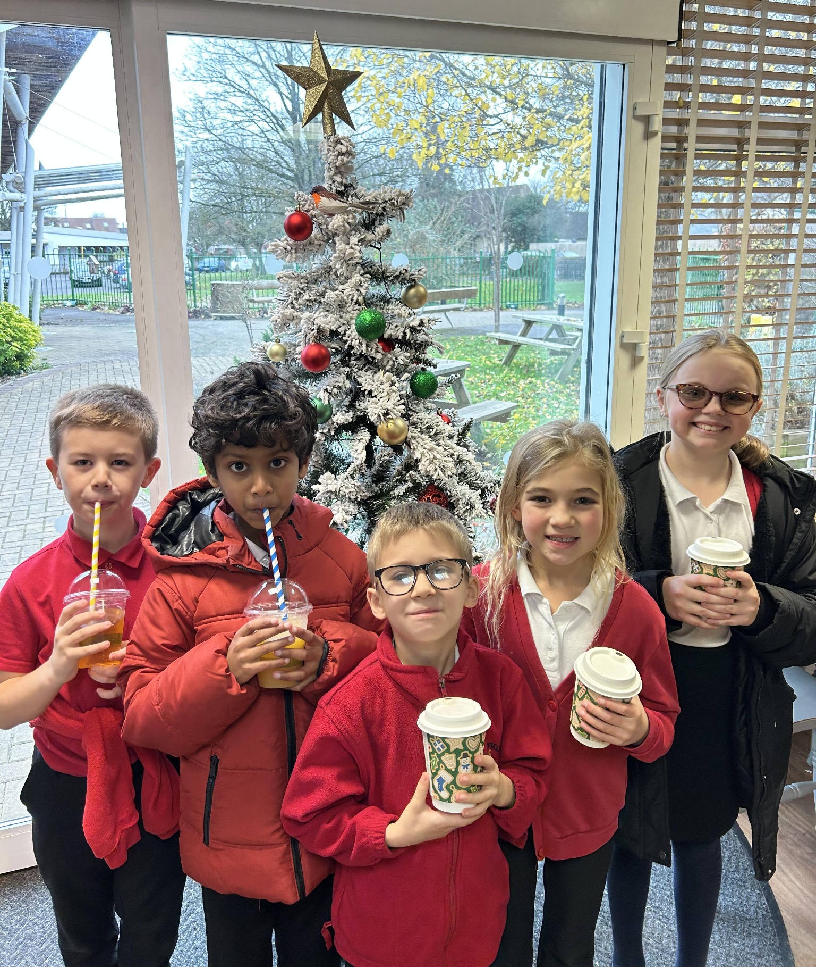


Diary Dates

Dec
Tues 19 Christmas Dinner Day
Christmas Jumper Day
PTA Mad hair day
Tues 19 End of Term
January
Tues 2 Inset Day
Wed 3 Inset Day
Thurs 4 Pupils return to school

February
Mon 12 – Fri 15 Half Term
Mon 19 Pupils return to school

