Dear Parents

Children in Need
We have raised a fantastic £417.79. Thank you to everyone who donated.


Travelling Book Fair
Thank you to everyone that came along and supported the recent travelling Book Fair held in school. The school receives commission from every sale and we are pleased to announce we received £289.68 which will go towards new books for school.

Christmas Dinner Bookings
Please be aware that the central catering team have made changes to the booking system and this may have affected any bookings made for Christmas Lunch on Tuesday 19th December. Please can you check that your child's booking is still showing and rebook if necessary.
Nativities
This year, Nativities will be held the week of the 11th December.

Tuesday 12th December Reception

Wednesday 13th December Year 2

Thursday 14th December Year 1

All performances at 9.15am and 2.15pm. Information to follow regarding tickets and costumes.

Westfield Girls Football
Westfield girls' football team competed in a tournament at Norton Hill School this week. They showed courage and determination against older and more experienced players in, what was for many, their first football match. Well done girls!
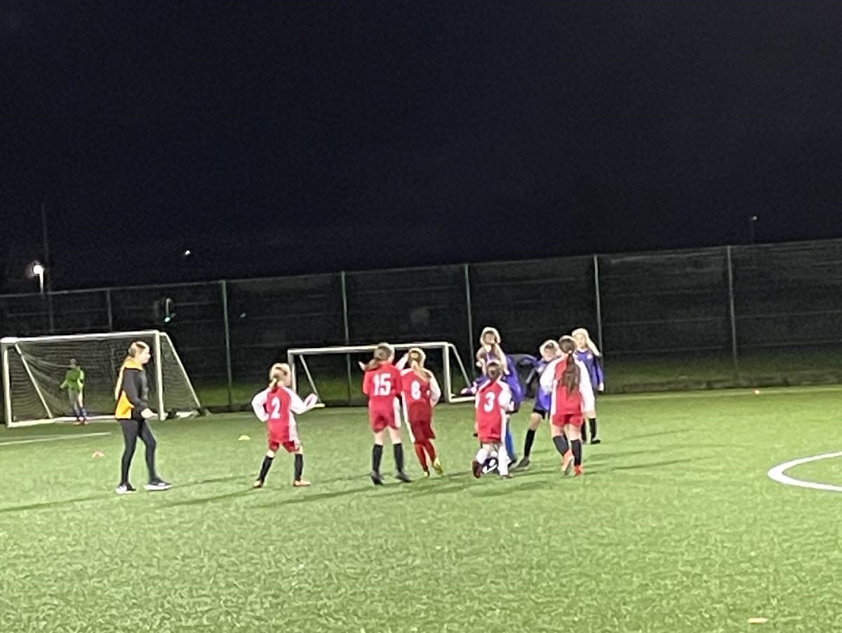

Top Class Attendance for last week

Dolphin | 99.3%
Butterfly | 98.6%

Reading Raffle

Key Stage 1
Winners: Badger 71%
2nd Place Squirrel 68%
Key Stage 2
Winners: Falcon 81%
2nd place: Eagle 79%

Top Doodling Classes
Doodle Maths

Eagle | 100%
Monkey | 67%
Squirrel | 63%

Doodle Tables

Falcon | 52%
Monkey | 52%
Eagle | 50%

Star Learners
Well done to this week’s Star Learners

Class | Name | School Value
Dolphin | Dolly Jackson | Resilience
Monkey | Ralfie Padfield | Ambition
Dragonfly | Kian Frayling | Ambition
Turtle | Lucas Farraday | Resilience
Panther | Faye Weeks | Ambition/ Collaboration
Butterfly | Lilly Willis | Collaboration
Eagle | Chloe Bundy | Resilience
Falcon | Mason Obi | Resilience

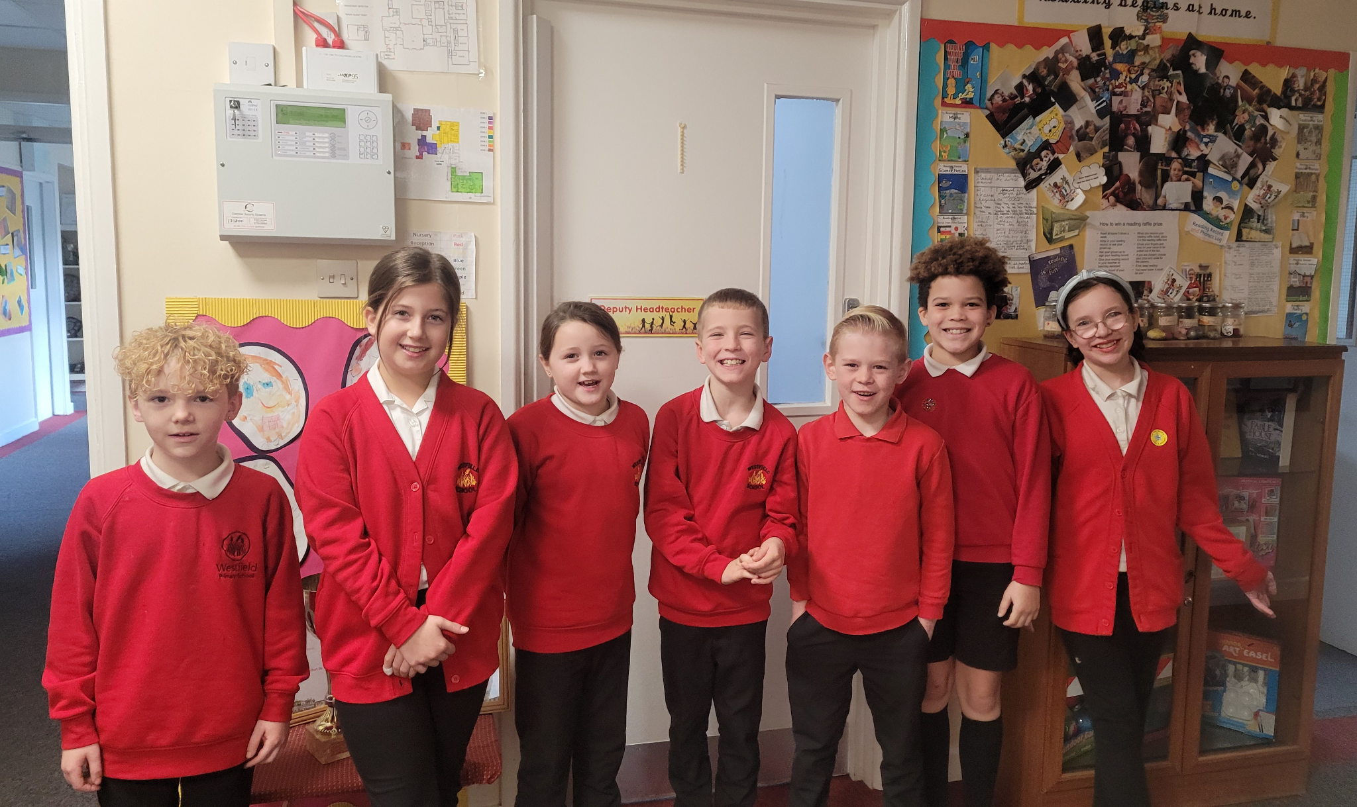



Diary Dates

Nov
Wed 29 Flu Vaccinations
Thurs 30 Westfield Christmas Light switch on

Dec
Fri 1 PTA Christmas Fayre
Tues 5 Year 6 Height & weight
Mon 11 Rainbow Theatre Pantomime
Tues 19 Christmas Dinner Day
Christmas Jumper Day
PTA Mad hair day
Tues 19 End of Term
January
Tues 2 Inset Day
Wed 3 Inset Day
Thurs 4 Pupils return to school

Year 3 sleepover

We are pleased to announce the date of our annual Year 3 sleepover at school. This year the sleepover will take place on Friday 7th June so please save the date!
More details will follow nearer the time. The sleepover is always a really enjoyable evening and helps to prepare some children for their first residential trip in Year 4.

