Dear Parents

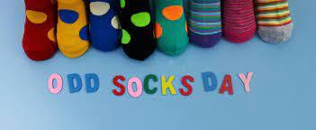
To launch our anti-bullying and friendship week next week we would like you all to wear odd socks to school on Monday 20th November. This is to celebrate us as individuals and to show that it is ok to be different. #oddsocks #oktobedifferent
Healthy Snacks
We are seeing an increasing number of unhealthy snacks being eaten at break time and lunchtime. Please can we remind you to provide your child with a healthy snack such as fruit, vegetables or breadsticks.
We encourage healthy eating within school, so please do not send in sweets or fizzy drinks as part of your child’s packed lunch.

Christmas Dinner
We will be having our Christmas Dinner on Tuesday 19th December. This will need to be pre-ordered on ParentPay by Thursday 14th December.

Children in Need
It has been lovely to see everyone dressed up in a variety of colourful outfits and Pudsey ears for Children In Need today!
So far we have raised a fantastic ££320 but there is still time to raise even more! Children have been busy baking some delicious treats to sell at the end of the school day so please bring some spare cash with you at pick up time today.
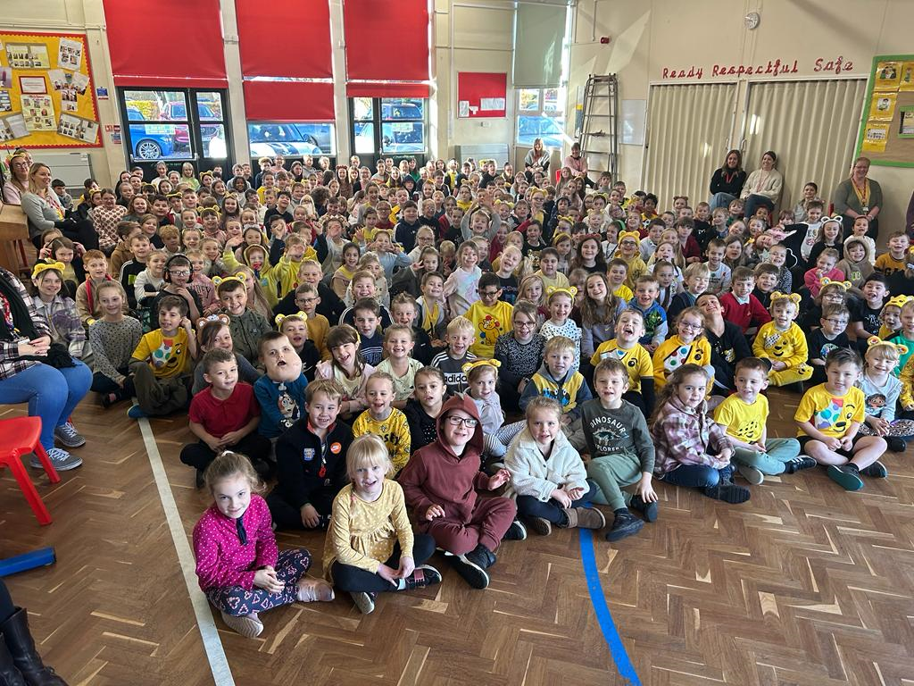
Nativities
This year, Nativities will be held the week of the 11th December.

Tuesday 12th December Reception

Wednesday 13th December Year 2

Thursday 14th December Year 1

All performances at 9.15am and 2.15pm. Information to follow regarding tickets and costumes.

Top Class Attendance for last week

Butterfly | 100%
Dolphin | 98.6%

Reading Raffle

Key Stage 1
Winners: Badger 66%
2nd Place Owl 64%
Key Stage 2
Winners: Eagle 82%
2nd place: Falcon 77%

Top Doodling Classes
Doodle Maths

Eagle | 68%
Dragonfly | 65%
Monkey | 59%

Doodle Tables

Eagle | 68%
Butterfly | 62%
Dragonfly | 42%

Star Learners
Well done to this week’s Star Learners

Class | Name | School Value
Dolphin | Josh Hutchins | Ambition
Monkey | Olivia Bevan | Respect
Dragonfly | Scarlett Padfield | **Everything**
Turtle | Kimberley Yelling | Ambition
Panther | Freddie Stenner | **Everything**
Butterfly | Callum Palmer | Respect & Resilience
Eagle | Mia Workman | **Everything**
Falcon | Lois Pearce | Respect
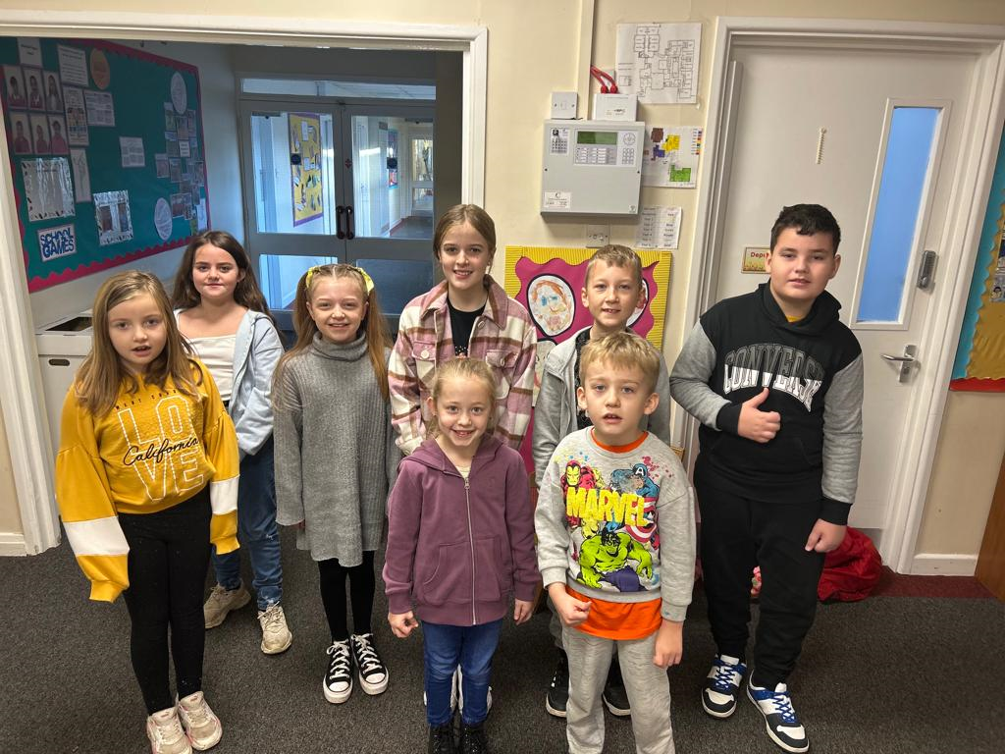

Diary Dates

Nov
Wed 29 Flu Vaccinations
Thurs 30 Westfield Christmas Light switch on

Dec
Fri 1 PTA Christmas Fayre
Tues 5 Year 6 Height & weight
Mon 11 Rainbow Theatre Pantomime
Tues 19 Christmas Dinner Day
Christmas Jumper Day
PTA Mad hair day
Tues 19 End of Term
January
Tues 2 Inset Day
Wed 3 Inset Day
Thurs 4 Pupils return to school




