Dear Parents

School Photos

On Tuesday (3rd ) and Wednesday (4th), Nigel Coles will be coming into school to take photos of the children
He will be in school early on both days to take photos of any siblings who are not in school. If you would like to have photos of all your children together, please wait outside the Hut from 8:15.
All children who are in school will be photographed during the school day individually and with their siblings.

Year 6 Camp Assembly
The muddy clothes are in the wash, the welly boots are drying out and we are all catching up on some much needed sleep. Thank you for all your support with the trip – we all had a brilliant time.
Our camp assembly will be held on Thursday 5th October at 2:15pm!
Parents / guardians are welcome to attend to hear all about what the children got up to in the Forest of Dean!
Please note: if you are unable to attend, videos / photos will be shared on Weduc following the assembly!
Miss Offer, Mrs Rich & the Year 6 Team

Benefit Related Free School Meals - All School Years
If you receive any of the benefits listed below, and your child attends a Bath and North East Somerset academy or maintained school, please register for benefit related free school meals.
Registration could attract Pupil Premium funding for your child’s school, £1455 per Primary pupil and£1035 per Secondary pupil.
- Universal Credit (provided you have an annual net earned income of no more than £7,400, as assessed by earnings from up to three of your most recent assessment periods)
- Income Support
- Income-Based Jobseekers Allowance
- Income Related Employment Support Allowance
- Child Tax Credit (WITHOUT Working Tax Credit) and have and annual household income (as assessed by HMRC) below £16,190
- Working Tax Credit Run-on which is only paid for 4 weeks after you STOP qualifying for Working Tax Credit
- The Guaranteed Element of State Pension Credit
- Support under PartV1 of the Immigration and Asylum Act 1999
Apply online at:
https://beta.bathnes.gov.uk/apply-free-school-meals
Email the team at: freeschoolmeals@bathnes.gov.uk
Or call 01225 394317
If you are already in receipt of benefit related free school meals, there is no need to reapply.
Top Class Attendance for last week

Butterfly | 99.4%
Rabbit, Dolphin & Turtle | 98%


Top Doodling Classes

Doodle Maths
Monkey | 93%
Eagle | 68%
Squirrel | 67%

Doodle Tables

Falcon | 78%
Eagle | 75%
Butterfly | 43%

Doodle learning
As a school we subscribe to both Doodle maths and Doodle tables. Our expectation is that children access these daily if possible to complete their assigned questions. Doodle tables are particularly valuable for speed and recall to prepare children for times table check in Year 4 and the end of KS2 SATs.
We wanted to remind you that Doodle tables and Doodle maths are available on any app store but will be different apps to download. If you use a desktop computer you are able to switch between the apps accessing the log in page on Doodle Learning. You will need to log out of one to switch to the other.

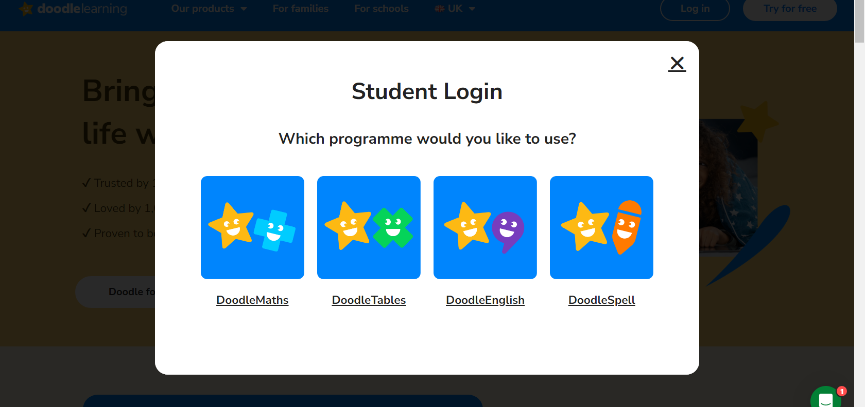
If you have any queries about your child’s account or if they are unable to log on at home please speak to your class teacher or Mrs Rich.
Star Learners
Well done to this week’s Star Learners

Class | Name | School Value
Dolphin | Layla Herniman | **Everything**
Monkey | Jacob Bishop | Ambition
Dragonfly | Grace Phillips | **Everything**
Turtle | Katie Nash | Respectful
Panther | Jesica Oxley | Ambition
Butterfly | Camille Trouche | Respect/Creativity
Eagle | Kian Francis | Respect/Ambition
Falcon | Ruby Street | **Everything**

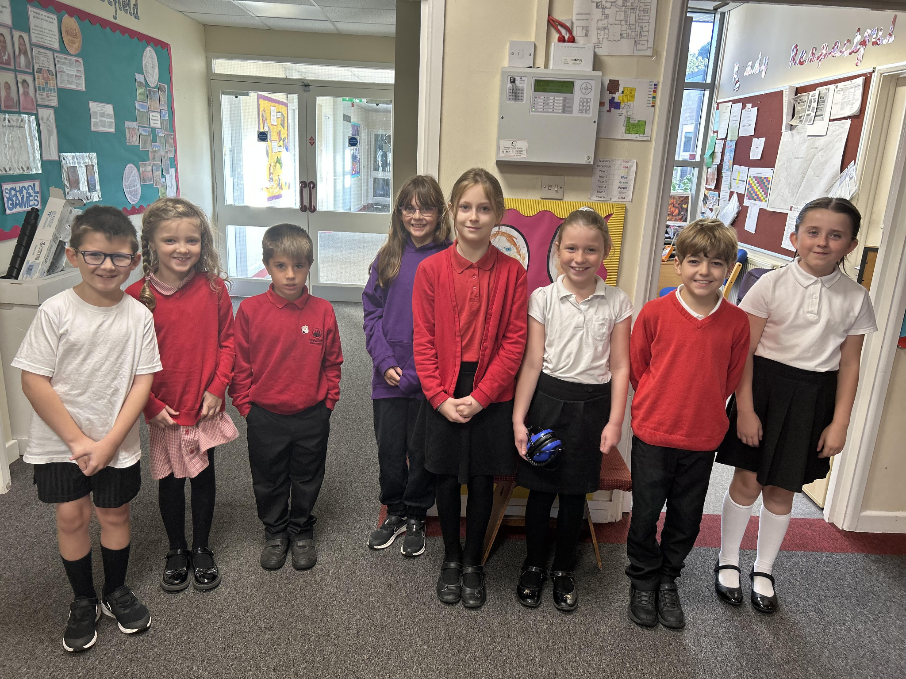


Reading Raffle
Key Stage 1
Winners: Squirrel 77 %
2nd Place Badger 66%

Key Stage 2
Winners: Panther 71%
2nd place: Butterfly 67%

Diary Dates
Oct
Tues 3 Nigel Coles Individual & Family Photos
Wed 4 Nigel Coles
Wed 4 School Tours 1:30pm
Tues 10 School Tours 9:30am
Fri 13 PTA School Disco - Years 1-6
Mon 16 Parents Evening
Thurs 19 Parents Evening
Thurs 19 School Tours 1:30pm
Fri 20 Pupils break up for half term
Mon 30 Inset Day
Tues 31 Term 2 Pupils return to school

Nov
Wed 29 Flu Vaccinations

Dec
Fri 1 PTA Christmas Fayre
