Dear Parents

Open Days
We are now taking bookings for our Open Days. This year we are offering potential parents the chance to visit the school on Thursday 28th September at 09:30, Wednesday 4th October 1:30pm, Tuesday 10th October at 9:30am and Thursday 19th October at 1:30pm. If you or anyone you know would like to visit then please get in touch with the school office.

Dinners
All dinners MUST be ordered by midnight Thursday every week for the following week on ParentPay. If nothing is ordered and your child is expecting a meal we will no longer be able to provide one and you will be asked to provide a packed lunch for them straight away.

Year 6 camp - Monday 18th September
Year 6 are excited and ready to set off on their residential. Please drop your child with their luggage in the school hall on Monday and then leave your child to go and register in class. You may wait on Longfellow Road to wave us off at 9.15am. Please remember all medication must be sent in its prescribed box with a completed medical form.


Value Champions
Well done to all our newly elected Value Champions.

Ambition - Maisie Daniells and Maisie Rippin
Creativity - Jake L’Esteve and Ruby Street
Collaboration - Lucas Wilcox and Emily James
Resilience - Maddison Padfield and Treyell Forde
Respect - Betsie Hamblin and Freya Dickinson
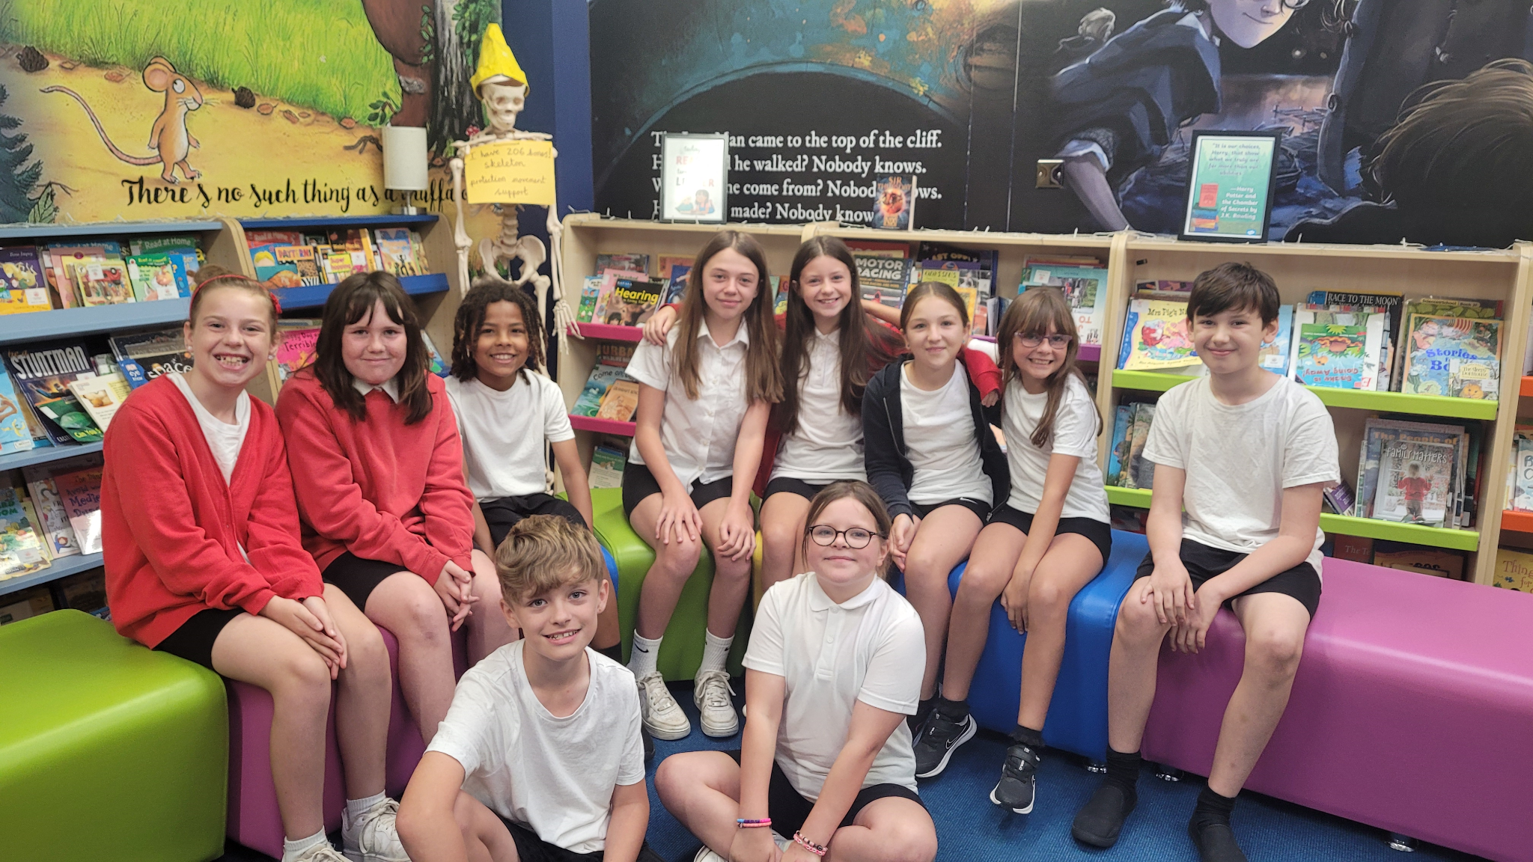


Harvest
We’re celebrating Harvest at the church on Tuesday 26th September. This is for children only due to limited space.

Top Class Attendance for last week

Falcon | 100%
Butterfly | 100%

Reading Raffle
Key Stage 1
Winners: Squirrel 94%
2nd Place Bumblebee 59%

Key Stage 2
Winners: Falcon 85%
2nd place: Panther 79%

Top Doodling Classes
Doodle Maths
Butterfly | 71%
Falcon | 52%
Dolphin | 45%

Doodle Tables
Falcon | 59%
Butterfly | 54%
Panther | 46%

Tidiest Classroom of the week!
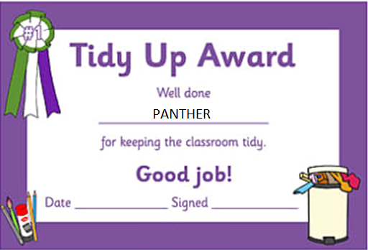

Zig Zag Lines outside of school
Yellow zig-zag lines, whether found outside schools, hospitals or police/fire stations, signify a strict no-stopping zone. This means you can’t park there at any time – even if the engine is still running. Bear in mind that this would be considered a waiting offence which, if you’re caught, could result in a penalty charge of £70.
Zig-zag lines serve a crucial purpose. Cars can easily obscure the visibility of young children who are leaving school or need to cross the road. This means children might not be aware of approaching cars and drivers might not spot them in time, which is highly dangerous.

Diary Dates
Sept
Mon 18 - Fri 22 Year 6 Camp
Mon 18 Year 2 Curriculum meeting
Tues 19 Year 5 Curriculum meeting
Tues 26 Harvest Festival
Thurs 28 School Tours 9:30am
Oct
Tues 3 Nigel Coles Individual & Family Photos
Wed 4 Nigel Coles
Wed 4 School Tours 1:30pm
Tues 10 School Tours 9:30am
Thurs 19 School Tours 1:30pm
Fri 20 Pupils break up for half term
Mon 30 Inset Day
Tues 31 Term 2 Pupils return to school
PTA
The next PTA AGM is on Tuesday 10th October at 6pm in the WAPS hut.
All parents and carers are welcome and encouraged to attend the AGM if possible. It is an ideal opportunity for you to find out more about what the PTA does and how its activities during the school year include both social and fundraising events for you and your child.
As a registered charity the PTA is required to appoint Officers at the AGM – a Chairperson, a Vice-Chair, a Treasurer, a Secretary, a Minute Secretary and an Events Co-ordinator; each of these positions could be taken on by an individual or shared if wished.
Please consider whether you could take on any of these positions –a brief description of what each role involves is below.
We are also looking for volunteers to shadow each of these roles to learn what they entail and ensure that the PTA can continue to run smoothly in the future.
CHAIR In this role you will be required to attend and chair all PTA meetings where possible and ensure good communication between parents and carers, committee members and the school staff. The Chairperson is also responsible for liaising direct with the Head to seek authorisation regarding all PTA activities and plans.
VICE CHAIR The Vice-Chair assists the Chair in their role and should step in to take any meeting where the Chair is unable to attend.
TREASURER The Treasurer is required to provide a report for each PTA meeting on the current state of the bank account. They are responsible for the PTA cheque book and the payment of all suppliers. The Treasurer is also responsible for keeping and submitting the yearly accounts to the Charities Commission.
SECRETARY (This can be combined with Minute Secretary or a role on its own) The secretary is responsible for producing (or organising for someone else to produce) a variety of letters, consent forms, posters, reminders, tear off slips, agendas and other documents relating to events during the year. You will need to use a computer either at home or at school for this but most documents are available electronically and need editing rather than re-writing. Events also need to be advertised on the PTA Facebook page and WEDUC.
MINUTE SECRETARY The Minute Secretary is required to attend and take minutes for all PTA meetings and ensure all parents and carers, committee members and school staff receives a copy.
EVENTS CO-ORDINATOR (can be shared) The Event Co-ordinator would be in charge of organising events such as the Fayres, Film Nights, Bingo, Ice-cream sales, whatever as a PTA you decide to put on. The PTA members would support the running of these events, but the co-ordinator would delegate things that may need buying, making or doing before and during the event.
If you would like to help at some events or take on a role but cannot attend the meeting, please email us on pta.westfield.school@gmail.com or fill in the Google form on Weduc
Thank you
PTA
