Dear Parents

Year 6 camp meeting - September 2023 (for current Year 5 children)
We are holding a camp meeting in the school hall on Wednesday 5th July at 3.15pm.
Please come along to hear about the activities your child will be taking part in, receive a kit list and ask any questions that you might have. Slides will be shared on Weduc for anyone unable to attend.

For parents and carers in Reception, Year 1 and Year 2
Can parents and carers please have a good check at home for any Little Wandle reading books. They will have similar front covers to this one below and say Little Wandle or Big Cat phonics in the top left hand corner.

We use these books in reading practice sessions every week and we have over 25 titles currently missing. Each book costs £6.00 to replace so it would be really helpful if any missing texts could be returned next week.

Doodle Summer Challenge
Please see below information about the Doodle Summer Challenge - a great way to keep your child engaged in learning over the summer. Look out for more information coming soon on Weduc.
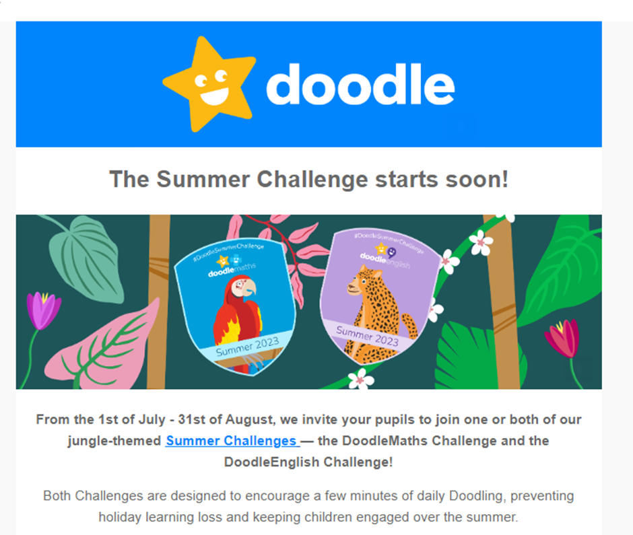

Top Class Attendance for last week

Dragonfly | 97.9%
Owl | 97.8%

Star Learners
Well done to this week’s Star Learners
Class | Name | School Value
Dolphin | Skylar Bristow | Resilience
Monkey | Fleur Wallwork | Resilience
Turtle | Iga Boron | Resilience
Panther | Kian Francis | All
Butterfly | Maisie Daniells | Creativity
Falcon | Brooke Horton | Resilience
Eagle | Leo Shirley | Collaboration

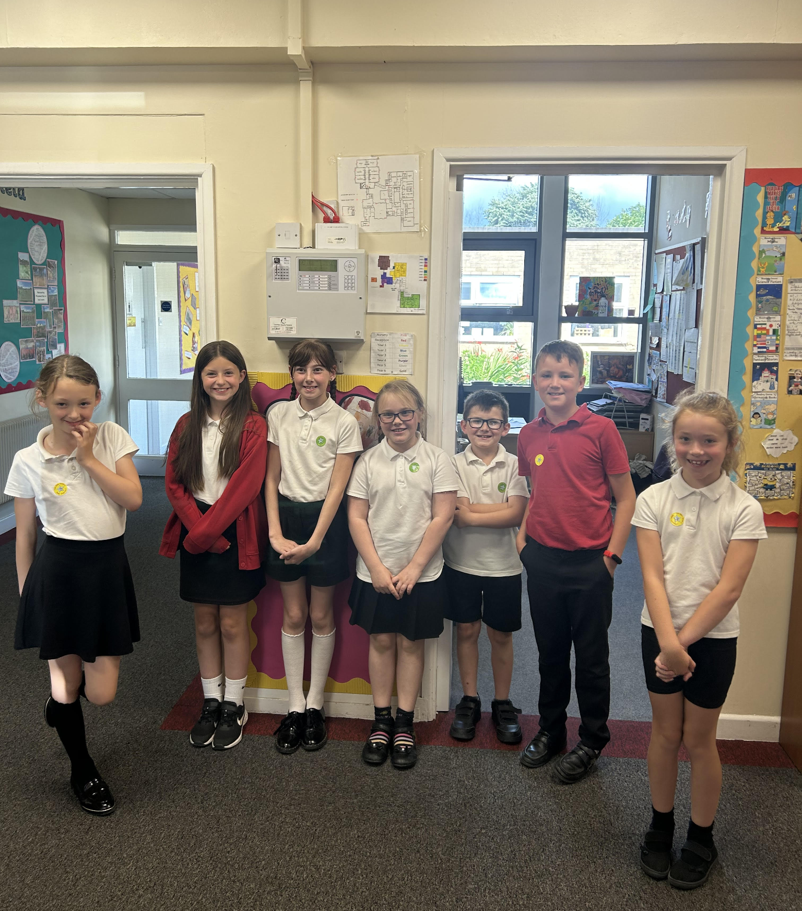

Diary Dates

July
Mon 3 Nursery & Reception Sports Day
Wed 5 Year 6 Camp Meeting (Sept 23)
Thurs 6 Shuffle Up day
Fri 7 School Fayre
Mon 10 – Fri 14 Fantastic Futures
Fri 21 End of school year


