Dear Parents

As we come to the end of a successful year I would like to take a moment to thank the staff for their hard work, commitment and support. We were one of the few schools that did not close due to industrial action and the only one to remain open on the snow day earlier this year. Ofsted also visited and absolutely recognised how good we were, including our outstanding provision for pupils' personal development. The children have all achieved well and flourished, and we are all very proud of them.
Thank you to parents and carers for your support too, you play a crucial role in the success of the school. Whether it is volunteering or supporting your children's learning at home your involvement makes a remarkable difference.
We say a farewell to our wonderful year 6 children who will be moving on to new adventures. We have watched them grow into confident young people who are now ready for the next chapter in their educational journey. We wish them all the very best.
From all of us at Westfield we wish you a very happy and safe holiday and look forward to welcoming you back on September 5th.

Fantastic Futures 2023
Last week Westfield Primary School again held its Fantastic Futures Week for the seventh year running to raise children’s awareness of different careers. During the week, the children were very fortunate to learn about a huge variety of different and amazing careers. The school’s visitors ranged from local universities, the NHS, architects, engineering, the CPS, the UK Space Agency and the Bristol Old Vic Theatre. They also had some surprise visitors including Jam, the T-Rex and the mad scientist, Atomic Andy!
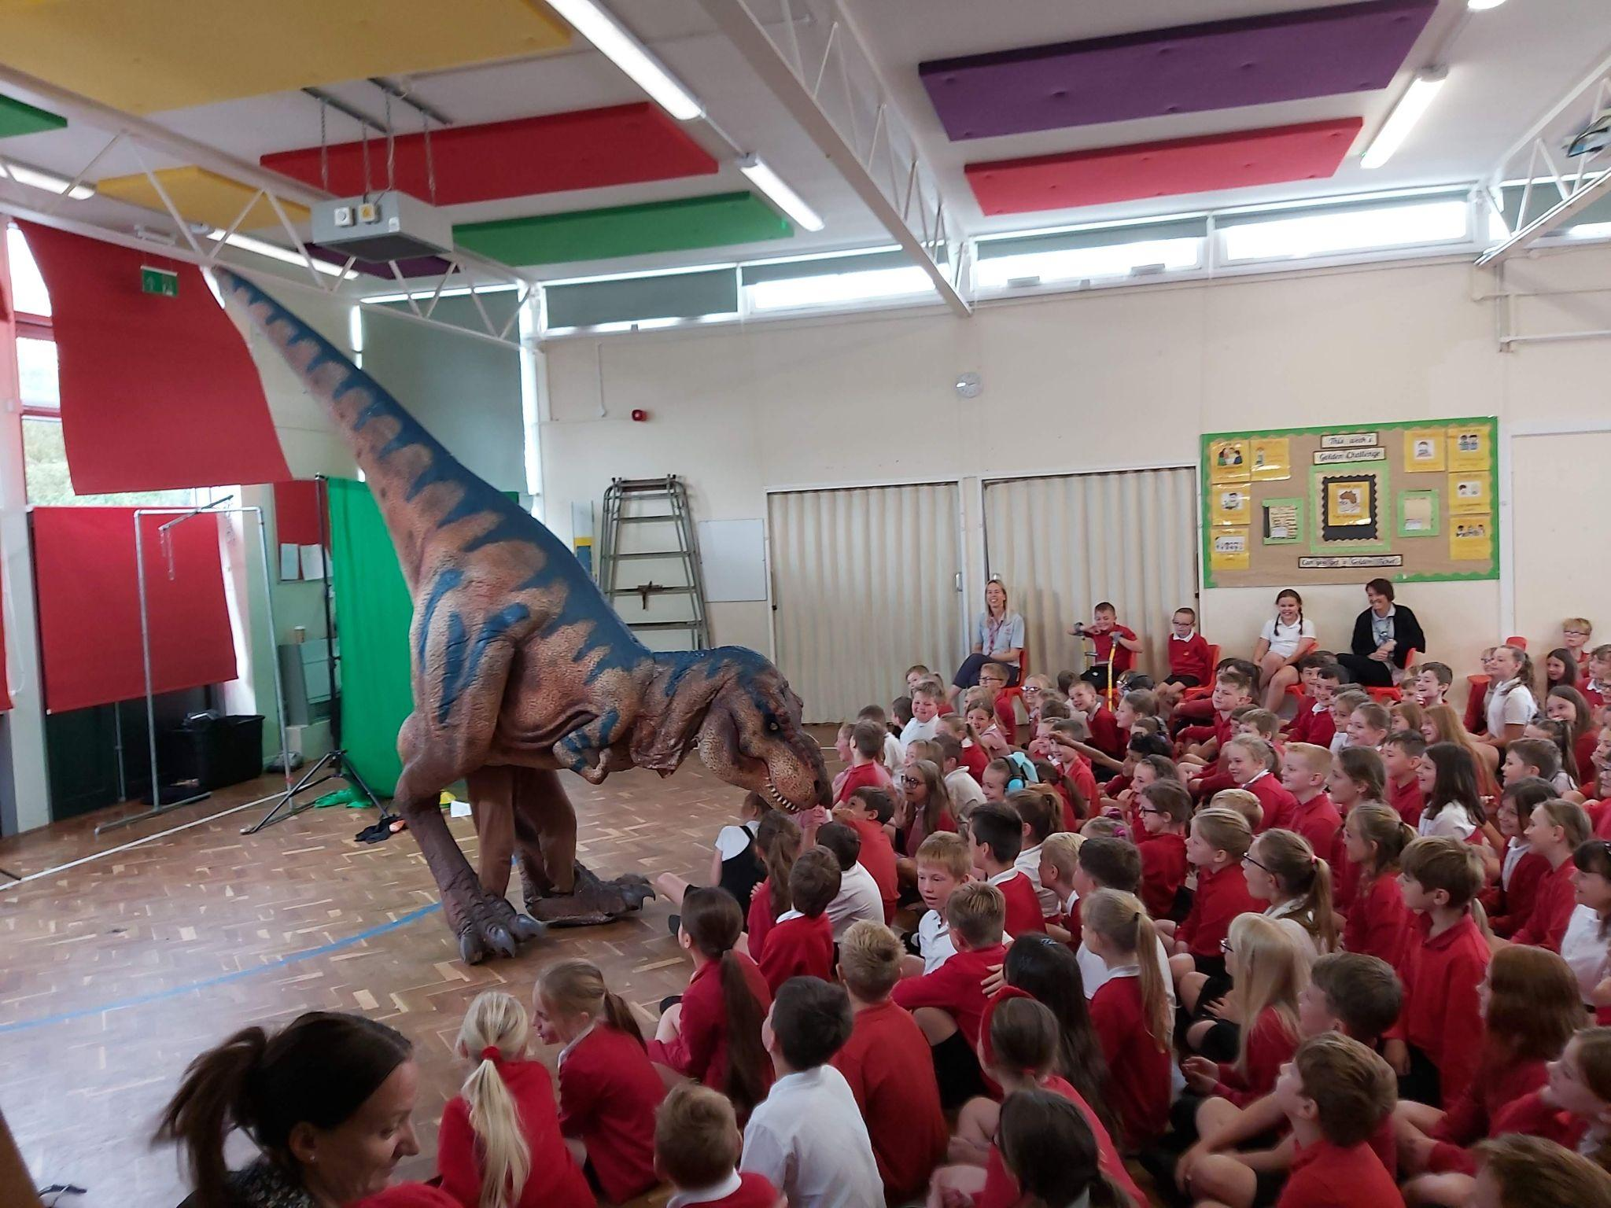

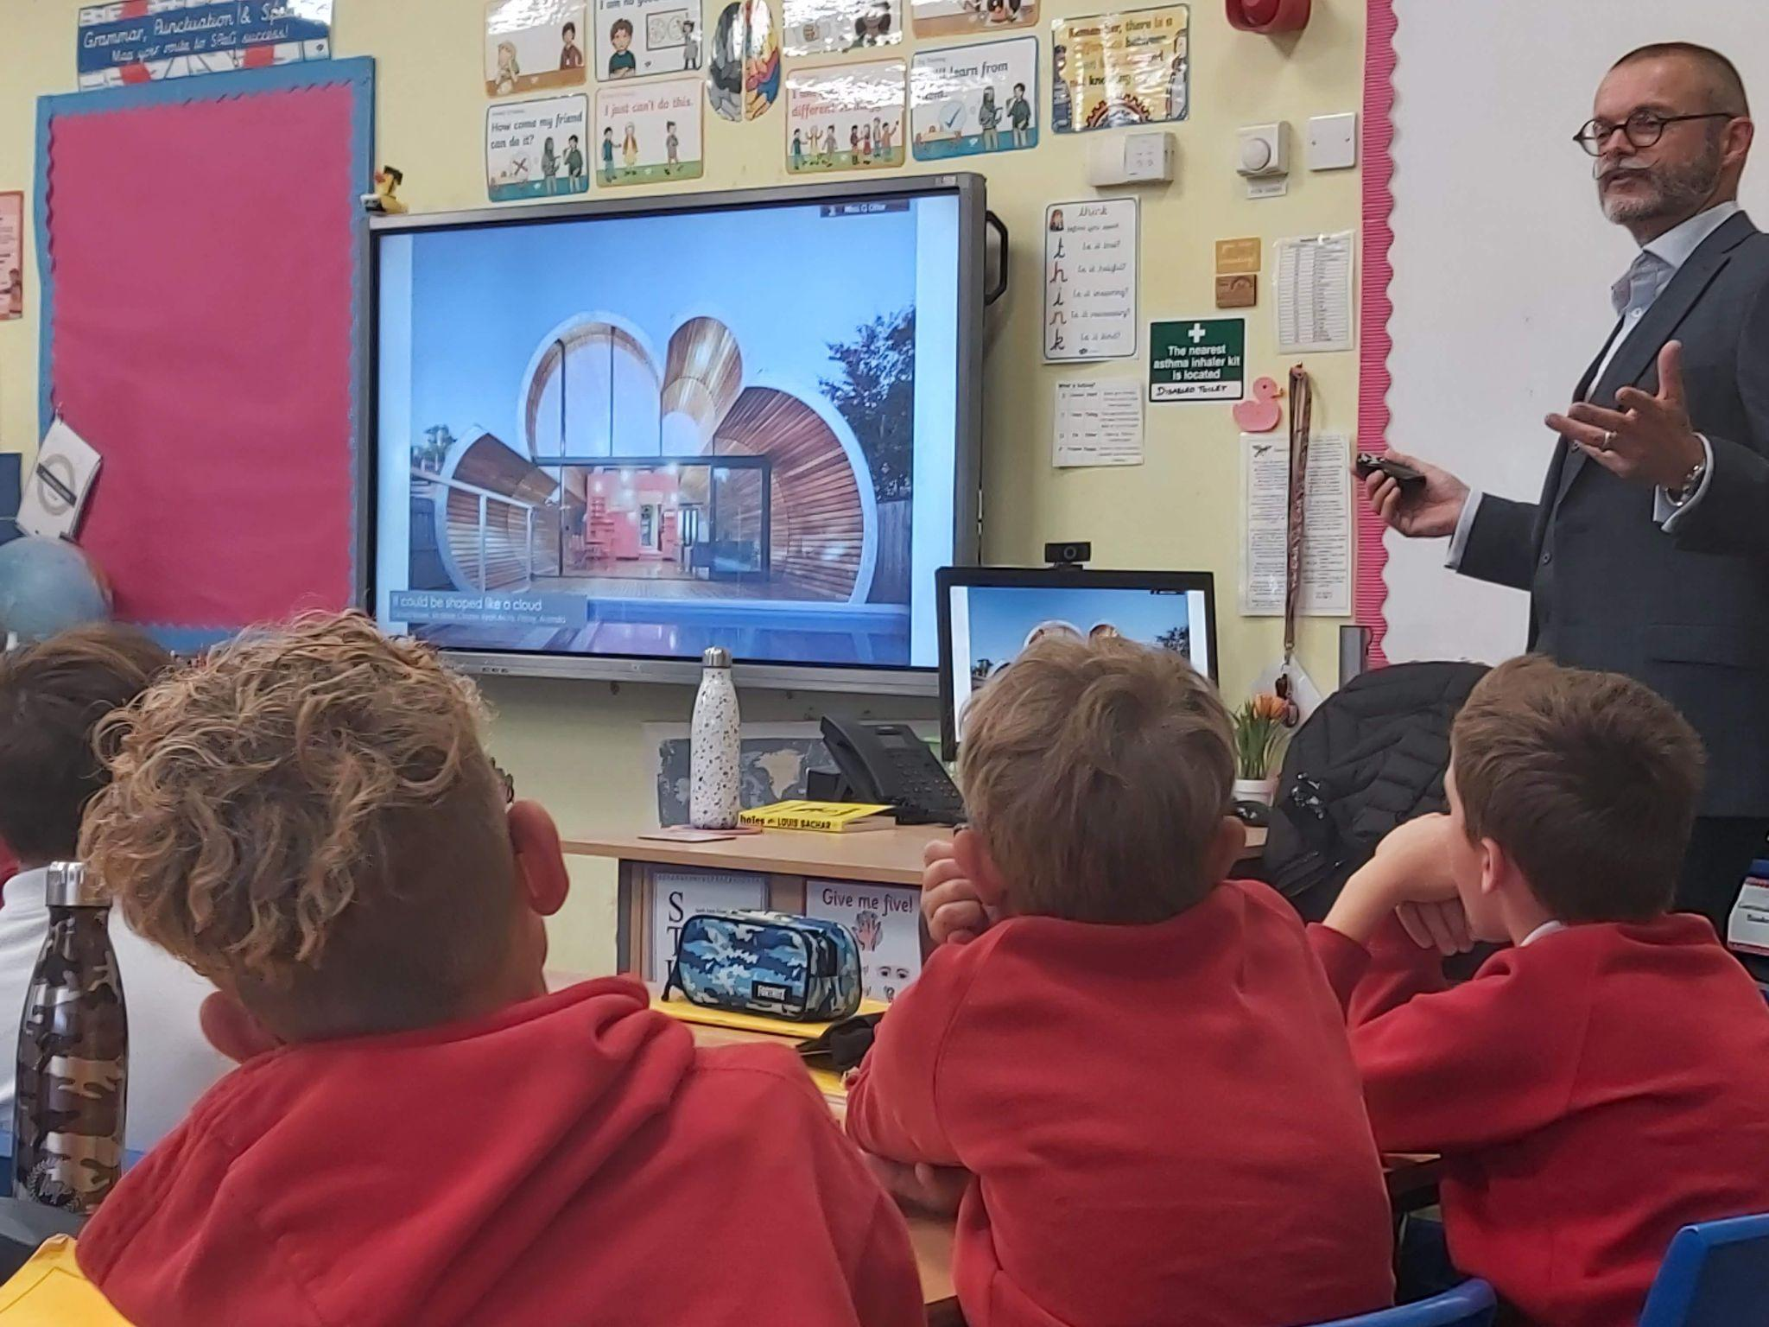

Staff Changes

At the end of this term we will be saying goodbye to Miss Courtecuisse, Miss Jones and Miss Blackwood. We wish them all the best in their new adventures!

We also have Miss Phillips joining us in September as a new class teacher. Welcome to #teamwestfield.

Miss Garland will be getting married over the summer and will be returning to school in September as Mrs B. Congratulations from everyone at #teamwestfield.

Term 5 and 6 lunchtime award winners.
Special mention to these children who have shown kindness and respect during lunchtimes! We popped to the cafe and treated them all to a hot chocolate or a fruit juice to say well done!
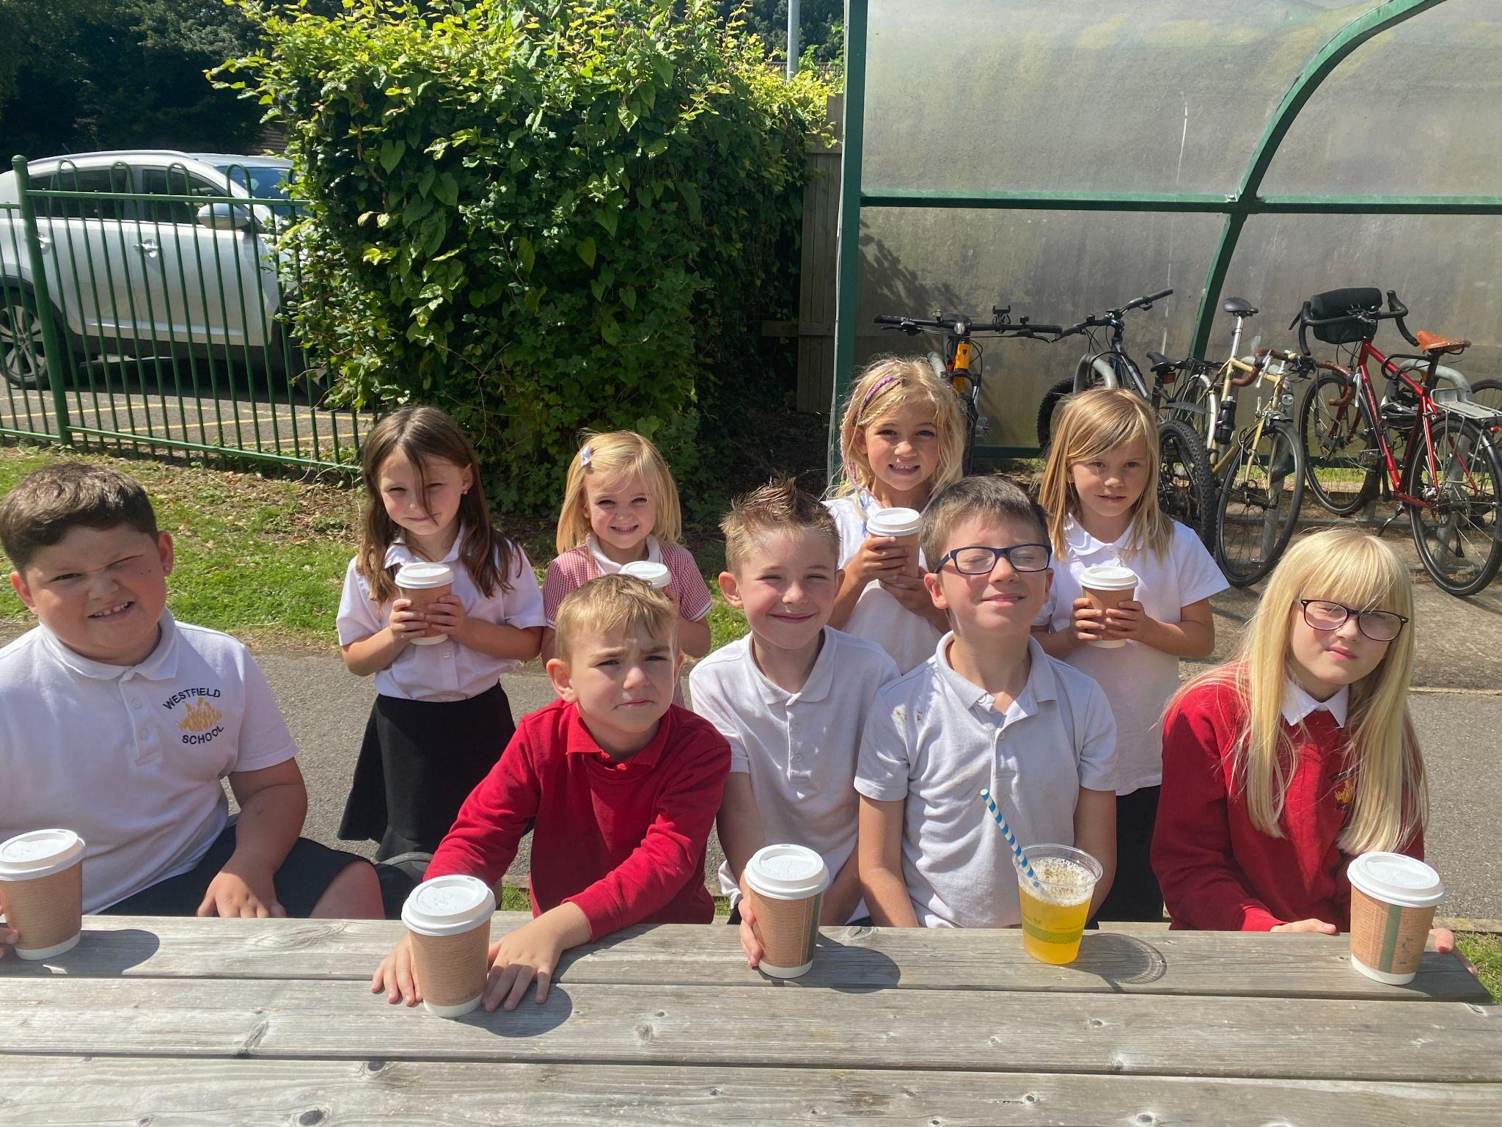
Reading Raffle and Doodle Maths Winners
Well done to the winners of Doodle Maths and the Reading Raffle for term 6. Well done to you all!
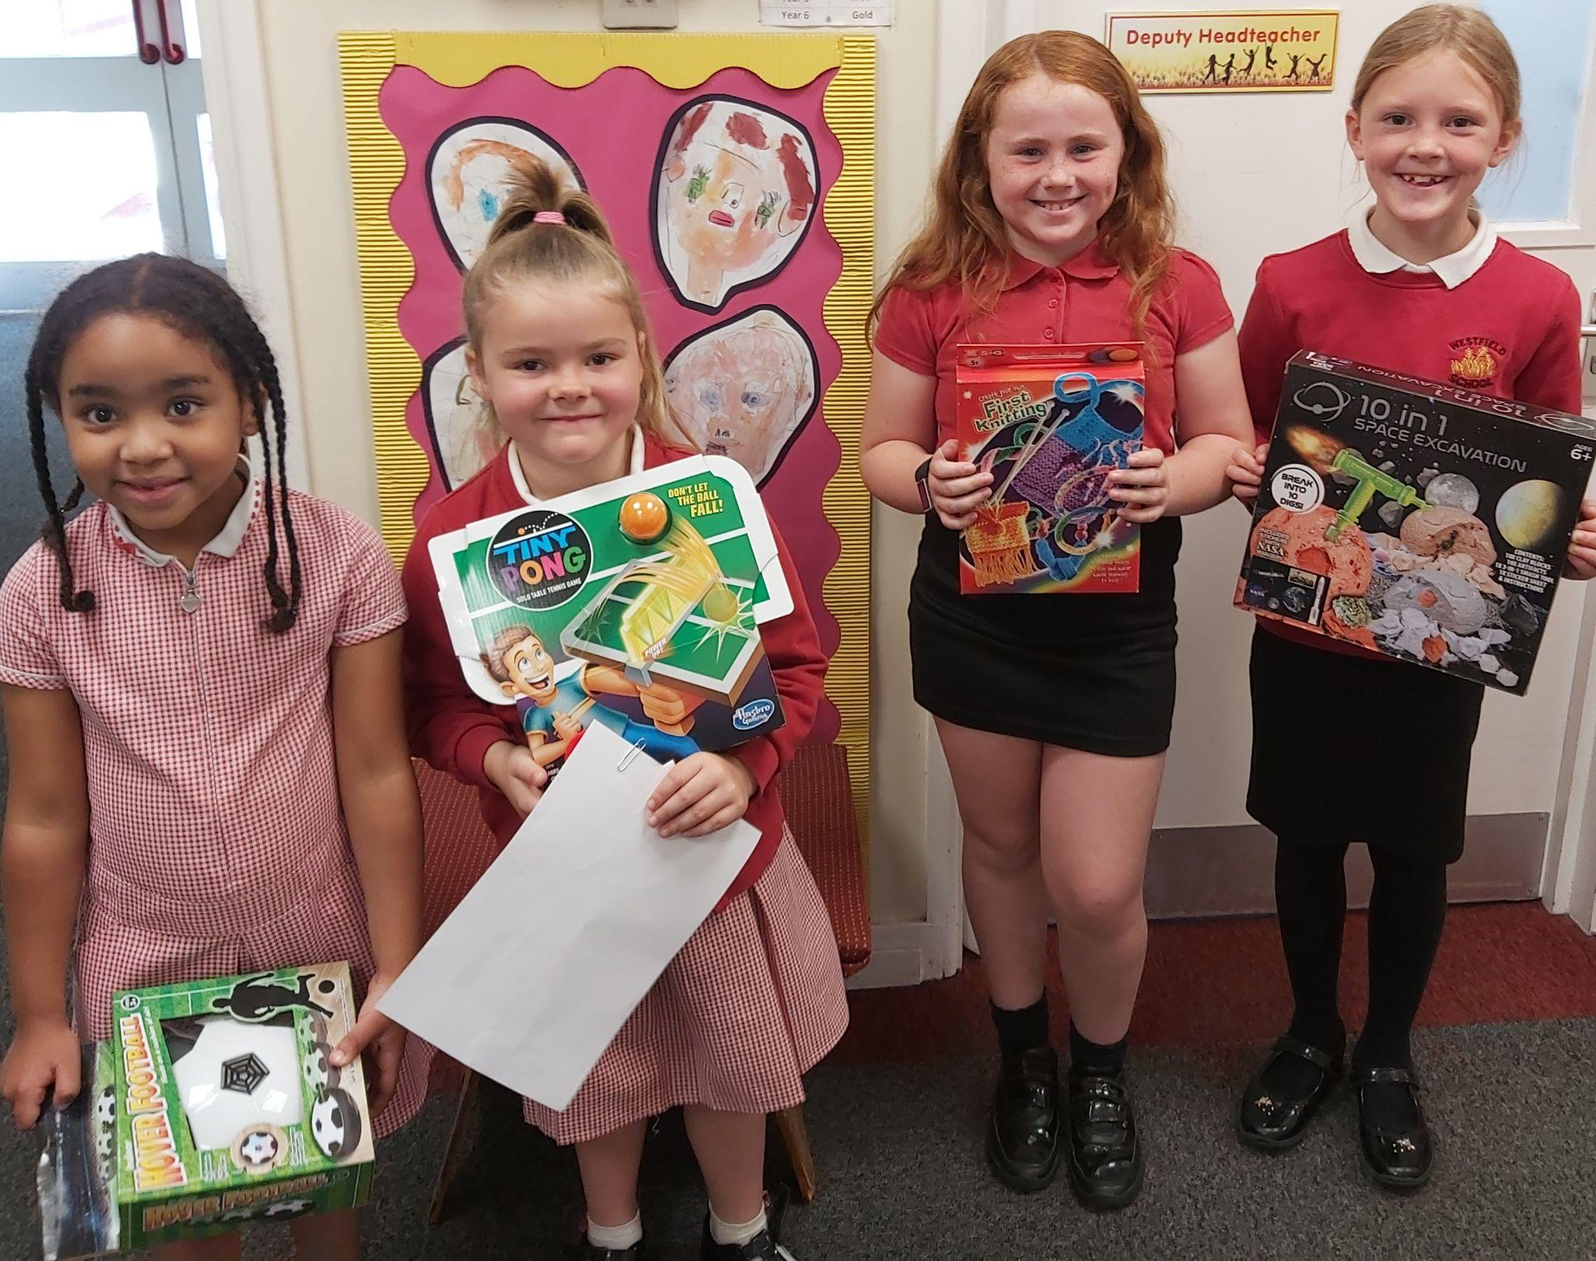
Well done to the Westfield Maypole Team
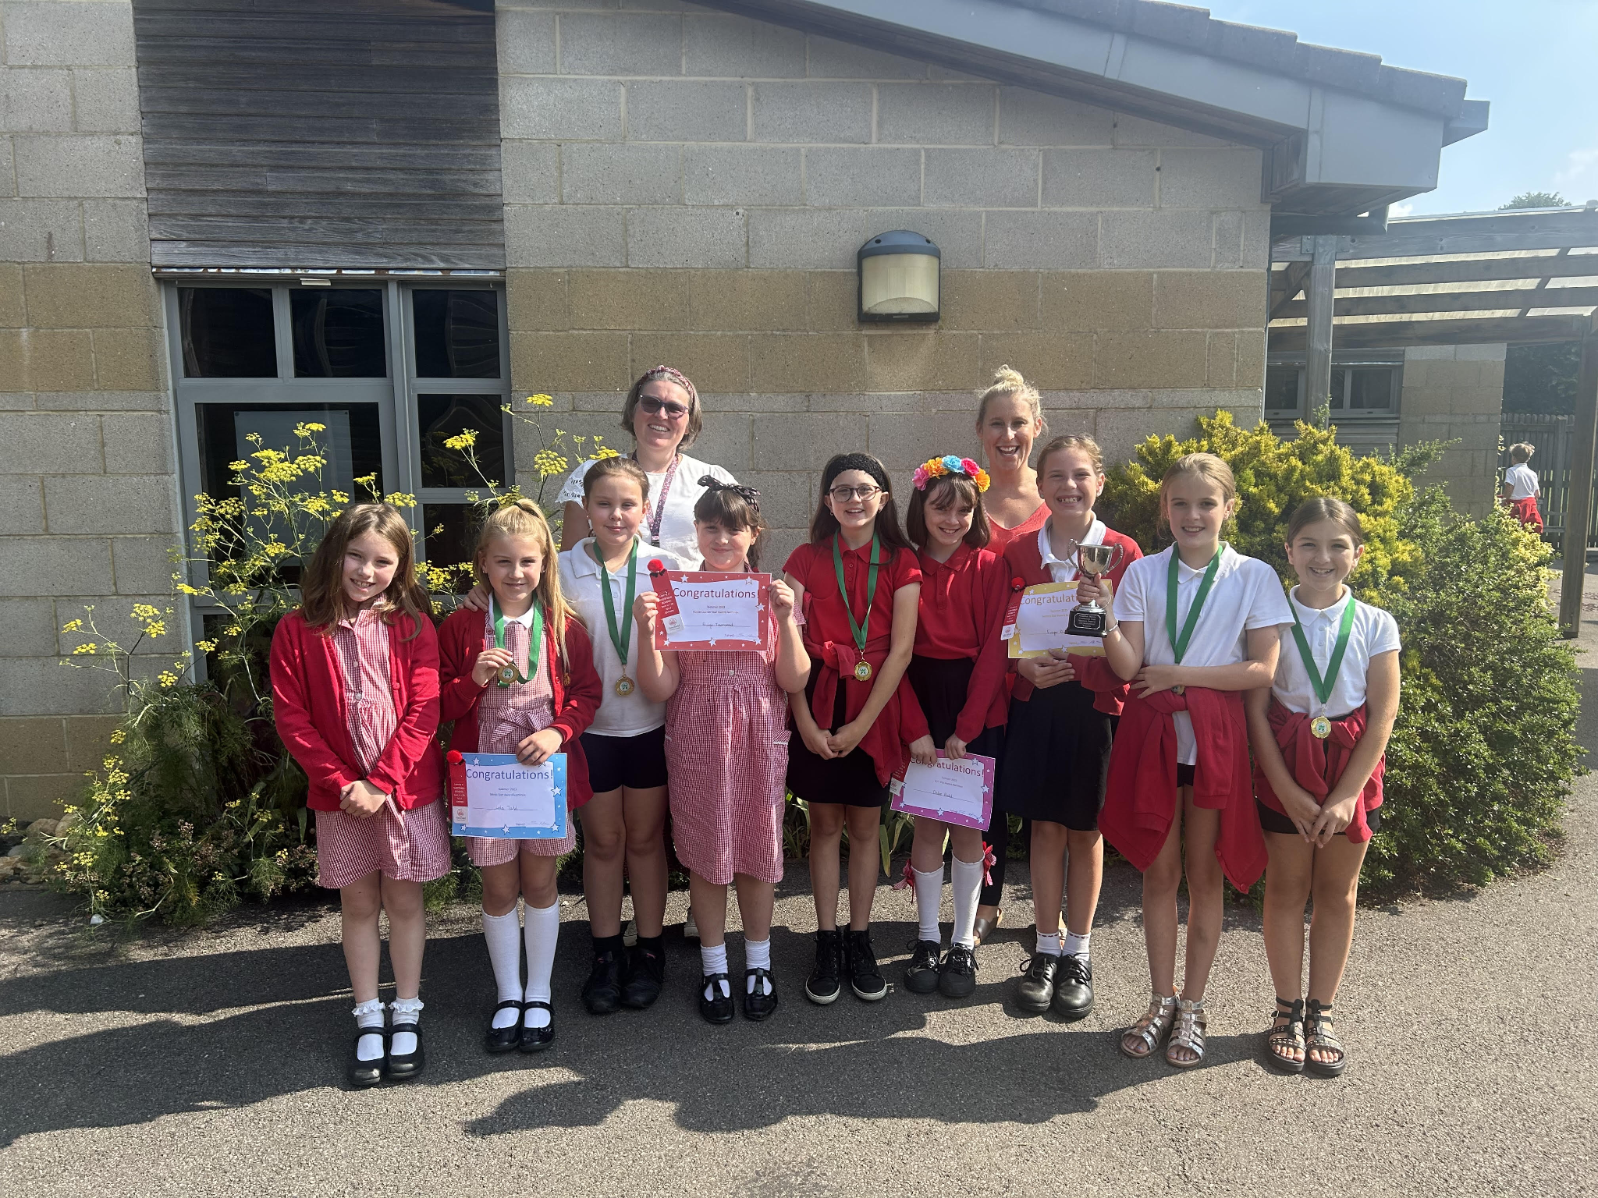
Star Learners
Well done to this week’s Star Learners
Class | Name | School Value
Dolphin | Maison Townsley | Resilience
Monkey | Katie Sage | Resilience
Turtle | Oliver Pillinger | **ALL**
Dragonfly | Rhys Bartlett | Resilience
Panther | Isla Thompson | Ambition
Butterfly | Lois Pearce | Respect
Falcon | Harvey Dickinson | Respect
Eagle | Ashton Ludlow | Respect
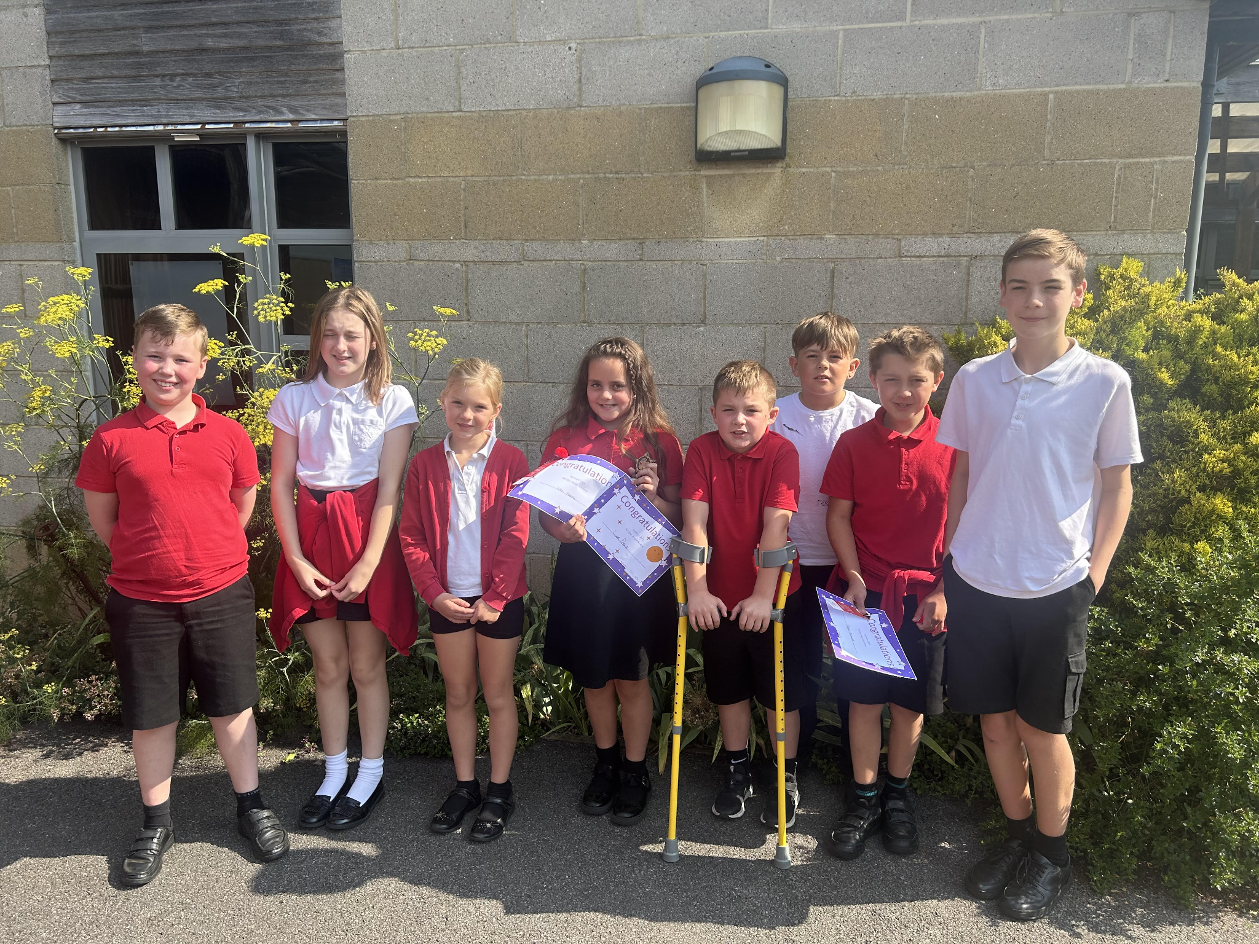
Parking Restrictions - St Peter’s Road
It has been brought to our attention that BANES are proposing to introduce various parking and loading restrictions affecting some of the roads around school. They are proposing to introduce no loading at any time in lengths of St Peter’s Rd, Westfield. This means it will be a finable offence to park there for drop off and pick ups.
For more information visit the BANES website http://www.bathnes.gov.uk/permanent-traffic-order-notices
Diary Dates

Sept
Fri 1 Inset Day
Mon 4 Inset Day
Tues 5 Pupils return to school - Term 1
Mon 18 - Year 6 Camp
Oct
Fri 20 Pupils break up for half term
Mon 30 Inset Day
Tues 31 Term 2
