Dear Parents

Sun Cream and Hats
With the weather being so warm can we please remind parents that children should come to school wearing sun cream. They should also bring a hat and water bottle. We recommend children wear an ‘all day’ sun cream.

Parents/ Carers of current Year 3
Your child hopefully came home with a letter about Year 4 residential next year. The letter detailed the dates and payment options. We have asked for a non-refundable deposit of £25 by Friday 30th June to secure your space.If you have any questions about camp please pop into the school office.
Scooters & Bikes
Please can we remind you that children should not be riding bikes/scooters through the school playground at pick up time. It’s important we keep the playground safe for everyone.
Also please can children not climb on any of the equipment, it's dangerous.

Sun Down Club
Please note there will be no after school club on the last day of term - Friday 21st July

New Year 6 buddies
We would like to train up new playground buddies by the end of this term. Playground buddies work with the younger children at lunchtime to support the SMSA staff in resolving conflicts and supporting friendships. The children work on a rota basis so are not expected to carry this out every lunchtime.
Applications are open now to all children in Year 5 who would like to be a buddy next year. Please write a short letter to me explaining why you would like to be a buddy and why you think you would make a good buddy. Please could these letters be handed to me by the end of June ready for training in July. If you have any questions please come and ask.
Mrs Bowery

Maths Workshop
Please keep an eye out on Weduc for a message from Mrs Rich regarding an upcoming Maths workshop for years 3,4,5.

Top Class Attendance for last week

Monkey | 100%
Squirrel | 99.3%

Star Learners
Well done to this week’s Star Learners
Class | Name | School Value
Dolphin | Alfie Davis | Ambition
Monkey | Mason Wooltorton | Resilience
Turtle | Tilly Want | Ambition, creative writing and trying her best at all times
Panther | Matthew Seaford | Ambition - handwriting
Butterfly | Maddison Padfield | Resilience
Falcon | Esmai Curtis | Resilience
Eagle | Lily Jones | Ambition
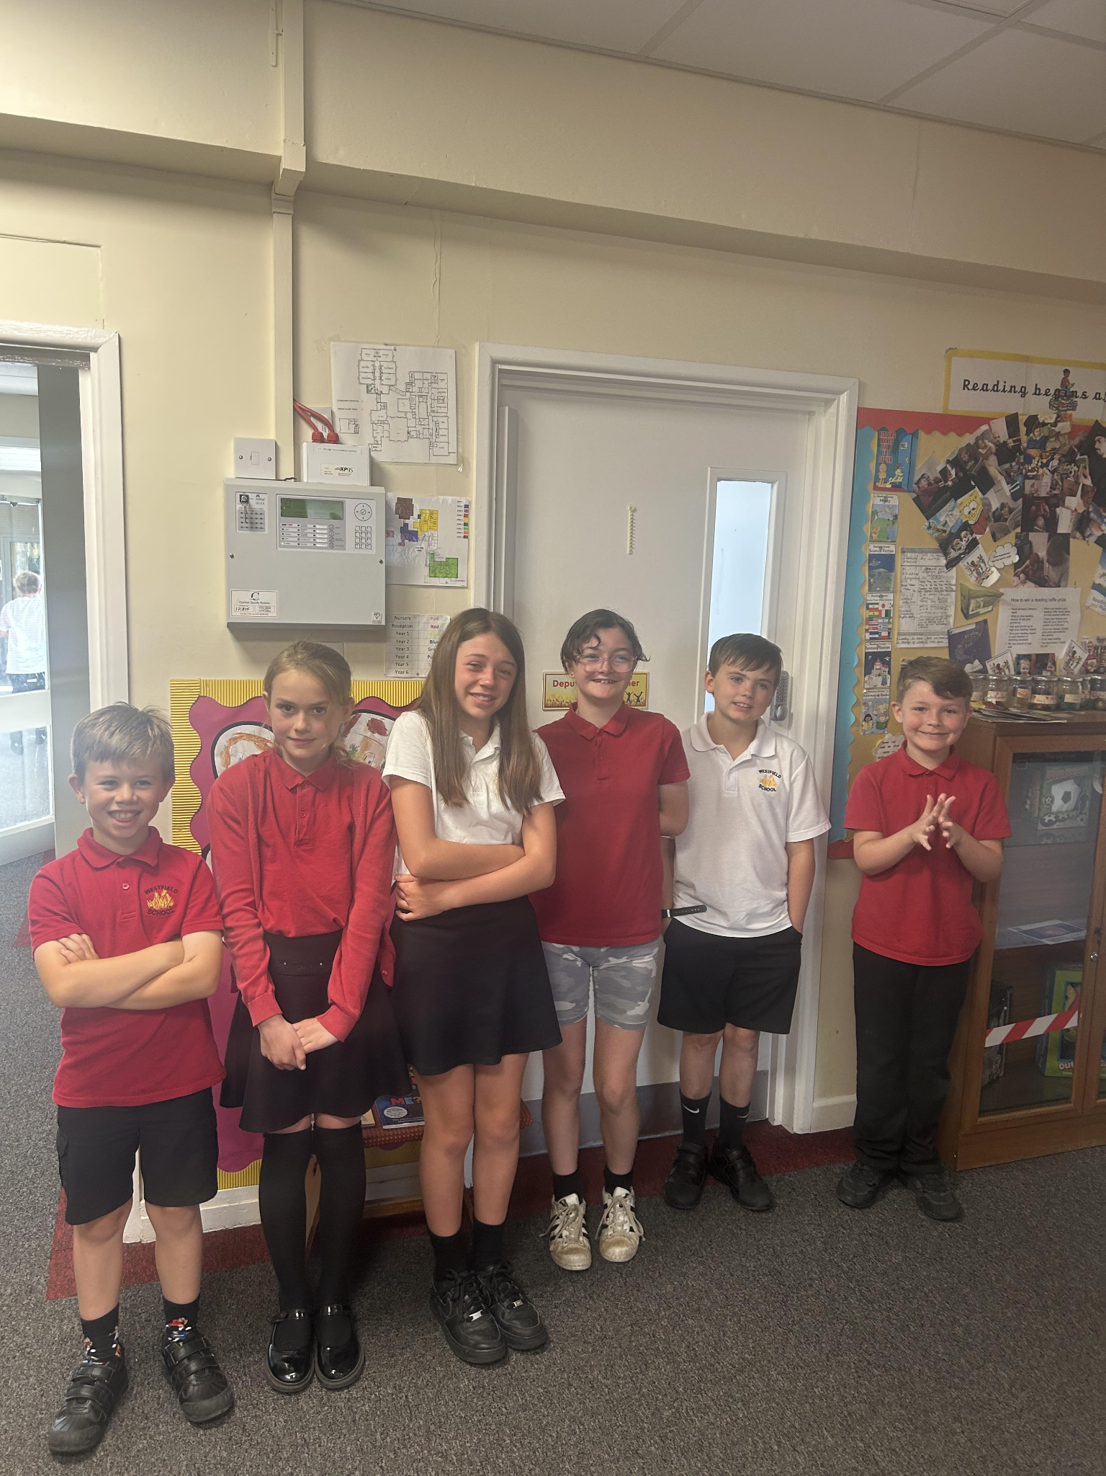

Diary Dates
July
Wed 5 Year 6 Camp Meeting (Sept 23)
Thurs 6 Shuffle Up day
Fri 7 School Fayre
Mon 10 – Fri 14 Fantastic Futures
Fri 21 End of school year

Sports Day

Years 4, 5 and 6 Friday 30th June AM
Year 1, 2 and 3 Friday 30th June PM
Early Years Sports Day Monday 3rd July P

