Dear Parents
KS2 SATs Next Week
Year 6 SATs breakfast will be running in the hall from Tuesday to Friday next week. The gates will open for Year 6 children only at 8am. The times will remain the same for the remainder of school at 08:30am.

School Dinners
Please make sure that you are continuing to book school dinners via ParentPay for your child by the end of the day every Thursday for the upcoming week.
If you have any further questions, please do not hesitate to contact the school office.

Funtastic Friday – Friday 19th May


School photos
Orders for all school class photos need to be in school or done online by Thursday 11th May.

Sports Day

Years 4, 5 and 6 Friday 30th June AM
Year 1, 2 and 3 Friday 30th June PM
Early Years Sports Day Monday 3rd July PM
We will confirm times nearer the date.

Top Class Attendance for last week

Dolphin | 98.7%
Turtle | 98.6%

Reading Raffle

Key Stage 1
Winners: Badger
Key Stage 2
Winners Eagle

Star Learners
Well done to this week’s Star Learners

Class | Name | School Value
Dolphin | Troy Amos | Ambition/ Collaboration
Monkey | Bella Bushnell | **Everything**
Turtle & Dragonfly | Summer Willcox | Creativity
Panther | Lois Evans | Respect
Butterfly | Mya Marsh | Respect
Falcon | Elli-Mai Townsley | Resilience
Eagle | Jasmine Workman | **Everything**
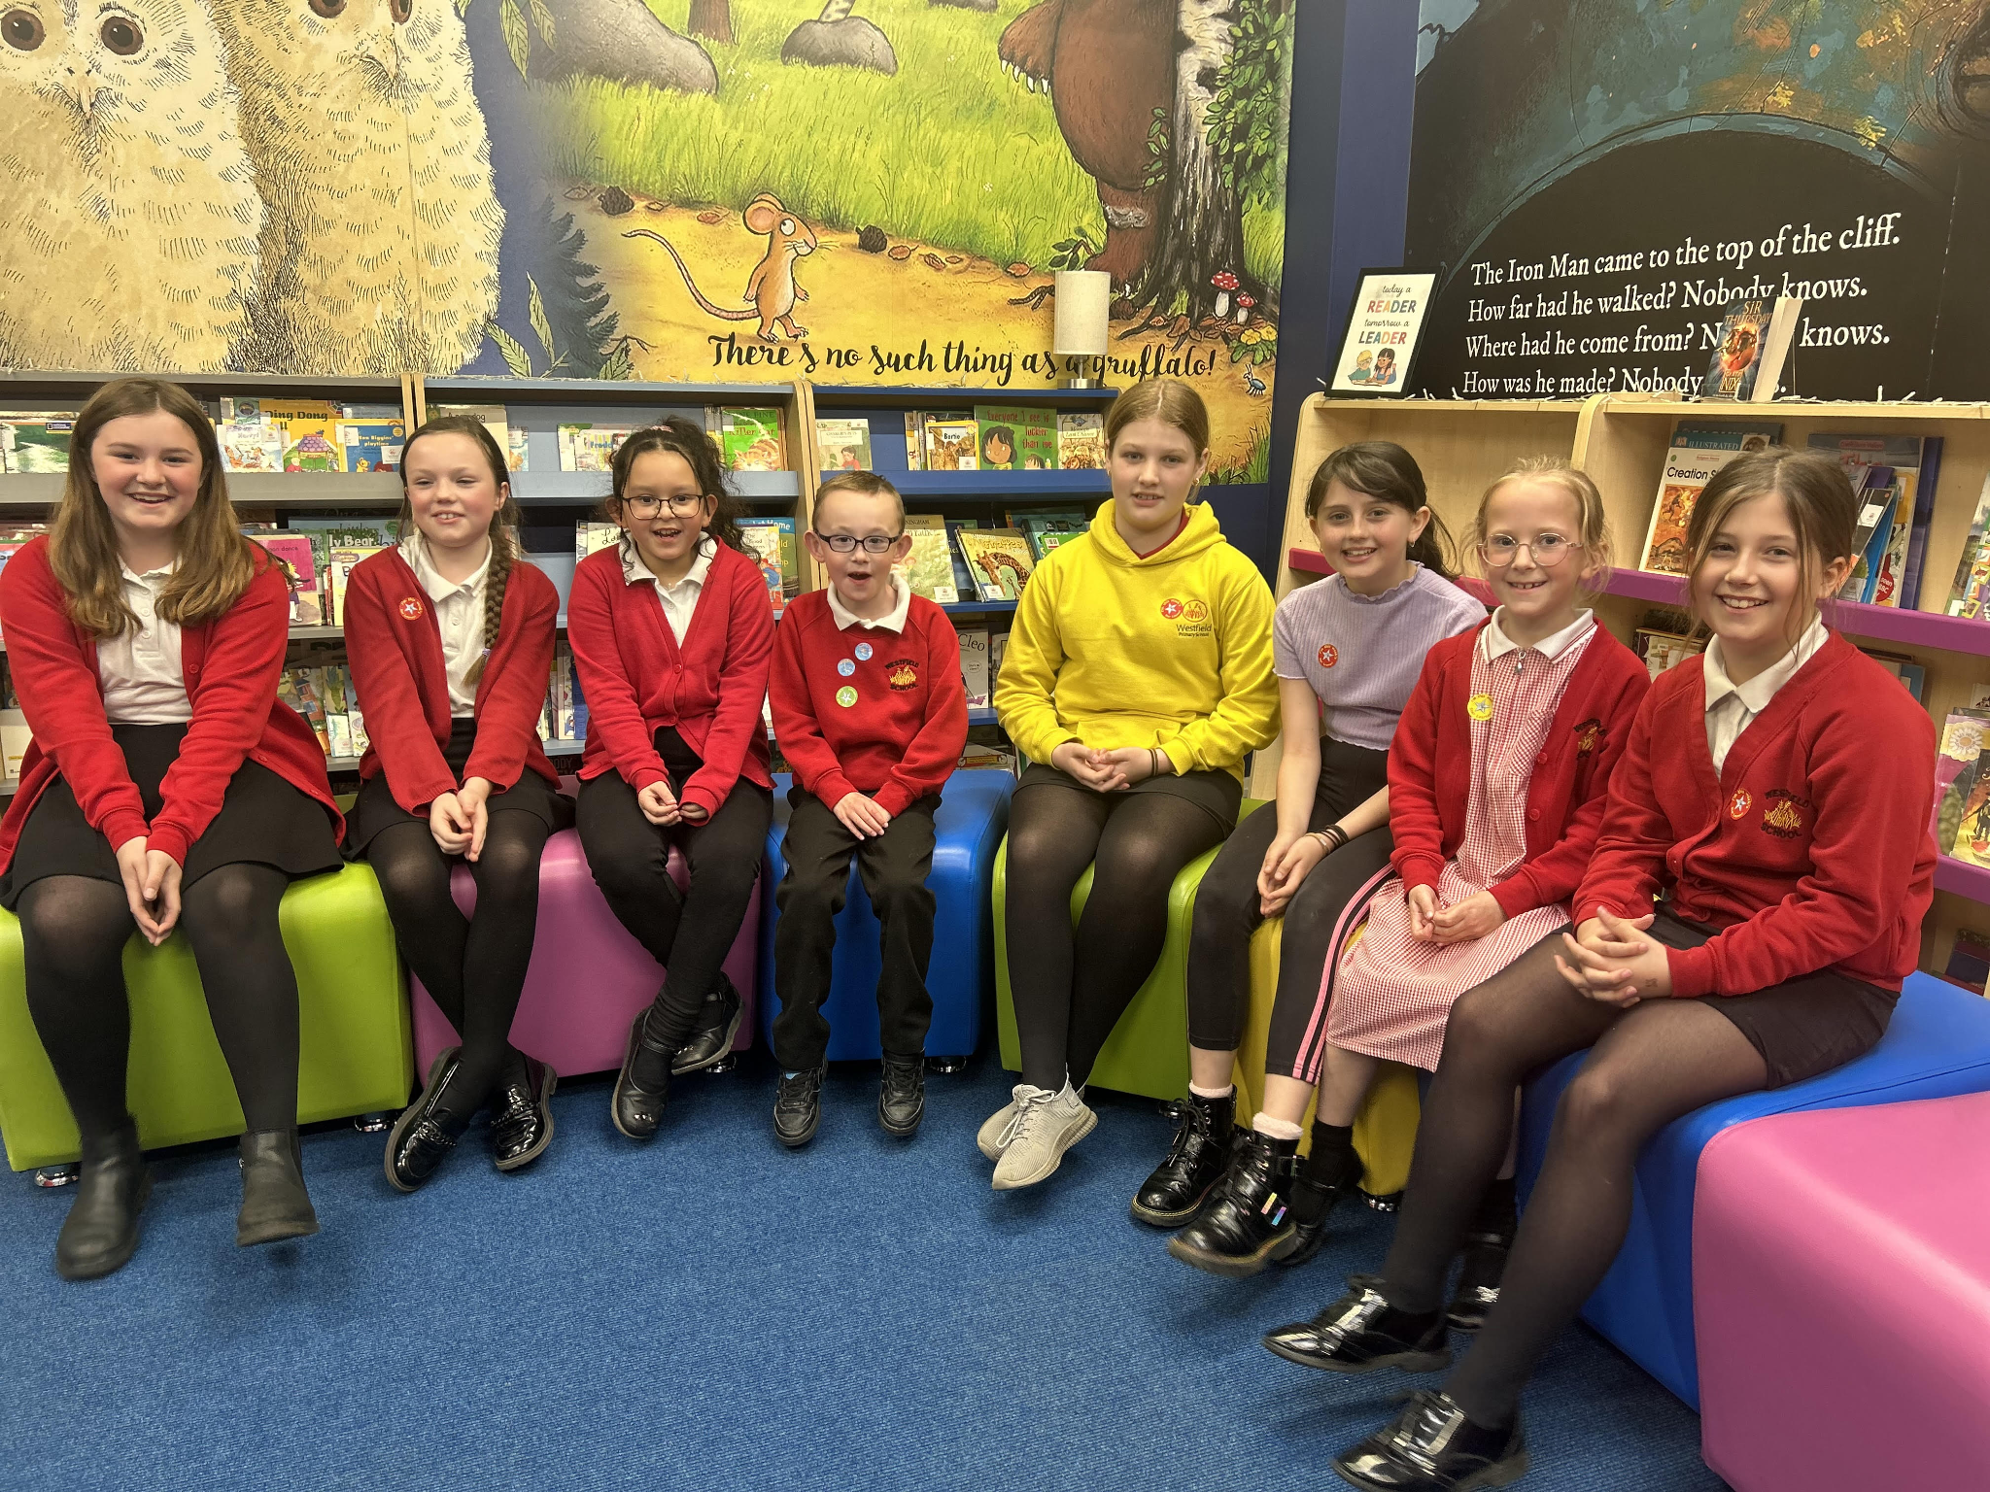
Top Doodling Classes

Doodle Maths & Doodle Tables

Eagle | 88%
Falcon | 64%

Diary Dates

May

Mon 8 Bank Holiday
Tues 9 - Fri 12 Year 6 SATs
Fri 26 End of Term
Mon 29 – Fri 2 Half Term

June
Mon 5 Pupils return to school
Fri 9 Year 3 sleepover at school

July

Wed 5 Year 6 Camp Meeting (Sept 23)
Mon 10 – Fri 14 Fantastic Futures
Fri 21 End of school year





