Dear Parents

Comic Relief - Friday 17th March
Today for Comic Relief, teachers have been taking part in Comic Relief Challenges. Here we have Mr Mills being gunged, Mrs Bowery walking around the field in custard filled wellies and Mrs Rich enjoying a baked bean bath. Children were invited to come into school wearing something red or fancy dress in exchange for a £1 donation and we are pleased to say we raised £268.
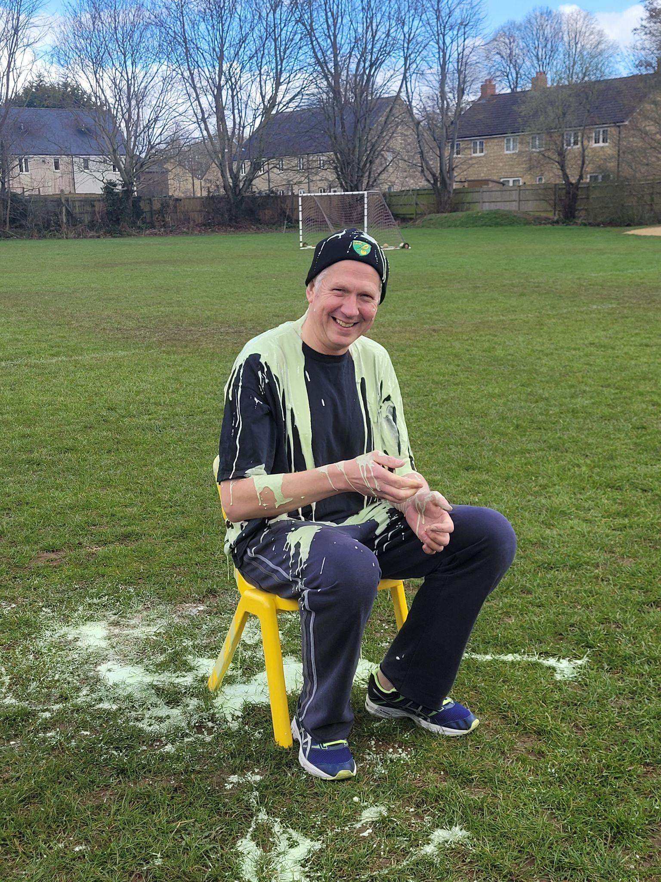

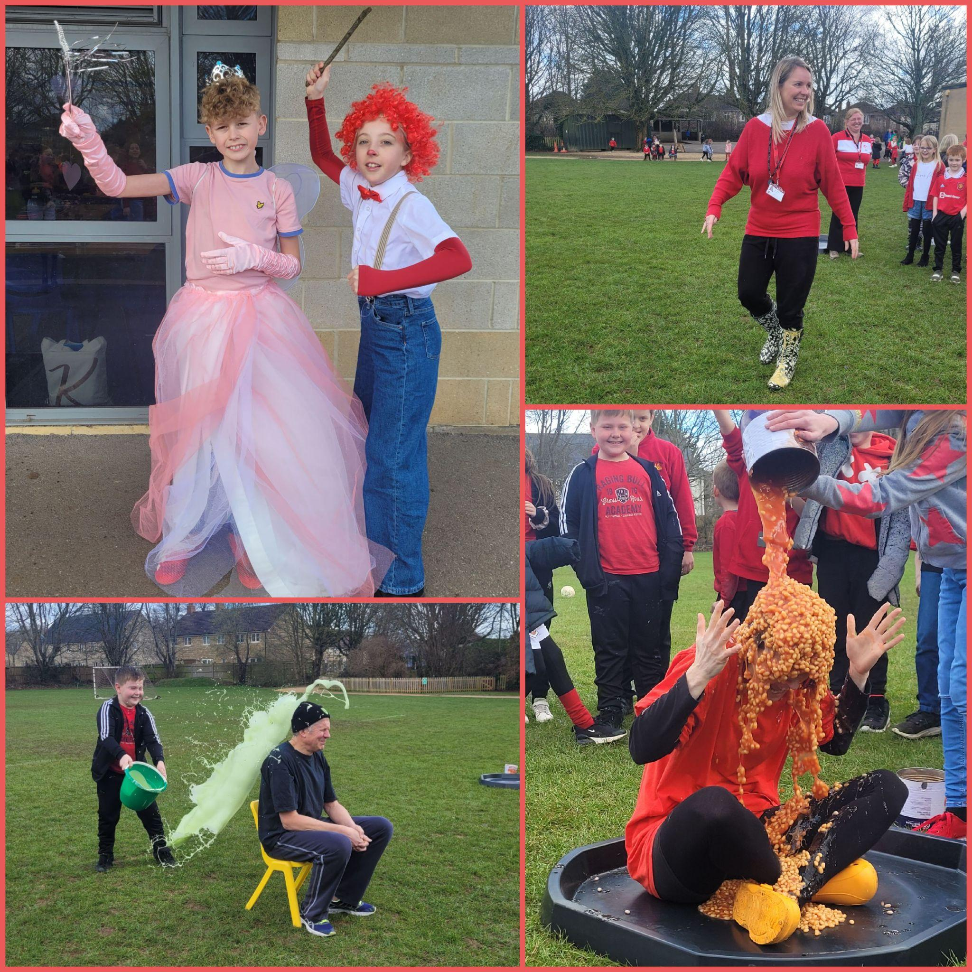

Dinners
Please make sure that you are continuing to book school dinners via ParentPay for your child by the end of the day every Thursday for the upcoming week.

If nothing is ordered and your child is expecting a meal we will no longer be able to provide one and you will have to bring a packed lunch up for them straight away.

Reading Raffle

Key Stage 1
Winners: Squirrel 68%
2nd Place: Badger 64%

Key Stage 2
Winners Eagle 97%
2nd place: Falcon 81%

Top Class Attendance for last week

Turtle | 97%
Bumblebee | 93%

Top Doodling Classes
Doodle Maths

Dragonfly | 78%
Eagle | 75%
Monkey | 73%
Doodle Tables

Dragonfly | 87%
Falcon | 84%
Turtle | 64%

Star Learners
Well done to this week’s Star Learners
Class | Name | School Value
Dolphin | Scarlett Padfield | **All**
Monkey | Leo Bryant | Ambition
Dragonfly | Colby Grimes | Resilience
Turtle | Eva Coles | Ambition
Panther | Tali Barnes | Resilience
Butterfly | Mia Barnard | Ambition
Falcon | Kleada Mezini | Ambition
Eagle | Lily Bridges | Respect
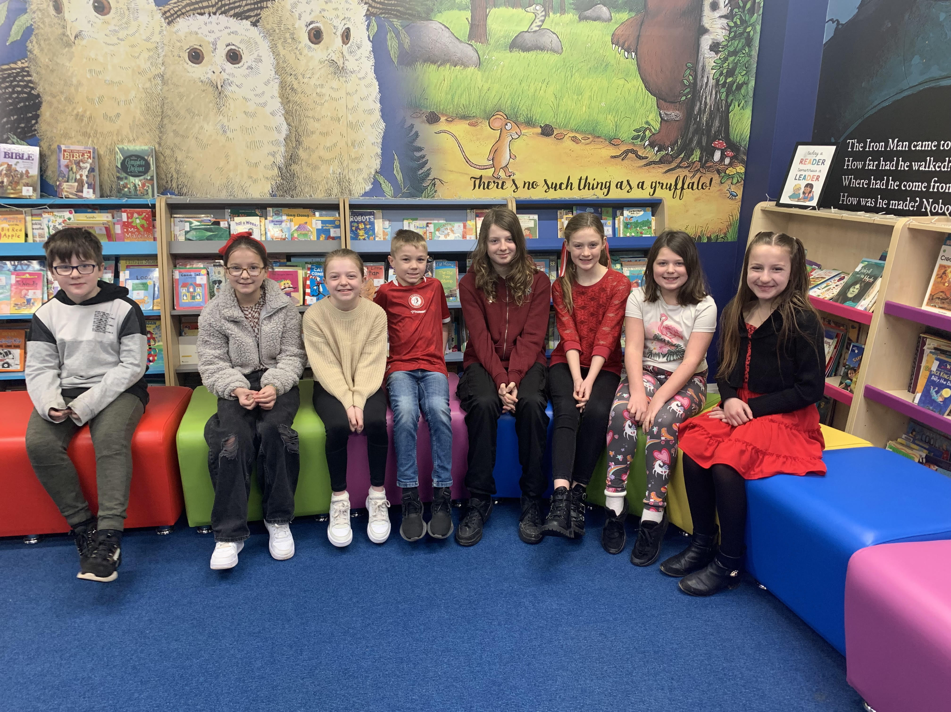


Diary Dates

March

Fri 31 End of Term

April
Mon 3 – Fri 14 Easter Holidays
Mon 17 Inset Day
Tues 18 Pupils return to school

May
Mon 1 May Bank Holiday
Wed 3 – Fri 5 Year 4 Camp
Mon 8 Bank Holiday
Fri 26 End of Term
Mon 29 – Fri 2 Half Term

June
Mon 5 Pupils return to school
Fri 9 Year 3 sleepover at school

July
Mon 10 – Fri 14 Fantastic Futures
Fri 21 End of school year




