Dear Parents
Car Park Barrier
Reminder - Please do not use the school car park if picking up your child from an after school club. The car park barrier will be closed and will not re-open until 5pm.

Help your child with home reading
Please can you make sure that you hear your child read their school reading book 5 days each week. This needs to be recorded in their reading record book. At KS1 we ask parents and carers to fill out the comments, whereas in KS2, the children should be recording what they have read and writing a comment. Both reading books and reading record books need to be in school EVERY DAY!

Christmas Dinner
We will be having our Christmas Dinner on Wednesday 14th December. This will also be Christmas Jumper day. This will need to be pre-ordered on ParentPay by Thursday 8th December.

Dinners
Dinners MUST be ordered by Thursday every week for the following week on ParentPay.
If nothing is ordered and your child is expecting a meal we will no longer be able to provide one and you will have to bring a packed lunch up for them straight away.
Any problems at all with Parentpay, please just call.
Snacks- advice on playtime snacks.
Please support our drive to encourage a healthy snack at morning break times. Children in Reception and KS1 all receive a free piece of school fruit. If children prefer they are able to bring their own fruit or chopped vegetables from home (either a whole piece or chopped in a pot). If your child has a specific medical or dietary need and requires a different snack from home please inform the class teacher. Snacks seem to have increased in size and content recently which is not inline with our policy. Any snack from home should be in a pot and not packets or wrappers to reduce the amount of litter.
KS2 are also encouraged to bring a healthy snack from home. Again we would like to ask that these are sent in a pot to reduce litter. Crisps, sugary cereal bars, fruit winders and any form of chocolate is not a healthy snack. Examples of a healthy snack for KS2 might be:
small pot of breadsticks, small pot of rice cakes, raw vegetable sticks, small cubes of cheese or a small scotch pancake.
We would also like to remind you that we are a nut free school. Whole nuts, peanut butter and nutella spreads are not allowed in lunch boxes.
Many thanks for your support with this.
Nativities
This year, Nativities will be held the week of the 5th December.
Each child will be issued two tickets per performance. You must bring your ticket with you to be admitted into school due to maximum numbers.
Reception Nativity
Wednesday 7th - 9:15am and 2:15pm
Year 1 Nativity
Tuesday 6th December - 9:15am and 2:15pm
Year 2 Nativity
Monday 5th December - 9:15am and 2:15pm

Star Learners

Class | Name | School Value
Monkey | Jack MacFarlane | Resilience
Dolphin | Emily Wilkins | Ambition
Dragonfly | Freddie Stenner | Respect
Turtle | Paige Andow | Respect
Butterfly | Alex Fuller | Collaboration
Panther | Willow Parker | Ambition
Falcon | Olivia Langan | Respect & Ambition
Eagle | Nikolaj Ostergaard | Collaboration
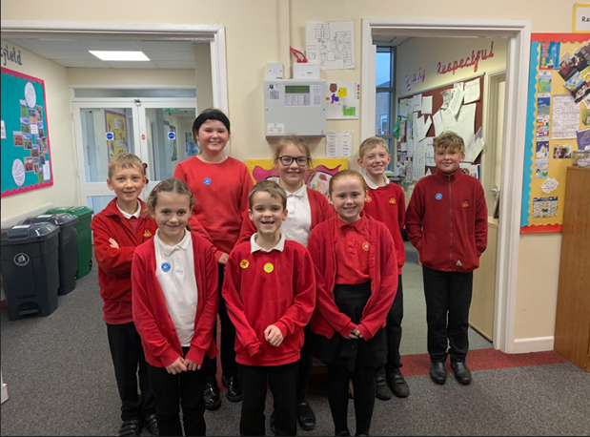

Little Princess Trust
Well done to Freddie Rogers from Panther class for donating your hair to the Little Princess Trust.
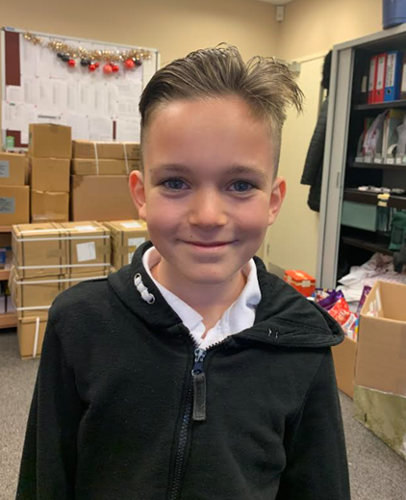

Diary Dates

December
Thurs 8 Pantomime in school
Mon 5 Year 2 Nativity 9.15am & 2.15pm
Tues 6 Year 1 Nativity 9.15am & 2.15pm
Wed 7 Reception Nativity 9.15am & 2.15pm
Tues 13 Christmas Service
Wed 14 Christmas Jumper Day
Christmas Dinner
Fri 16 End of Term

Mon 19 – Mon 2 Christmas Holidays

January
Tues 3 Inset Day
Weds 4 Pupils return to school

February
Fri 10 End of Term
Mon 13 – Fri 17 Half Term
Mon 20 Pupils return to school

March
Thurs 2 World Book Day
Fri 31 End of Term

April
Mon 3 – Fri 14 Easter Holidays
Mon 17 Inset Day
Tues 18 Pupils return to school

May

Wed 3 – Fri 5 Year 4 Camp
Fri 26 End of Term
Mon 29 – Fri 2 Half Term

June
Mon 5 Pupils return to school

July

Mon 10 – Fri 14 Fantastic Futures
Fri 21 End of school year



