Dear Parents
Open Days
We are now taking bookings for our Open Days. This year we are offering potential parents the chance to visit the school on a Tuesday at 9:30am or a Thursday at 1:30pm. If anyone you know would like to visit please ask them to get in touch.


Baby News
Congratulations to Gracie Busson who has become a big sister! The family welcomed twin boys born on the 26th October weighing 4lbs 7oz and 4lbs 4oz.
Help your child with home reading
Please can you make sure that you hear your child read their school reading book 5 days each week. This needs to be recorded in their reading record book. At KS1 we ask parents and carers to fill out the comments, whereas in KS2, the children should be recording what they have read and writing a comment. Both reading books and reading record books need to be in school EVERY DAY!

Dinners
Dinners MUST be ordered by Thursday every week for the following week on ParentPay.
If nothing is ordered and your child is expecting a meal we will no longer be able to provide one and you will have to bring a packed lunch up for them straight away.

As you know we are part of the MAT and our catering providers have to follow their strict guidelines with regards to ordering. We are now a hub kitchen for 6 other schools and cook over 800 meals a day so we would really appreciate your support with this.
Any problems at all with Parentpay, please just call.
Bedtime Stories

On Thursday 10th November, we will be holding our annual Bedtime Stories evening alongside the Poetry Slam. Children in KS1 and Year 3 are invited to come back to school dressed in their pyjamas and enjoy a hot chocolate and a story with their teacher in their classrooms. This will run from 5:15pm until 6pm. Teddies are welcome too! Please note that it is essential that you book your child in for this event – we cannot accept children unless we have a reply slip for them. Please return all slips by Monday 7th November.
While the Bedtime Story is happening, we will again be holding a Poetry Slam in the school hall for children in Years 4, 5 and 6. This is an opportunity for some of our older children to read and perform a poem that they have chosen and rehearsed in class.
Reminder- The Travelling Book Fayre will open on Wednesday at 2.30pm in the hall. Come and have a look at a huge range of wonderful books to buy. Thank you to the PTA for agreeing to run the book shop.
Pantomime

Following the success of last year's performance of Sleeping Beauty from the Rainbow Theatre we are welcoming the theatre company back for a second year. This year we are in for a real treat as they perform Aladdin to us in two separate shows.
The PTA have once again very generously agreed to pay for half of the total cost which reduces the payment to £1.00 per child. Please find this payment on Parent Pay. We would appreciate payment by 1st December.
Nursery pre-school parents. The dates are Friday 2nd December (am) and Thursday 8th December (pm). Please only pay for your pre-school child if they are in Nursery on these dates.

Star Learners
Congratulations to all our Star Learners this week. Keep up the good work!
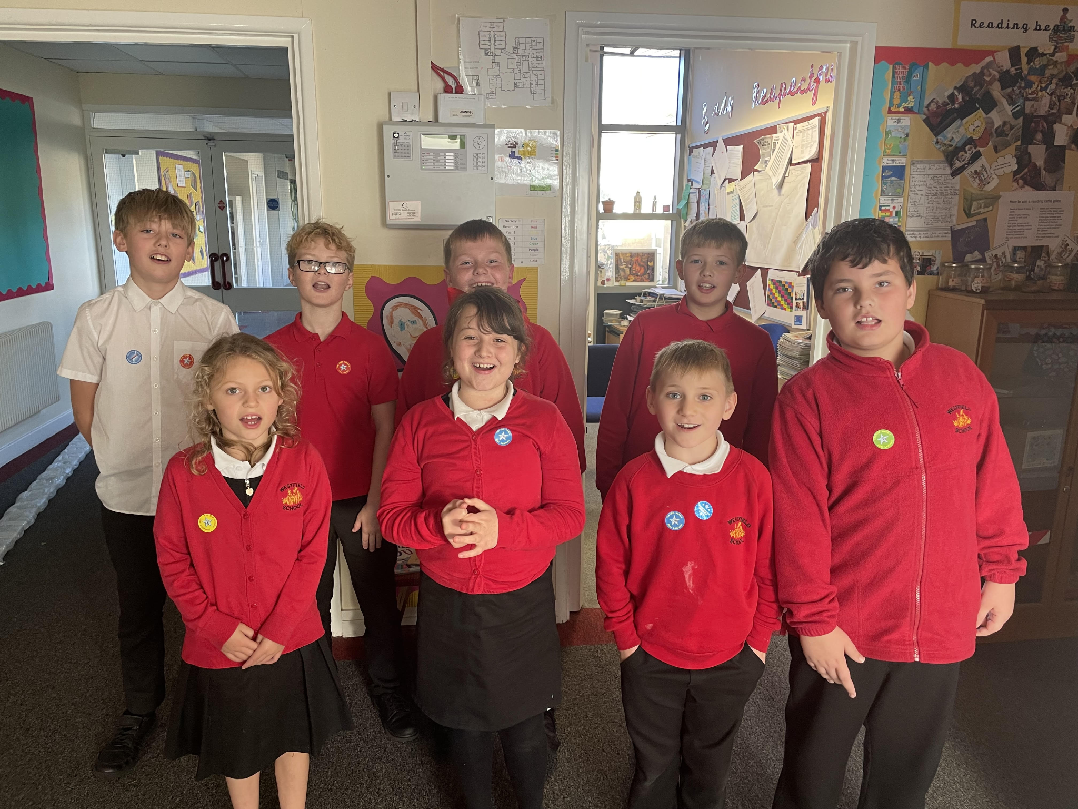


BBC Children in Need
Children in Need is taking place on Friday 18th November and all children are invited to wear a piece of clothing or accessory that includes spots.
KS1 - we are hosting a colouring competition for KS1, please collect colouring templates from the school office in exchange for a small donation. Entries must be in school by Thursday 17th November as winners will be announced in assembly on Friday 18th November.
KS2 - we are offering the children the chance to have their faces painted by our Year 6 value champions during break time and lunchtime. If you would like your child to be included, then please send them in with a small donation.

Stay and Sessions

We are excited to welcome you back to our Stay and sessions. For each of the sessions, one family member is invited to meet in the hall at 8:45am for a brief talk with Miss Offer and Mrs Rich, before popping into their child’s classroom at 9am until 9:15am to join in with different activities. Please note, the Stay and Regulate sessions in Term 6 will be in the morning for KS1 and afternoon for KS2. Here are the dates to add to your diary.

KS1 Dates

Term 2 | Stay and Calculate | Wednesday 16th November
Term 3 | Stay and SPAG | Tuesday 17th January
Term 4 | Stay and Read | Wednesday 1st March (World Book Week)
Term 5 | Stay and Problem Solve | Tuesday 25th April
Term 6 | Mental health and wellbeing | Tuesday 13th June (AM)

KS2 Dates

Term 2 | Stay and Calculate | Monday 14th November
Term 3 | Stay and SPAG | Thursday 19th January
Term 4 | Stay and Read | Monday 27th February
Term 5 | Stay and Reason | Thursday 27th April
Term 6 | Mental health and wellbeing | Tuesday 13th June (PM)

In KS1, each class has a bedtime story bag which the children will take turns to bring home. Inside you will find a lovely story book and a tasty hot chocolate sachet to snuggle up and enjoy. Here is a photo of Archie from Bumblebee Class enjoying the story bag at home.
Look out for the bedtime story bag coming home with your child.
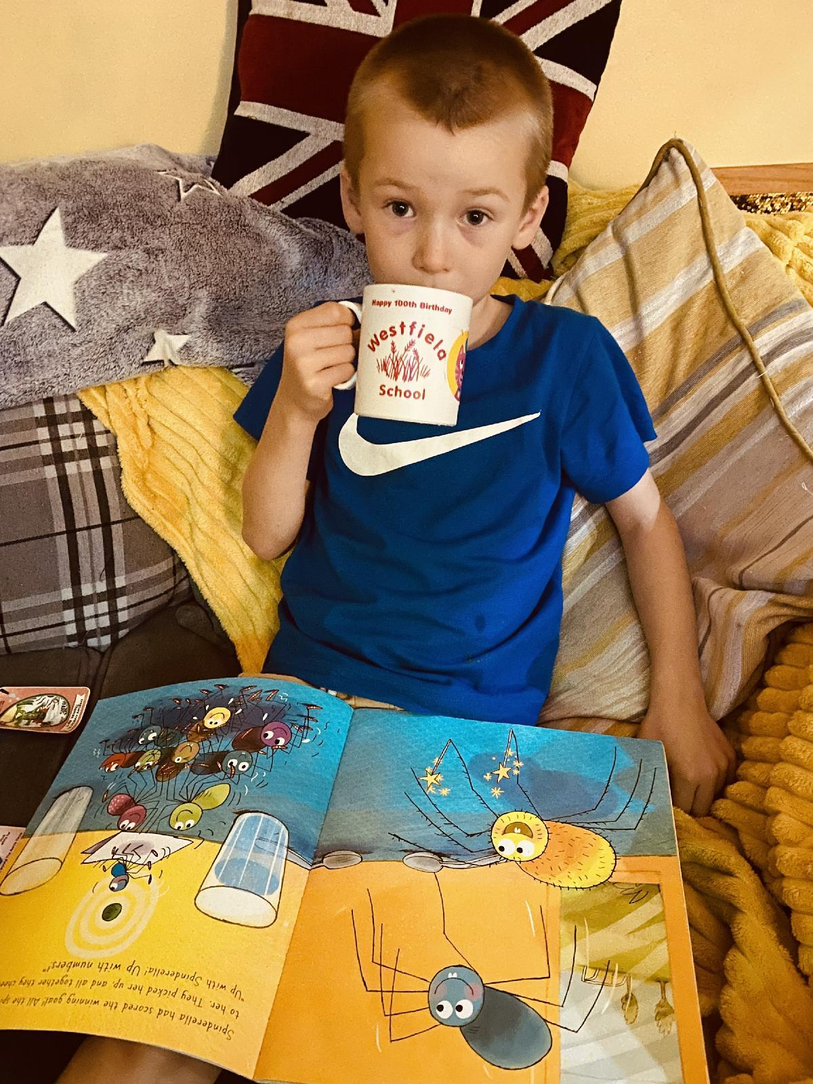
The Music Man visits Westfield

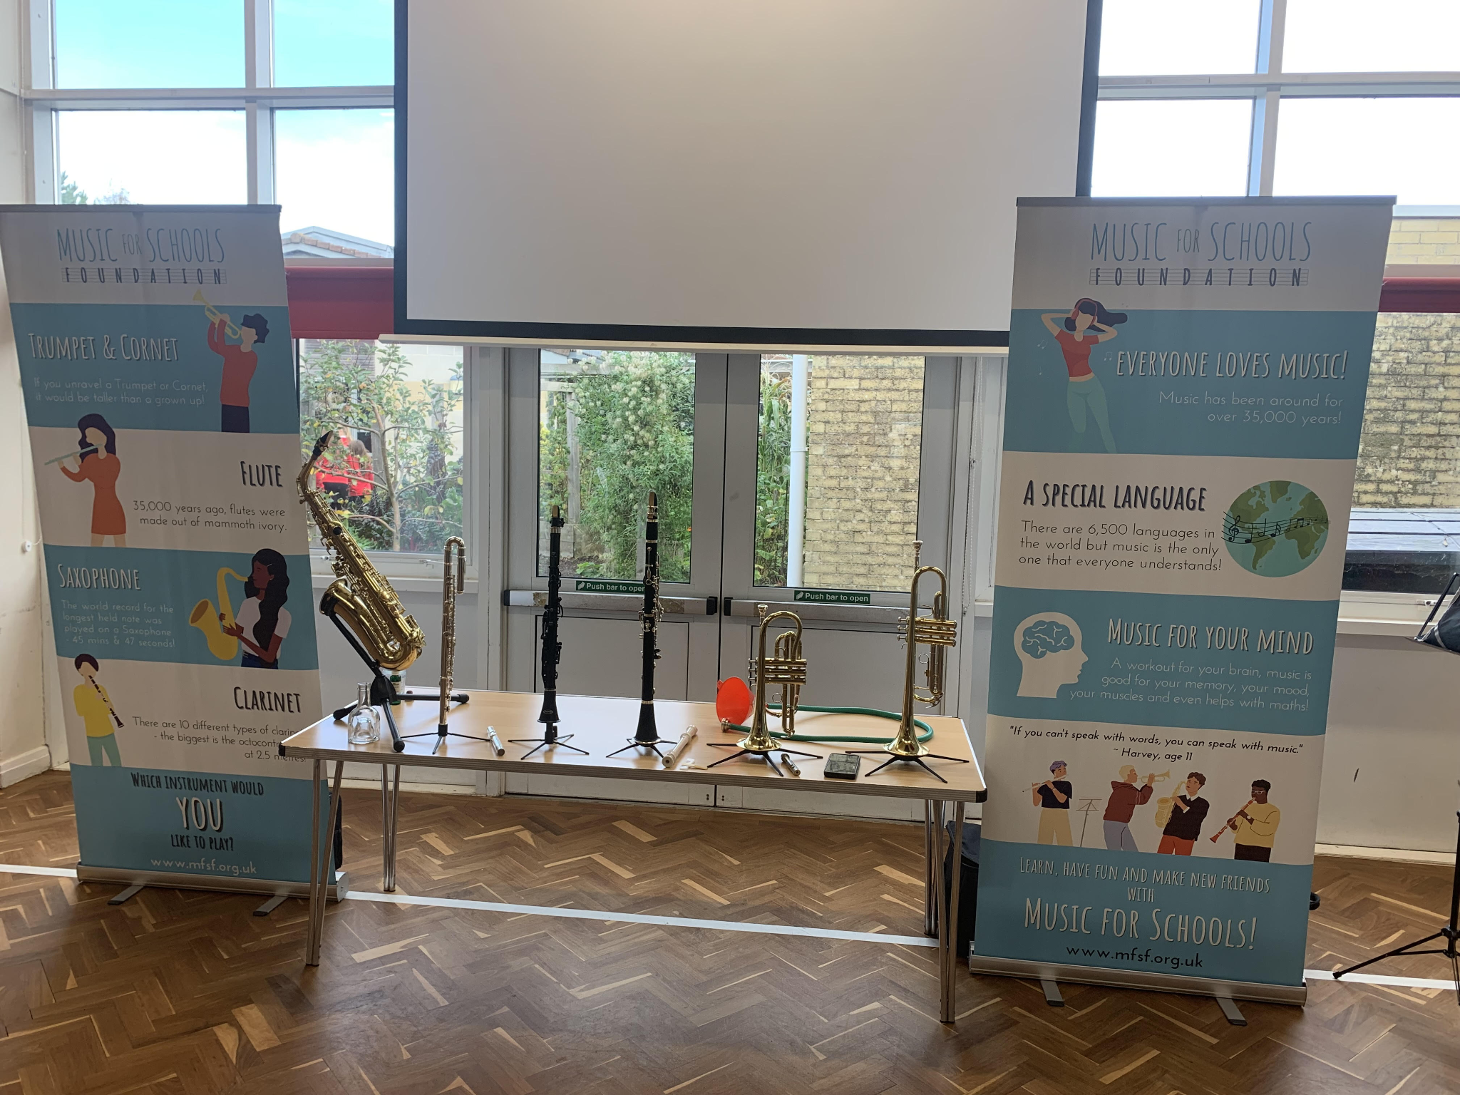

Children in Years 2-6 had a fantastic assembly with the Music Man earlier on this week. If your child has felt inspired to learn and you would like more information then please get in touch with Miss Offer on Weduc.

Diary Dates
November
Thurs 10 Bedtime story night (Nursery - Yr3)
Poetry Slam - (Yr 4- 6 in hall)
Mon 14 Start of Anti Bullying Week
Thurs 24 Westfield Christmas Light Switch On

December
Fri 2 & Thurs 8 Pantomime in school for all children
Mon 5 Year 2 Nativity 9.15am & 2.15pm
Tues 6 Year 1 Nativity 9.15am & 2.15pm
Wed 7 Reception Nativity 9.15am & 2.15pm
Tues 13 Christmas Service
Wed 14 Christmas Jumper Day
Christmas Dinner
Fri 16 End of Term
Mon 19 – Mon 2 Christmas Holidays

January
Tues 3 Inset Day
Weds 4 Pupils return to school

February
Fri 10 End of Term
Mon 13 – Fri 17 Half Term
Mon 20 Pupils return to school

March
Thurs 2 World Book Day
Fri 31 End of Term

April
Mon 3 – Fri 14 Easter Holidays
Mon 17 Inset Day
Tues 18 Pupils return to school

May
Wed 3 – Fri 5 Year 4 Camp
Fri 26 End of Term
Mon 29 – Fri 2 Half Term

June
Mon 5 Pupils return to school

July
Mon 10 – Fri 14 Fantastic Futures
Fri 21 End of school year





To sign up go to
http://www.strattonunitedfc.co.uk/girls_football.html

