Dear Parents
Baby News
Congratulations to Raya and Lacey Whittock who have a new baby sister! Frankie Maeve Rodd was born on 19.11.22 weighing 9lbs 2oz.
Can you help?
We are still in need of a tall cardboard box (large enough for some children to hide behind) for our Year 2 Christmas play. If you are able to help with this, please let Year 2 know!
Bags2 School collection - Monday
We are holding a clothes collection, please could you bring in bags on 28th November and drop them to the school office.
For every bag of clothes that is donated the school will receive money!
Help your child with home reading
Please can you make sure that you hear your child read their school reading book 5 days each week. This needs to be recorded in their reading record book. At KS1 we ask parents and carers to fill out the comments, whereas in KS2, the children should be recording what they have read and writing a comment. Both reading books and reading record books need to be in school EVERY DAY! 

Christmas Dinner
We will be having our Christmas Dinner on Wednesday 14th December. This will also be Christmas Jumper day. This will need to be pre-ordered on ParentPay by Thursday 8th December.

Dinners
Dinners MUST be ordered by Thursday every week for the following week on ParentPay.
If nothing is ordered and your child is expecting a meal we will no longer be able to provide one and you will have to bring a packed lunch up for them straight away.
Any problems at all with Parentpay, please just call.
Pantomime - Friday 2nd December and Thursday 8th December. Please could we remind you to pay for the school pantomime by Thursday please.
Nursery pre-school parents. The dates are Friday 2nd December (am) and Thursday 8th December (pm). Please only pay for your preschool child if they are in Nursery on these dates.
Snacks- advice on playtime snacks.
Please support our drive to encourage a healthy snack at morning breaktimes. Children in Reception and KS1 all receive a free piece of school fruit. If children prefer they are able to bring their own fruit or chopped vegetables from home (either a whole piece or chopped in a pot). If your child has a specific medical or dietary need and requires a different snack from home please inform the class teacher. Snacks seem to have increased in size and content recently which is not inline with our policy. Any snack from home should be in a pot and not packets or wrappers to reduce the amount of litter.
KS2 are also encouraged to bring a healthy snack from home. Again we would like to ask that these are sent in a pot to reduce litter. Crisps, sugary cereal bars, fruit winders and any form of chocolate is not a healthy snack. Examples of a healthy snack for KS2 might be:
small pot of breadsticks, small pot of rice cakes, raw vegetable sticks, small cubes of cheese or a small scotch pancake.
We would also like to remind you that we are a nut free school. Whole nuts, peanut butter and nutella spreads are not allowed in lunch boxes.
Many thanks for your support with this.
Christmas Light Switch on
The KS2 Choir sang beautifully at the Christmas Light Switch On and represented the school brilliantly! They should be so proud of their performance. Well done KS2 Choir - you’re all singing superstars!

Nativities
This year, Nativities will be held the week of the 5th December.
Please could all costumes be in school by Monday 28th November. Each child will be issued two tickets per performance. You must bring your ticket with you to be admitted into school due to maximum numbers.
Reception Nativity
Wednesday 7th - 9:15am and 2:15pm
Year 1 Nativity
Tuesday 6th December - 9:15am and 2:15pm
Year 2 Nativity
Monday 5th December - 9:15am and 2:15pm
Star Learners

Class | Name | School Value
Monkey | Isla Parker | Collaboration
Dolphin | Jessica Best | Respect
Dragonfly | T’Maine Ford | Resilience
Turtle | Camille Trouche | Ambition
Butterfly | Riley Bishop | Ambition
Panther | Amy Emery | Ambition
Falcon | Frankie Stevenson | Ambition
Eagle | Amelia Snow | Ambition

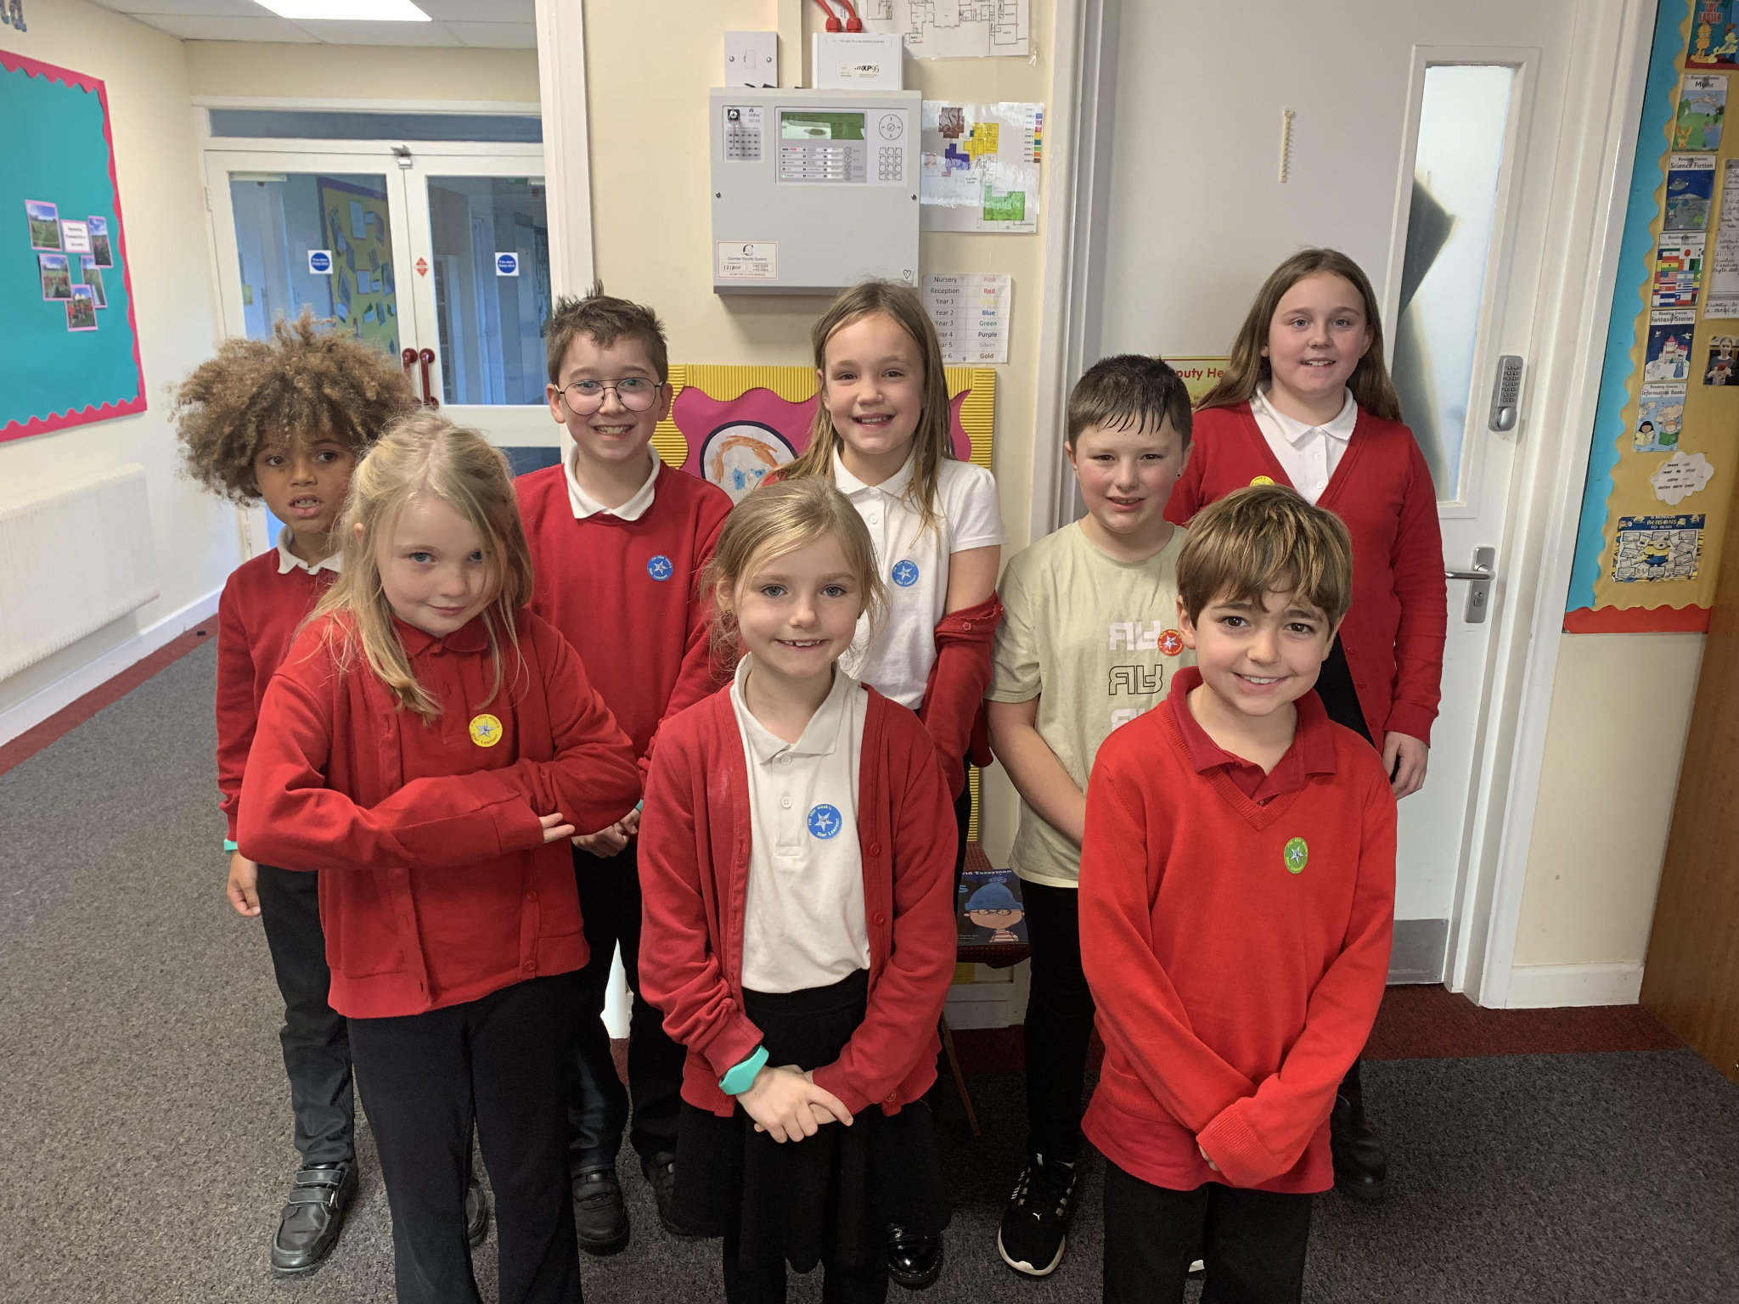
Diary Dates

December
Fri 2 & Thurs 8 Pantomime in school for all children
Mon 5 Year 2 Nativity 9.15am & 2.15pm
Tues 6 Year 1 Nativity 9.15am & 2.15pm
Wed 7 Reception Nativity 9.15am & 2.15pm
Tues 13 Christmas Service
Wed 14 Christmas Jumper Day
Christmas Dinner
Fri 16 End of Term

Mon 19 – Mon 2 Christmas Holidays

January
Tues 3 Inset Day
Weds 4 Pupils return to school

February
Fri 10 End of Term
Mon 13 – Fri 17 Half Term
Mon 20 Pupils return to school

March
Thurs 2 World Book Day
Fri 31 End of Term

April
Mon 3 – Fri 14 Easter Holidays
Mon 17 Inset Day
Tues 18 Pupils return to school

May

Wed 3 – Fri 5 Year 4 Camp
Fri 26 End of Term
Mon 29 – Fri 2 Half Term

June
Mon 5 Pupils return to school

July

Mon 10 – Fri 14 Fantastic Futures
Fri 21 End of school year

