Dear Parents

Baby News
Congratulations to Dolcie Weston who has become a big sister! Ronni-Dean was born on Monday weighing 8lbs 8oz.

No Smoking
Please be reminded that smoking on and around the school grounds is not permitted.
No Dogs
Just a gentle reminder that no dogs are allowed on the school site, this includes the carrying of dogs. Thank you for your support.
Values Champions
Well done to all our newly elected Value Champions

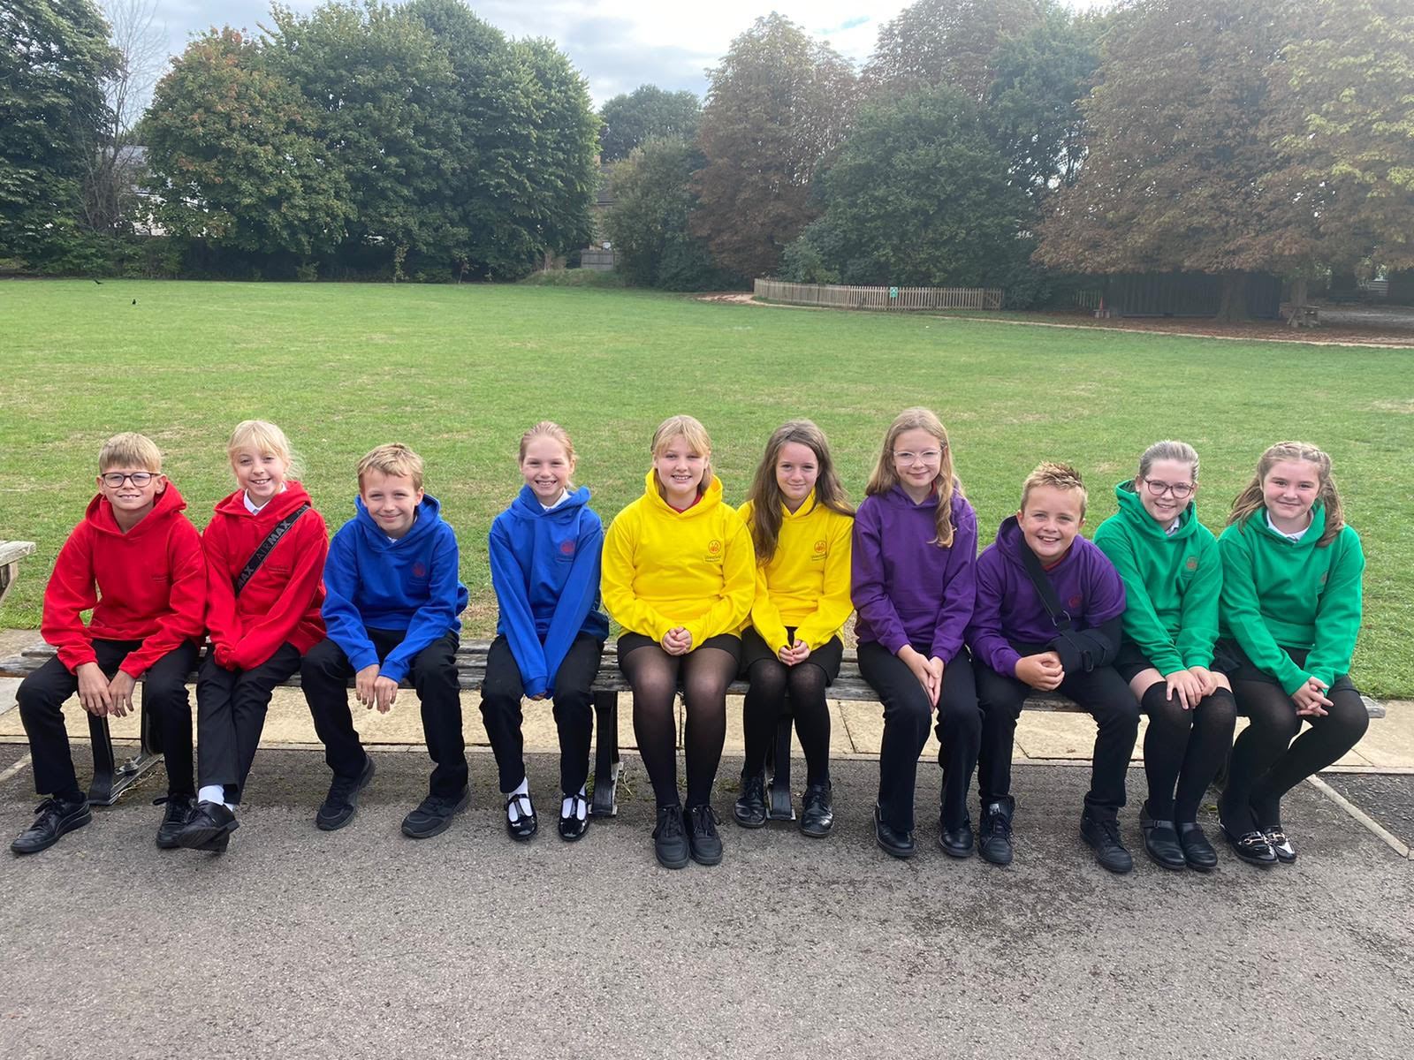

Ambition - Jasmine Workman & Lola Rogers
Creativity - Josie Davies & Ollie Newman
Collaboration Rohan Gumbleton & Florence Sheppard
Resilience - Reggie Francis & Hannah Hucker
Respect - Honey Drew & Ellie-Mai Townsley

Year 5 and 6 Bikeabilty
Year 5 and 6 who have signed up for Bikeability have come home with a consent form today. Please could this be returned as soon as possible. There are still 20 spaces remaining. Please sign up on Parent Pay if your child would like to take part. There is no charge for children in receipt of free school meals.

Help your child with home reading
Please can you make sure that you hear your child read their school reading book 5 days each week. This needs to be recorded in their reading record book. At KS1 we ask parents and carers to fill out the comments, whereas in KS2, the children should be recording what they have read and writing a comment. Both reading books and reading record books need to be in school EVERY DAY!

Dinners
Dinners MUST be ordered by Thursday every week for the following week on ParentPay.
If nothing is ordered and your child is expecting a meal we will no longer be able to provide one and you will have to bring a packed lunch up for them straight away.

As you know we are part of the MAT and our catering providers have to follow their strict guidelines with regards to ordering. We are now a hub kitchen for 6 other schools and cook over 800 meals a day so we would really appreciate your support with this.
Any problems at all with Parentpay, please just call.

School Uniform
Thank you for ensuring all of the children returned to school looking smart in their school uniform, including black footwear. A little reminder however is required for PE Kit. All PE kits should be free from any logo or brand name, apart from the school logo.

Tee Shirt or Polo Shirt - White
PE Shorts - Black
Trainers or Daps - Black or White
Year 6 camp - Monday 26th
Year 6 are excited and ready to set off on their residential. Please drop your child with their luggage in the school hall on Monday and then leave your child to go and register in class. You may wait on Longfellow Road to wave us off at 9.15am. Please remember all medication must be sent in its prescribed box with a completed medical form.

Harvest
We’re celebrating Harvest at the church on Tuesday 4th
October. This is for children only due to space.

This year we are asking for donations to be made to the Somer Valley Food Bank. Drop off points can be found below.

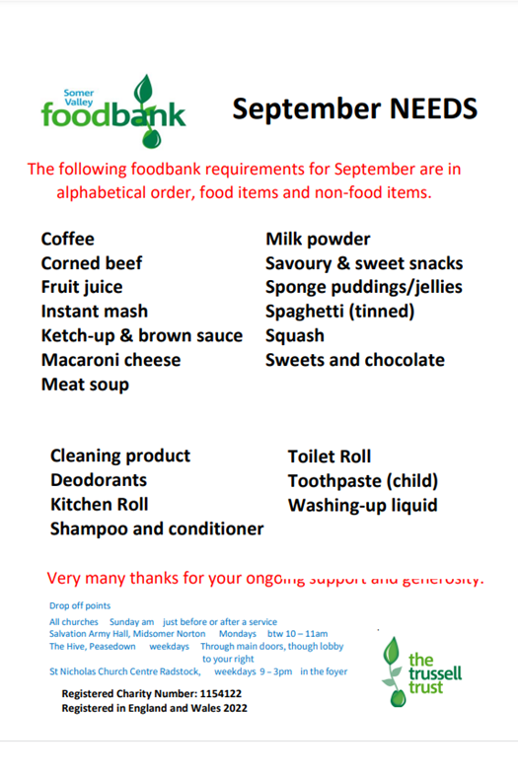

Hello Yellow - Monday 10th October

This World Mental Health Day, thousands across the country are coming together to say #HelloYellow. We will be taking part in #HelloYellow and raising vital funds to support Young Minds Children’s Mental Health Charity.

To take part, please send children in wearing yellow or a yellow accessory.
We'll have buckets out on the playground for donations!

Diary Dates

October

Tues 4 Harvest church service - pupils only
Tues 4 Nigel Coles Photos
Weds 5 Nigel Coles Photos
Mon 17 & Virtual Parents evening - details to
Thurs 20 follow
Fri 21 Inset Day
Mon 24 – Fri 28 Half Term
Mon 31 Pupils return to school

November
Thurs 10 Bedtime story night (Nursery - Yr3)
Poetry Slam - (Yr 4- 6 in hall)
Mon 14 Start of Anti Bullying Week
Thurs 24 Westfield Christmas Light Switch On

December
Fri 2 & Thurs 8 Pantomime in school for all children
Mon 5 Year 2 Nativity 9.15am & 2.15pm
Tues 6 Year 1 Nativity 9.15am & 2.15pm
Wed 7 Reception Nativity 9.15am & 2.15pm
Tues 13 Christmas Service
Wed 14 Christmas Jumper Day
Christmas Dinner
Fri 16 End of Term
Mon 19 – Mon 2 Christmas Holidays

January
Tues 3 Inset Day
Weds 4 Pupils return to school

February
Fri 10 End of Term
Mon 13 – Fri 17 Half Term
Mon 20 Pupils return to school

March
Thurs 2 World Book Day
Fri 31 End of Term

April
Mon 3 – Fri 14 Easter Holidays
Mon 17 Inset Day
Tues 18 Pupils return to school

May
Wed 3 – Fri 5 Year 4 Camp
Fri 26 End of Term
Mon 29 – Fri 2 Half Term

June
Mon 5 Pupils return to school
July
Mon 10 – Fri 14 Fantastic Futures
Fri 21 End of school year



